Comprehensive Analysis of Land Use and Land Cover Shifts from A Redd Perspective: A Case Study of Banepa Municipality, Nepal

Sujan Ghimire¹, Hemanta Poudel*², Sharad Upadhyaya³,Dr. Binod Kumar Adhikari⁴.
¹Student, Geomatics Engineering, Kathmandu University. [Email:sujanghimire500@gmail.com] [ORCID: https://orcid.org/0009-0002-8078-5743].
^{*2}Student, B.Sc.CSIT, Tribhuvan University. [Email:hemantapoudel14@gmail.com]
[ORCID: https://orcid.org/0009-0006-2391-4720].
³Student, B.Sc.CSIT, Tribhuvan University. [Email: sharadupadhyaya23@gmail.com]
⁴IOST Department, Tribhuvan University. [Email:binod.adhikari@ac.tu.edu.np]

Received: November 25, 2023; Revised & Accepted: December 25, 2023
Copyright: Ghimire, Poudel, Upadhyaya & Adhikari (2023)

This work is licensed under a Creative Commons Attribution-Non Commercial 4.0 International License.

Abstract
This paper examines the dynamic changes in land use and cover in Banepa Municipality over three decades, from 1991 to 2021, using the remote sensing method within the REDD perspective. It uncovers an 11% surge in built-up areas and a 5% decline in forest cover, with minimal agricultural fluctuations (1%) and a substantial 7% decrease in barren land. Urgent concerns about ecological balance prompt a call for immediate REDD implementation.
To address these issues, the study advocates for employing monitoring methods, including remote sensing, to evaluate forest and land resources. This data can inform comprehensive studies on the drivers of deforestation and forest degradation, alongside feasibility and sectorial analyses, including cost-benefit assessments for effective land-use planning. The conclusion stresses the imperative need for planned urban development in Banepa to preserve open spaces, forests, and agriculture. This study provides vital insights into the intricate relationship between land-use changes and climate impact, emphasizing the urgency of sustainable development actions.

Keywords: deforestation, spatial, land use, land cover, urbanization, remote sensing

Introduction
Land use and land cover change has become pivotal in modern strategies for resource management and environmental monitoring. Advances in vegetation mapping have driven extensive research, enabling accurate assessments of global forest, grassland, and agricultural health. Understanding human impacts on ecosystems is crucial for sustainable resource management. As environmental challenges persist, monitoring land use changes remains instrumental for informed decision-making and holistic conservation practices. This literature review emphasizes the evolving significance of research in land use and land cover change within contemporary environmental science and resource management(Zubair, 2006).
Land use and land cover are closely linked, with each influencing the other. Changes in land use can impact land cover, and vice versa, illustrating a dynamic relationship. (Riebsame et al., 1994) Shifting land use patterns, driven by social factors, can have far-reaching consequences, affecting biodiversity, water and radiation budgets, trace gas emissions, and overall climate and biosphere dynamics.
The concept of Reducing Emissions from Deforestation and Forest Degradation (REDD) is a key incentive-based mechanism discussed within the United Nations Framework Convention on Climate Change (UNFCCC). Recently expanded to REDD+, this framework incorporates a broader array of forest-related activities, acknowledging participatory forest management regimes like community forestry.(Verbist et al., 2011)
The utilization of remote sensing and GIS techniques in land use/cover mapping has emerged as a valuable and detailed approach for enhancing the identification and planning of agricultural, urban, and industrial areas within a region (Selçuk et al., 2003). The application of remotely sensed data has revolutionized the study of land cover changes, enabling faster, cost-effective, and more accurate assessments, particularly in conjunction with Geographic Information System (GIS) technology (Lo & Choi, 2004). With advancements in high spatial resolution satellite imagery and sophisticated image processing, remote sensing and GIS have become integral for routine and consistent monitoring and modeling of land use/land cover patterns, emphasizing their pivotal role in updating and mapping land use/cover. (Kachhwala, 1985)
Satellite imagery, including freely available datasets like Landsat 5 Thematic Mapper (TM), Landsat 7 TM, Landsat 7 ETM+, and Landsat OLI, plays a pivotal role in analyzing land cover and its changes, as demonstrated by various studies. Landsat-TM images, archived since the early 1970s, offer a valuable resource for identifying and monitoring land cover and land use dynamics, with the entire Landsat archive freely accessible. (Chander et al., 2009)
The correlation between Land Use and Land Cover (LULC) and Reducing Emissions from Deforestation and Forest Degradation (REDD) is integral to environmental studies, where LULC changes significantly impact carbon emissions and the effectiveness of REDD strategies (Maryantika & Lin, 2018). A comprehensive understanding of LULC dynamics proves essential for successful REDD implementation, emphasizing the importance of sustainable land management and carbon sequestration.

Research Objective
The research has three primary objectives. Firstly, it aims to generate a detailed Land Use and Land Cover (LULC) map for Banepa, outlining the distribution of various land classes, including Forest, Agricultural Land, Barren Land, and Built-up areas. Secondly, the project seeks to detect and analyze changes in land use over a period of three decades in Banepa, providing insights into the evolving landscape of the municipality. Lastly, the study approaches the analysis from the perspective of Reducing Emissions from Deforestation and Forest Degradation (REDD), intending to assess and understand the implications of land-use changes in Banepa within the context of REDD strategies. These objectives collectively contribute to a comprehensive examination of the dynamic relationship between land use and environmental considerations in Banepa Municipality.

Methodology

Study area
Banepa Municipality, which is the subject of our study, is one of the eastern Bagmati region's most dynamic commercial hubs situated at 27°38′ N and 85°31′ E, Banepa sits at 1500m above sea level, covering about 54.60 sq. km with 14 wards. According to the 2021 census by the Central Bureau of Statistics, Nepal, Banepa is home to 67,690 people. This mix of historical significance, ongoing urban changes, and environmental shifts makes Banepa a fascinating focus for our study. Our study site was the Banepa Municipality because it has historically been a significant trading hub on the Araniko Highway-based trade route that connects Nepal and Tibet. We choose Banepa municipality as our study area due to the municipality's rapid urban development. In Banepa, a sizable portion of land being urbanized every year while the amount of agricultural and forested land is rapidly declining.

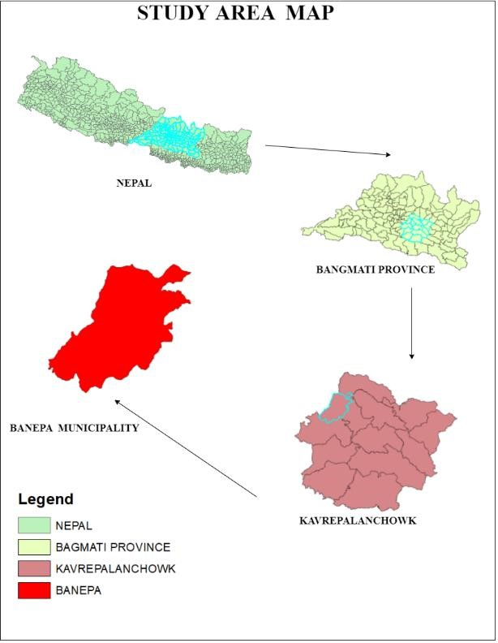
Figure 1: Location map of study area

Data Used
Table 1: Characteristics of Acquired Image
Data Type | Captured Date | Source
LandSat5 TM | 18th June, 1991 | USGS
LandSat7 TM | 20th feb, 2001
LandSat7 ETM+ | 4th march, 2011
LandSat8 OLI | 19th April, 2021

Table 1 outlines the attributes of obtained satellite imagery data sourced from the USGS website, with the primary selection criterion being the availability of Google Earth images (1991, 2001, 2011, 2021) for the study area. Additionally, the acquired images have a multispectral band and a resolution of 30 meters.

Working procedure

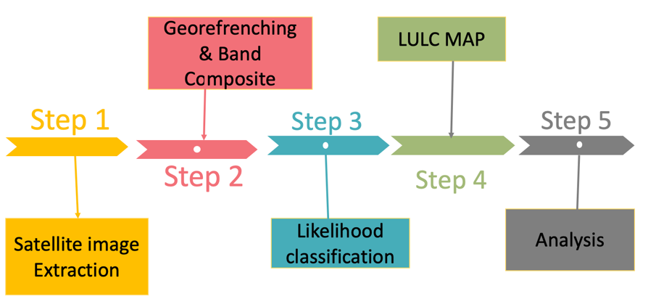
Figure 2: Working Procedure
In this study's procedural approach, five key steps were followed to analyze the changes in land use and land cover in Banepa Municipality.
The initial step involved extracting satellite images to capture the spatial information of the study area. At the outset, satellite images from the corresponding years (1991, 2001, 2011, and 2021) were obtained freely from the United States Geological Survey (USGS) website.
Subsequently, in the second step, georeferencing and band composite processes were applied to enhance the quality and accuracy of the images. The third step utilized likelihood classification to categorize different land cover types based on spectral signatures. ENVI software was employed for Supervised Image Classification using the Maximum Likelihood Classifier (MLC). The initial plan involved classifying the image into four land cover categories: Built-up, Barren, Agriculture, and Forest land. To facilitate the maximum likelihood method, a minimum of 30 ground-referenced samples for each category were extracted for accurate image classification. This classification facilitated the creation of a detailed Land Use and Land Cover (LULC) map in the fourth step, illustrating the distribution of various land features across the municipality. The final step, Step 5, encompassed a comprehensive analysis of the LULC map, enabling the interpretation and understanding of the patterns and trends of land use changes over the specified period.

Results and Analysis
The Land Use and Land Cover (LULC) map for Banepa Municipality was acquired at decade intervals from 1991 to 2021. The classification of land use and cover provides valuable information regarding the extent of various land classes, including Forest, Agricultural Land, Barren Land, and Built-up areas. The gathered statistics are visually presented in charts corresponding to each respective year.

Analysis of LULC for 1991
Classification and analysis of the images of 1991 shows there is abundance of forest and the agricultural land. Table 1 shows the class-wise area and percentage in 1991. It shows that among a total of 54577239.36 m² of the municipality, forest cover 42%, agricultural land cover 44%, barren land cover 10% and built-up cover 4%. It shows that only the city center is somewhat densely populated. Outer ring of the city center had a very sparse built-up. Agricultural land and forest covered most of the area during that time. Pie chart shows the percentage-wise distribution of the LULC classes.

Table 2: Statistical distribution of LULC classes of Banepa in 1991
S.N. | Class | Area (m²) | Percentage (%)
1 | Forest | 23056066.96 | 42
2 | Agricultural Land | 23997145.56 | 44
3 | Barren Land | 5510578.67 | 10
4 | Built-up | 2013448.17 | 4

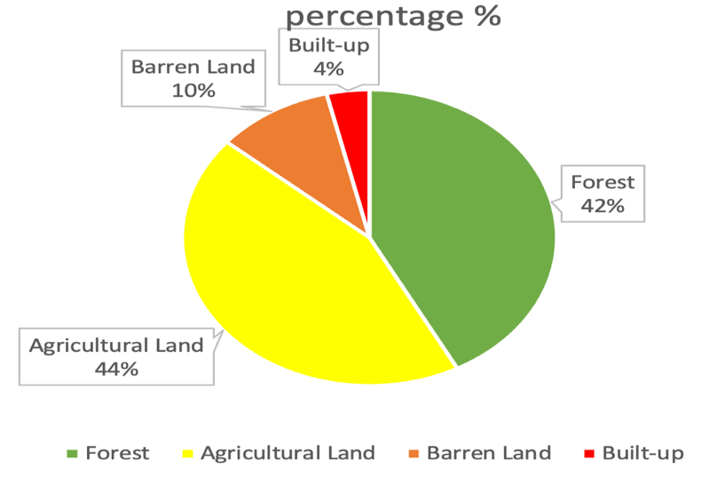
Figure 3: Pie-chart showing percentage of LULC classes in 1991

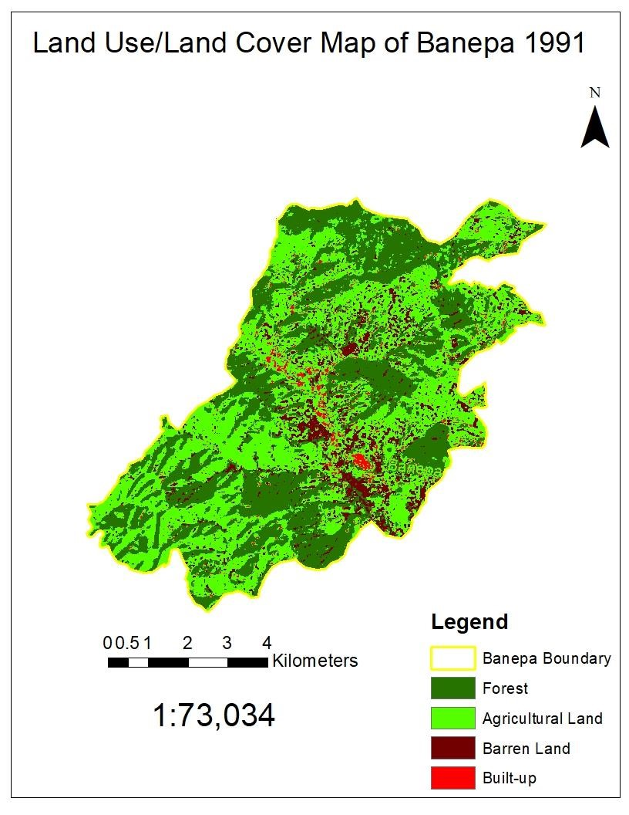
Figure 4: LULC map of Banepa in 1991

Analysis of LULC for 2001
Table 2 shows the class-wise area and percentage in 2001. It shows that among total area of the municipality, forest cover 41%, agricultural land cover 41%, barren land cover 9% and built-up cover 9%. It shows that the city center (CBD) is populated and very few places outside of CBD is populated. The expansion of built-up is not seen to have followed any model. Increase in built-up over a decade is seen very critical i.e. doubling of built-up increase is witnessed. Core city has been compact but still Built-up is sparse and is very slowly growing far apart from the CBD. Agricultural land and forest still covers most of the area but a slight decrease in forest area despite different approaches of forest protection is seen. Carbon sink is not only related to but also to the green vegetation and the agricultural land is seen to have been decreased by 4% in just a decade with a 5% increase of the built-up, which is not a good sign for REDD implementation. Pie chart shows the percentage-wise distribution of the LULC classes.

Table 3: Statistical distribution of LULC classes of Banepa in 2001
S.N. | Class | Area (m²) | Percentage (%)
1 | Forest | 22509308.48 | 41
2 | Agricultural Land | 22477677.06 | 41
3 | Barren Land | 4769846.17 | 9
4 | Built-up | 4820407.65 | 9

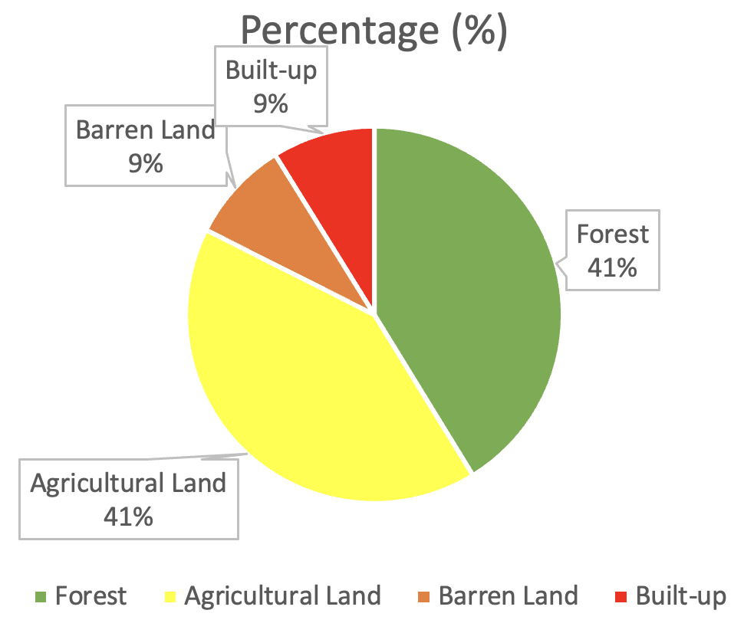
Figure 5: Pie-chart showing percentage of LULC classes in 2001

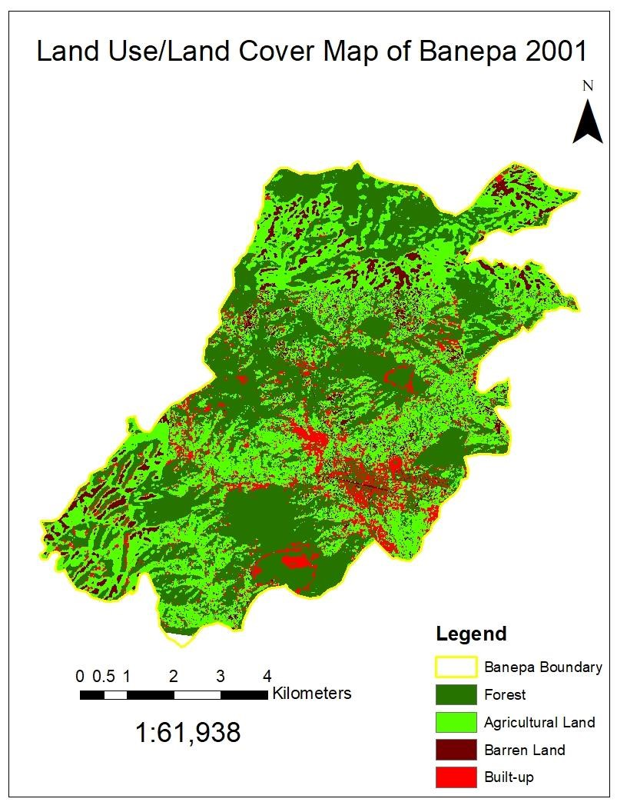
Figure 6: LULC map of Banepa in 2001

Analysis of LULC for 2011
Statistics shows that the municipality is getting critical from REDD perspective. The total forest coverage has declined to 39%, agricultural land has declined than of 1991 but slightly increased than of 2001 although there is increase in the built-up by 3% from 2001 to 2011. It seems that the forest area might have been encroached for the agricultural purpose. Declination of barren land by 2% is a good sign from the REDD perspective that helps increase in capacity of carbon sink but is not capable of compensating the 3% decline of forest cover. CBD is getting more compact without leaving any open spaces in between. This haphazard expansion of built-up, more compact built-up obviously requires more vehicles which are responsible for increasing carbon emission and decreasing of carbon sink. Pie chart shows the percentage-wise distribution of the LULC classes.

Table 4: : Statistical distribution of LULC classes of Banepa in 2011
S.N. | Class | Area (m²) | Percentage (%)
1 | Forest | 21492196.1 | 39
2 | Agricultural Land | 23123057.49 | 42
3 | Barren Land | 3498593.25 | 7
4 | Built-up | 6463392.52 | 12

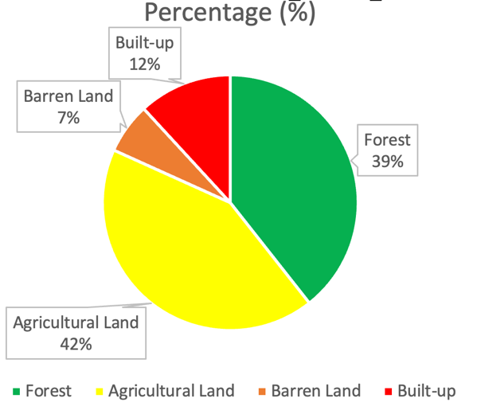
Figure 7: Pie-chart showing percentage of LULC classes in 2011

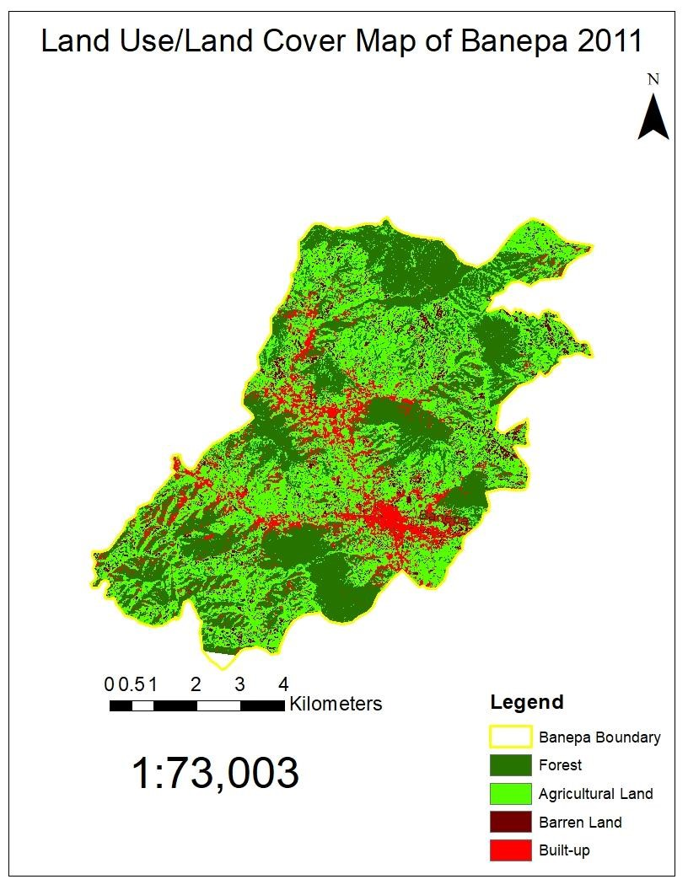
Figure 8: LULC map of Banepa in 2011

Analysis of LULC for 2021
LULC map and associated statistical attributes shows there is a declining trend in the forest cover but a slight increase in the agricultural land. Barren land has decreased to 3%. It seems that the barren land has been utilized for agricultural purpose, but map shows the distribution of barren land is changing from one place to other. Barren land was seen around the city center as well in prior decades but now has been detected in peripheral region or outward from the CBD. 3% increase in built-up is witnessed, which shows city is getting even more compact and built-up is expanding outwards from the core city as well. Increasing built-up by decreasing forest cover and barren land shows there is more flow of people towards the core city. Pie chart shows the percentage-wise distribution of the LULC classes.

Table 5 : Statistical distribution of LULC classes of Banepa in 2021
S.N. | Class | Area (m²) | Percentage (%)
1 | Forest | 20130152.65 | 37
2 | Agricultural Land | 24655309.76 | 45
3 | Barren Land | 1366084.68 | 3
4 | Built-up | 8425692.278 | 15

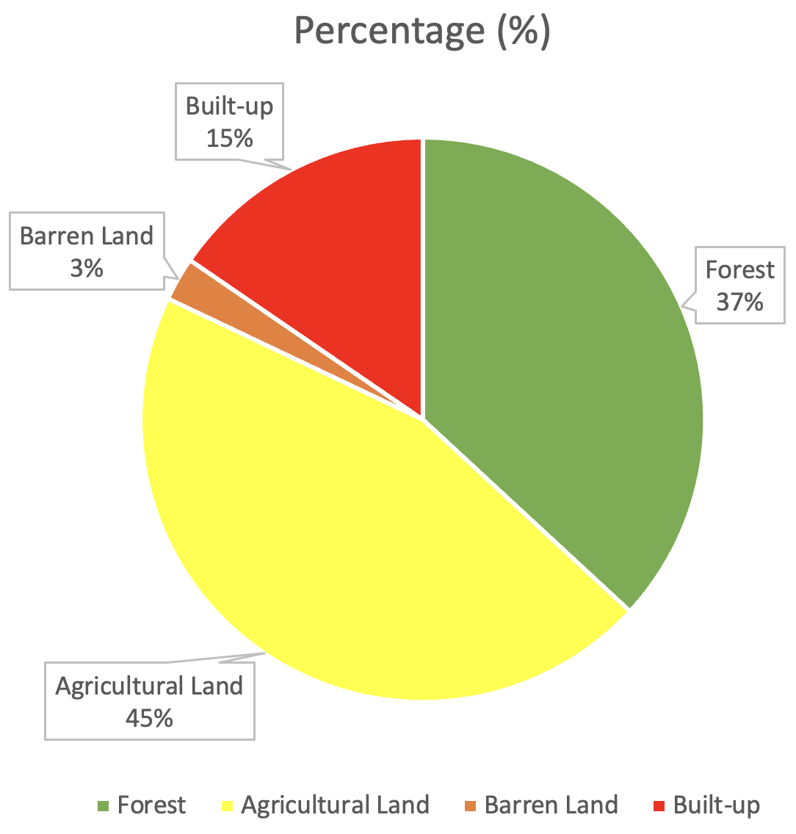
Figure 9: Pie-chart showing percentage of LULC classes in 2021
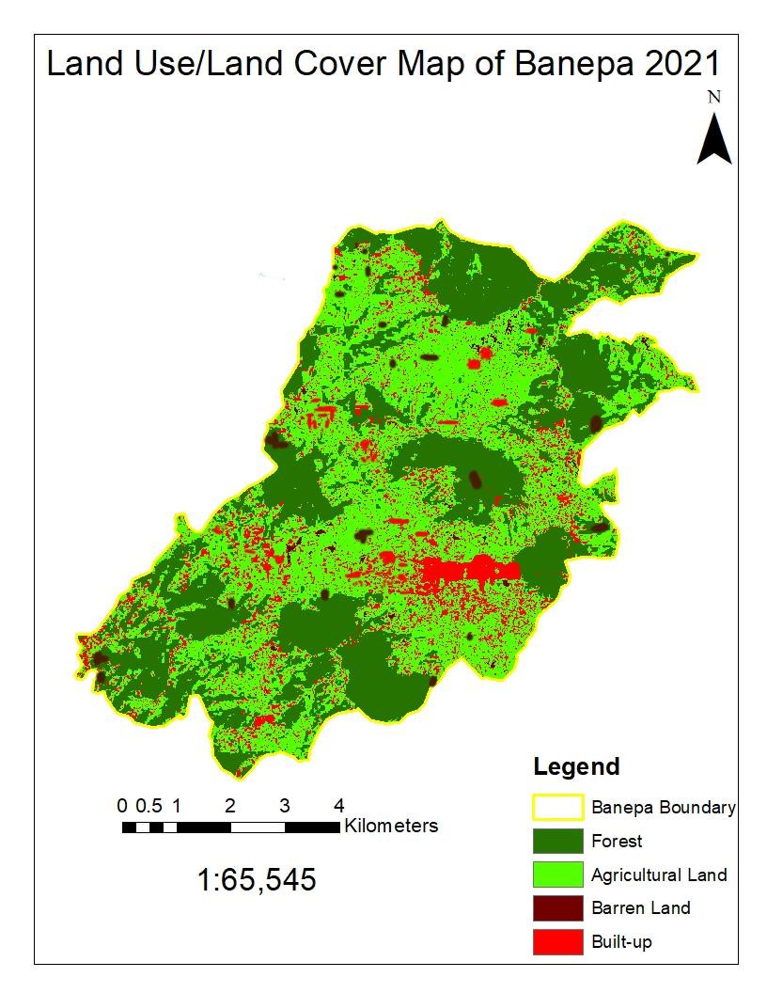
Figure 10: LULC map of Banepa in 2021

Discussion and conclusion
The statistical data derived from the spatial analysis and the previously presented LULC maps for the Banepa municipality that were created by categorizing satellite images from 1991, 2001, 2011, and 2021 show that there has been a rapid growth in the built-up (urban area) without any kind of systematic plan or model. The forest cover has drastically decreased (5% in three decades) while the amount of agricultural land has remained essentially steady. Maintaining the ecological balance through regulating the carbon sink is a top concern given the increase in built-up areas of more than 10% over the past three decades. It should not take long to deploy REDD. Monitoring methods for forests and land should be used to evaluate their resources, producing data that will help with studies on drivers of deforestation and forest degradation and feasibility and sectorial studies including cost- benefit analysis.

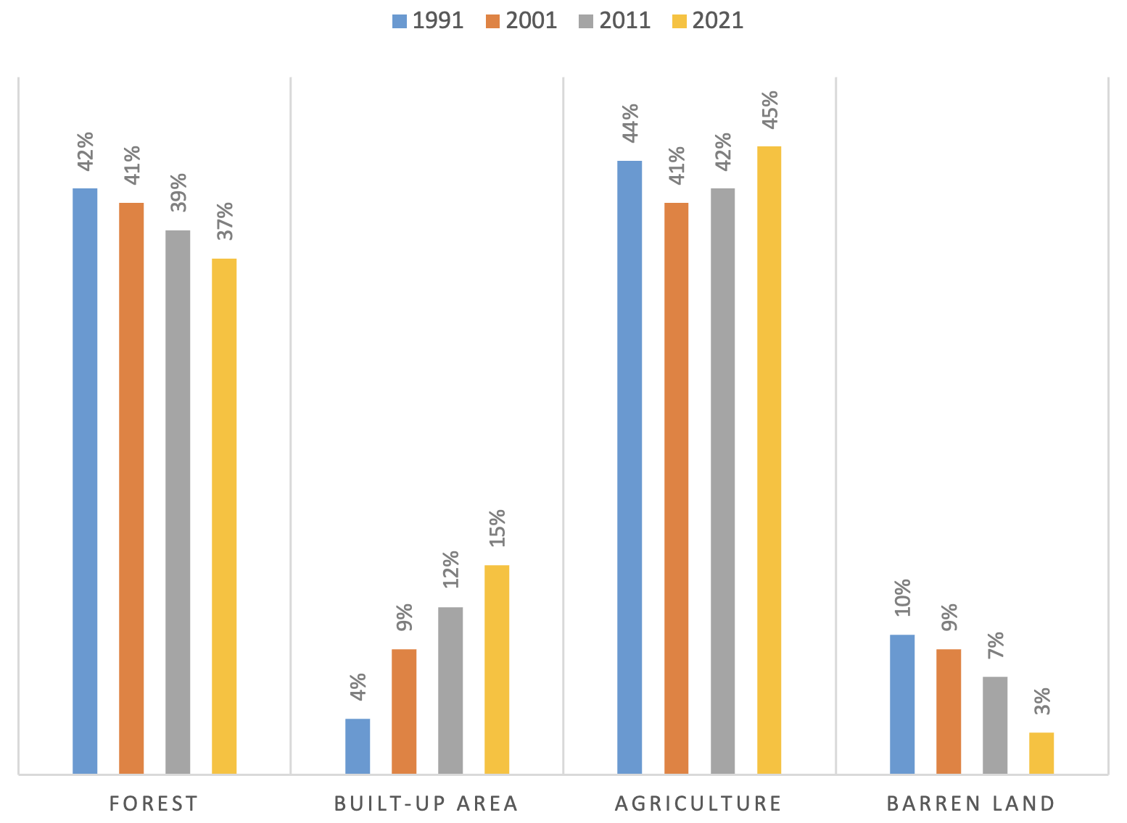
Figure 11: Comparison of LULC in three decades
Studies on alternative land uses and risk of land conversion should be conducted including assessing how conversion forests and related greenhouse gas emissions could be halted and reversed considering direct and underlying drivers of deforestation and forest degradation. Participatory and negotiated territorial development and other land-use planning approaches should be facilitated for selecting and balancing land uses, and to enhance synergies and socio-economic benefits, while safeguarding ecosystems and contributing to combat climate change. Climate change is linked closely to REDD perspective. It can be concluded that climate change is a consequence of dramatic change in land-use and drastic change of land-use too change the land-use. Carbon footprint (sum of all emissions of carbon oxides introduced by human activities in a timeframe directly or indirectly) is one of the influencing factor of climate change. This can be combatted only by the implementation of REDD. No abrupt change in map is seen in land-use because the factors of change are densified within the CBD of Banepa. But the municipality is extended to remote places as well which constitutes most of the part of municipality. Thus, urgent action is needed in the urban region of the municipality for planned development of the urban infrastructure ensuring sufficient open spaces and conserving the forest cover and agricultural land at the fullest potential.

References
Banepa Municipality. (n.d.). Retrieved from Banepa Municipality: https:// banepamun.gov.np/ne/node/3
Chander, G., Markham, B. L., & Helder, D. L. (2009). Summary of current radiometric calibration coefficients for Landsat MSS, TM, ETM+, and EO-1 ALI sensors. Remote sensing of environment, 113(5), 893-903.
Eddin, B. (n.d.). The Application of Remote Sensing and GIS in Urban Planning.
Kachhwala, T. (1985). Temporal monitoring of forest land for change detection and forest cover mapping through satellite remote sensing. Proceedings of the 6th Asian Conf. on Remote Sensing. Hyderabad, 1985.
Karna, K. B., Shrestha, S., Sainju, S., Sigdel, G. P., Shrestha, S., & Karmacharya, A. (n.d.). Introduction to Remote Sensing: An Introductory Book. Land Management Training Center, Government of Nepal .
Lo, C., & Choi, J. (2004). A hybrid approach to urban land use/cover mapping using Landsat 7 Enhanced Thematic Mapper Plus (ETM+) images. International Journal of Remote Sensing, 25(14), 2687-2700.
Maryantika, N., & Lin, C. (2018). Analyzing Land use Land Cover and Deforestation in the REDD+ AREA, Central Kalimantan Province, Indonesia. IGARSS 2018-2018 IEEE International Geoscience and Remote Sensing Symposium.
Poudel, H., Ghimire, S., & Upadhyaya, S. (2023). Suitability Analysis for Waste Disposal Site Using GIS Based Multi-Criteria Decision Analysis: A Case Study of Jhapa District, Nepal. Nepal Journal of Multidisciplinary Research, 6(3), 115-128.
Riebsame, W. E., Meyer, W. B., & Turner, B. (1994). Modeling land use and cover as part of global environmental change. Climatic change, 28(1-2), 45-64.
Selçuk, R., Nisanci, R., Uzun, B., Yalcin, A., Inan, H., & Yomralioglu, T. (2003). Monitoring land-use changes by GIS and remote sensing techniques: case study of Trabzon. Proceedings of 2nd FIG regional conference, Morocco,
Verbist, B., Vangoidsenhoven, M., Dewulf, R., & Muys, B. (2011). Reducing emissions from deforestation and degradation (REDD). KLIMOS. https://ees. kuleuven. be/klimos/papers/wp3reddfinal. pdf.
Zubair, A. O. (2006). Change detection in land use and Land cover using remote sensing data and GIS (A case study of Ilorin and its environs in Kwara State). Department of Geography, University of Ibadan, 176.

