Figure 1: Flow chart of critically sick children admitted with Acute Kidney Injury in Pediatric intensive care unit of a tertiary care hospital, attached to a Government Medical College of Central Gujarat, India (N=146).

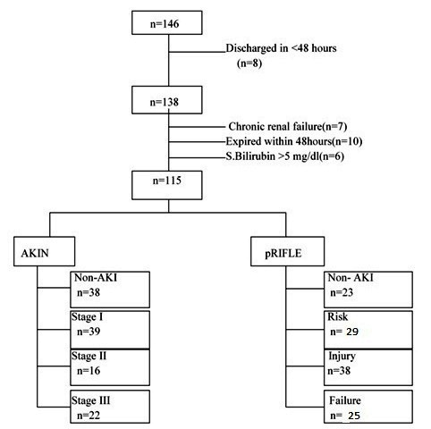
AKI- Acute kidney injury, AKIN-Acute kidney injury network classification, pRIFLE- Pediatric Risk, Injury, Failure, Loss, End Stage Renal Disease

Table 1. Comparison of critically sick children admitted with Acute Kidney Injury in Pediatric intensive care unit of a tertiary care hospital, classified by pRIFLE versus AKIN classification.

Total n = 115 (38) |  | pRIFLE
 |  | Non-AKI  n = 23 (2) | Risk  n = 29 (8) | Injury  n = 38 (16) | Failure  n = 25 (12)
A  K  I  N | Non-AKI n = 38 (5) | 23 (2) | 12 (3) | 3 (0) | 0 (0)
 | Stage 1 n = 39 (15) | 0 (0) | 15 (5) | 20 (10) | 4 (0)
 | Stage 2 n = 16 (8) | 0 (0) | 2 (0) | 12 (6) | 2 (2)
 | Stage3 n = 22 (10) | 0 (0) | 0 (0) | 3 (0) | 19 (10)
Kappa-0.474, SE of kappa = 0.059, 95% confidence interval: 0.359 to 0.589
*Figures in brackets indicates mortality

Table 2 Stage wise mortality among critically sick children admitted with Acute Kidney Injury in Pediatric intensive care unit of a tertiary care hospital, classified by pRIFLE versus AKIN (N=115)
pRIFLE stage | Mortality | AKIN stage | Mortality
No AKI | 02/23 (8.7%) | No AKI | 5/38 (13.2%)
Risk | 08/29 (27.6%) | Stage 1 | 15/39 (38.5%)
Injury | 16/38 (42.1%) | Stage 2 | 08/16 (50%)
Failure | 12/25 (48%) | Stage 3 | 10/22 (45.5%)

