Manuscript: SEX DIFFERENCES IN SUBCUTANEOUS ADIPOSITY AND NUTRITIONAL STATUS IN INDIAN CHILDREN
Authors: Sampriti Debnath¹, Nitish Mondal², Jaydip Sen³
- UGC-Junior Research Fellow, Department of Anthropology, University of North Bengal, P.O.: NBU, Dist.: Darjeeling-734013, West Bengal, India
- Assistant Professor, Department of Anthropology, Assam University, Diphu Campus, P.O.: Diphu, Dist.: Karbi Anglong-782460, Assam, India
- Professor, Department of Anthropology, University of North Bengal, P.O.: NBU, Dist.: Darjeeling-734013, West Bengal, India.

Running head: Subcutaneous adiposity and nutritional status among Indian children

Funding: The financial assistance was provided by University Grants Commission in the form of University Grants Commission-Junior research Fellowship [Reference No: 674/(NET-JUNE 2014)].

Conflict of interest: The authors report no conflicts of interest. The authors alone are responsible for the content and writing of the paper.

Corresponding Author: Dr. Jaydip Sen, Professor, Department of Anthropology, University of North Bengal, Raja Rammohunpur, Darjeeling-734013, West Bengal, India. E-mail: jaydipsen@rediffmail.com
ABSTRACT

Background: The skinfold thickness is now considered to be an important indicator of body composition and nutritional status. Assessment of subcutaneous fat present among the children is becoming very necessary due to the increasing trends of overweight and obesity among children. Objectives: Present study determines age-sex specific subcutaneous adiposity and its use in assessment of nutritional status using skinfold thickness among rural school-going children of Eastern-India. Subjects and methods: The study was conducted among the rural school-going 1262 children (619 boys; 643 girls) aged 5–12 years. Anthropometric measurements of height, weight and skinfold thickness were recorded using standard procedures. Age-sex-specific smooth percentile curves were derived using the L,M and S model for BSF, TSF, SSF and SISF Result: Age-sex specific mean values of skinfold thicknesses of BSF, TSF, SSF, SISF and PBF of girls were observed to be higher than boys (p<0.05).The age-sex specific mean values of BSF, TSF, SSF, SISF, ∑4SKF and PBF did not show any age specific trend. Comparison with the NHANES-III data showed poor attainment of body adiposity and nutritional status. Conclusion: These findings are important for future investigations in the field and in epidemiological and clinical settings.

Keywords: Subcutaneous fat, Body adiposity, Skinfold, Anthropometry, Nutrition Assessment, Children, India

INTRODUCTION
Anthropometric measures are still considered to be the reliable non-invasive, inexpensive and widely accepted technique to assess child undernutrition. The measures mostly comprise of height, weight, skinfold thickness measurements¹. The body mass index (BMI kg/m²) is also widely used as an index of body fatness, it is a measure of weight relative to height rather than of adiposity and a global proxy of nutritional status and is highly correlated with different components of weight (e.g. lean mass or fat free mass, fat mass, skeletal muscle mass and bone mass) yet, it cannot differentiate between them². During growth height and weight changes results in substantial increases are complicated the interpretation among children and adolescents⁴. For example, increase in BMI levels during puberty seems to be largely the result of increases in fat-free mass rather than body fatness^{5,6,7}.Variation in the relative distribution of adipose tissue in the human body is an important topic it can be related to changes major several non-communicable diseases (e.g. cardiovascular diseases, metabolic disorders and gastrointestinal abnormalities, hyperlipidemia, sleep apnea, hepatic steatosis, polycystic ovary disease, cholelithiasis and glucose intolerance) and the distribution of adipose tissue is also associated with physical growth and maturation^{8,9,10,11}. Epidemiologic evidence supports the theory that relation between excess adiposity (e.g., obesity) and disease risk burden begins early in life^{8,11}. Children with higher adiposity levels tend to be advanced bone ages, and early physical growth attainments and maturation occurs among them^{12,13}.
Skinfold measurements of subcutaneous adiposity have a long history in nutrition-related research^{9,14} and have been used to determine the body composition and relative subcutaneous fat distribution^{3,15,16}. Amount of subcutaneous fat is very specific to adipose tissue and can be measured non-invasively. Therefore, skinfold thickness is an important, very useful and valid anthropometric indicator of regional and total body adiposity/fatness in clinical or epidemiological research settings^{11,15,17}. Skinfold thickness has been used extensively for estimating the changes in body composition and observed to be a very useful technique due to easy to use and simplicity in clinical and epidemiological research studies^{9,14,15,18,19}. Adipose tissue accumulation in body is dependent on nutritional status and skinfold thickness is serves as widely use a practical tool for assessment in population or clinical situation evaluating nutritional status^{3,17}. Few studies have reported age-sex variations in subcutaneous adiposity pattern using skinfold thickness among children^{3,9,17,19,20}.
The objectives of the present study are to determine the sex-age specific subcutaneous adiposity and its use in assessment of nutritional status using skinfold thickness among rural school-going children of Eastern-India.

MATERIAL AND METHODS
The present cross-sectional study was carried out among 1262 school-going children (boys: 619; girls: 643) aged 5-12 years residing in rural areas of Phansidewa Block of the Darjeeling, West Bengal, India. This community block (Latitude 26º 34´59´´ N, Longitude 88º 22´00´´ E) is situated near the Indo-Bangladesh border region and ~35– 40 km from the sub-divisional town of Siliguri and covers an area of 308.65 km². According to the National Census (2011), the block has a total population of 1,71508 individuals (males: 87,945; females: 83,563) with the literacy rate of 41.59% (males: 51.85%; females: 30.80%). The Phansidewa block has availability of all the basic amenities, such as hospitals, schools, markets, post office and government offices³.
The children covered in course of the study were enrolled in 12 primary schools located under three Gram Panchayets (a village level local governing authority). The three Gram Panchayets were selected using random sampling method. There were fourteen primary schools situated under the three Gram Panchayets. For selecting the schools under study, the following two criteria were considered:
(i) At least 120 students were enrolled per class so that the minimum sample size could be covered.
(ii) Convenience and easy road accessibility from the block level town of Phansidewa.
To avoid the possible sampling biasness, the schools which have poor student strength, low school attendance and situated in very remote locations were excluded. The socio-economic data on age, sex, parents’ occupation and nature of occupation, parents’ education, monthly family income, family size, family types, house-conditions, electricity facility, drinking water and toilet facilities were collected using a structured schedule. A modified version Kuppuswamy’s socio-economic scale was used to evaluate the socio-economic status (SES) of the children²¹. The determination of SES showed that all the children belonged to lower-middle SES. The subjects of the present study were free from any physical deformities, surgical episode and diseases at time of data collection. The data of the present study was collected during the period from September 2014 to November 2015.
Anthropometric measurements recorded
Anthropometric measurements were recorded using standard anthropometric procedures¹. Height of the children was recorded to the nearest 0.1 cm with help of an anthropometer rod with the head held in the Frankfort horizontal plane. Weight of the children was taken wearing minimum clothing and with bare feet using a portable weighing scale to the nearest 100 gm. The skinfold measurements of bicep (BSF), triceps (TSF), sub-scapular (SSF) and supra-iliac (SISF) were measured using a Holtain skinfold calliper (London University Institute of Child Health, UK) on the left side of each child to the nearest to 0.2 mm. Each of the four sites of measurement (e.g., BSF, TSF, SSF and SISF) was marked carefully before measurement. The procedure was explained to the child before taking the measurements. The skinfold calliper was calibrated to exert a constant pressure of 10 gm/mm². The children were measured with ample precision for avoiding any possible systematic errors of anthropometric data collection (e.g., instrumental or landmarks)²². Intra-observer and inter-observer technical errors of the measurements (TEM) were calculated to determine the accuracy of the anthropometric measurement using the standard procedure²³. For calculating TEM, height and weight were recorded from different data set of 50 children other than those selected for the study by SD and JS. The coefficient of reliability (R) of the measurements was calculated for testing the reliability of the measurements. Very high values of R (>0.97) were obtained for height and weight and these values were observed to be within the recommended cut-off of 0.95²³ Hence, the measurements were considered to be reliable and reproducible. All the measurements in course of the present study were recorded by SD.
The sum of two skinfolds (∑2SKF) and sum of four skinfold (∑4SKF) calculated using the standard equations:
∑2SKF (mm)= TSF+SSF
∑4SKF (mm)= BSF+TSF+SSF+SISF
The body density (D) was calculated for the evaluation of peripheral adiposity or percent of body fat (PBF) using the standard equations of Deurenberg et a1.²⁴:
D_{Boys}= 1.1133−0.0561(log ∑4SKF) + 1.7(age*10⁻³)
D_{Girls}= 1.1187−0.063(log ∑4SKF) + 1.9(age*10⁻³)
The assessment of peripheral adiposity or PBF of the children was calculated using the standard equation of Westrate and Deurenberg²⁵:
PBF=[562−4.2(age−2)]/D− [525−4.7(age−2)

Statistical analysis
The data were statistically analyzed using the Statistical Package for Social Sciences (SPSS, Inc., Chicago, IL; version 17.0). The descriptive statistical analysis of the data obtained was depicted in terms of mean and standard deviation (±SD). One-way analysis of variance (ANOVA) has been performed to test the age-specific mean differences in anthropometric variables of the groups using the Scheffe procedure was done to assess age-specific mean differences in the anthropometric and body composition variables. Independent sample t-test was done to assess sex difference in mean values of anthropometric variables. The LMS model was proposed to convert the measurements for children of known age-sex to evaluate the centiles^{26,27}. The LMS Chart Maker software program (The Institute of Child Health, London) was used to obtain the smooth centile curves that fitted smooth centile curves to the reference data. The method summarizes percentiles at each age based on the power of age-specific Box-Cox power transformations used to normalize data. The centile curves (3rd, 10th, 25th, 50th, 75th, 90th and 97th) were derived as reference data for further evaluation of body composition. A p-value of <0.05 is considered to be statistically significant.

RESULTS
Age and sex-specific subject distribution, means and standard deviation of BSF, TSF, SSF, SISF, 2SKF and ∑4SKFamong boys and girls are depicted in Table 1. Age-specific mean skinfold value was observed to be slightly higher among girls than boys, especially in TSF and SSF in older age groups (e.g. 10-12 years). Age specific mean BSF and SISF were observed to be higher among boys than girls in younger age groups (e.g., 5-8 years). The mean values of ∑4SKF were observed to be higher among the boys than girls of younger age groups (e.g. 5-8 years) and higher among the girls than boys in older age groups (9-12 years). The mean age and sex specific mean ∑4SKF values ranged from 22.17 mm (in 11 years) to 26.12mm (in 5 years) among boys and 22.63mm (in 6 years) to 26.06mm (in 9 years) among girls. The overall mean values of ∑4SKF were observed to be higher among girls (25.57±8.72 mm) than boys (23.45±7.36 mm). The age specific PBF ranged from 13.24% (in 11 years) to 15.29% (in 5 years) (in boys) and 14.91% (in 8 years) to 17.22% (in 10 years) (in girls). The age-specific mean differences were observed to be statistically significant using ANOVA for all the variables of boys and girls except in case of boys in TSF, SSF, ∑2SKF and ∑4SKF.The age-sex specific mean values of BSF, TSF, SSF, SISF, ∑2SKF and ∑4SKF did not show any age specific trend. The results of the independent sample t-test showed statistically significant sex-specific differences in overall mean values of TSF (F-value= 48.81, d.f.,1,1261), SSF (F-value=73.58, d.f.,1,1261),SISF (F-value= 32.15, d.f.,1,1261), PBF (F-value= 53.91, d.f.,1,1261), 2SKF (F-value= 65.46, d.f.,1,1261) and ∑4SKF (F-value= 28.06, d.f.,1,1261) (p<0.05). Age-sex specific percentile curves of BSF, TSF, SSF and SISF using LMS for assessment of nutritional status is depicted in Figure 1.

Table 1: Age-sex specific mean and standard deviation of anthropometric variables among the children
Age  Group | BSF (mm) |  | TSF (mm) |  | SSF (mm) |  | SISF (mm) |  | 2SKF (mm) |  | 4SKF (mm) |  | PBF
Age  Group | Boys | Girls | Boys | Girls | Boys | Girls | Boys | Girls | Boys | Girls | Boys | Girls | Boys | Girls
5  years | 7.36  ±1.74 | 5.54  ±1.58 | 8.46  ±2.22 | 8.59  ±1.90 | 5.23  ±1.83 | 4.89  ±1.07 | 5.07  ±2.00 | 3.93  ±1.00 | 13.69  ±3.76 | 13.53  ±2.69 | 26.12  ±16.37 | 22.98  ±4.41 | 15.29  ±4.10 | 15.89  ±2.63
6  years | 5.03  ±1.21 | 4.88  ±1.30 | 7.67  ±1.51 | 8.47  ±2.07 | 5.00  ±0.95 | 5.21  ±1.26 | 4.69  ±1.19 | 4.07  ±1.00 | 12.67  ±2.13 | 13.68  ±3.08 | 22.39  ±3.90 | 22.63  ±4.50 | 13.98  ±2.06 | 15.41  ±2.61
7  years | 5.17  ±1.41 | 4.97  ±1.56 | 7.85  ±1.75 | 7.98  ±2.19 | 5.29  ±1.02 | 5.16  ±1.41 | 4.82  ±1.32 | 4.67  ±3.33 | 12.13  ±2.40 | 13.22  ±3.42 | 23.13  ±4.45 | 22.80  ±5.97 | 14.19  ±2.25 | 15.10  ±3.25
8  years | 5.20  ±1.46 | 4.85  ±1.62 | 7.53  ±2.00 | 8.00  ±2.30 | 5.50  ±1.40 | 5.52  ±1.72 | 5.11  ±1.66 | 4.50  ±1.51 | 13.02  ±3.07 | 13.57  ±3.74 | 23.33  ±5.39 | 22.86  ±5.84 | 14.07  ±2.68 | 14.91  ±3.20
9  years | 4.98  ±2.30 | 5.48  ±2.54 | 7.73  ±2.89 | 8.88  ±3.21 | 5.52  ±1.90 | 6.29  ±2.36 | 5.26  ±2.10 | 5.41  ±2.76 | 13.25  ±4.32 | 15.21  ±5.31 | 23.48  ±8.18 | 26.06  ±9.16 | 13.85  ±3.18 | 16.17  ±4.01
10  years | 5.09  ±1.45 | 5.54  ±2.30 | 8.27  ±2.44 | 9.75  ±3.59 | 5.65  ±1.25 | 7.38  ±3.83 | 5.66  ±2.04 | 6.34  ±3.95 | 13.92  ±3.27 | 17.13  ±7.10 | 24.67  ±6.04 | 29.01  ±11.48 | 14.47  ±2.76 | 17.22  ±4.40
11  years | 4.45  ±1.23 | 5.95  ±2.77 | 7.42  ±1.75 | 9.56  ±3.52 | 5.38  ±1.15 | 7.27  ±3.24 | 4.92  ±1.16 | 6.17  ±2.82 | 12.80  ±2.62 | 16.80  ±6.53 | 22.17  ±4.57 | 28.94  ±10.18 | 13.24  ±2.31 | 17.06  ±4.16
12  years | 4.44  ±1.08 | 5.82  ±2.97 | 7.78  ±1.81 | 8.55  ±2.13 | 5.43  ±0.95 | 6.41  ±2.08 | 5.19  ±1.37 | 5.53  ±2.15 | 13.21  ±2.42 | 15.03  ±3.80 | 22.85  ±4.12 | 26.31  ±7.11 | 13.57  ±2.00 | 15.91  ±3.11
Total | 5.22  ±4.52 | 5.36  ±2.18 | 7.80  ±2.12 | 8.82  ±2.93 | 5.36  ±1.38 | 6.17  ±2.68 | 5.06  ±1.67 | 5.22  ±2.88 | 13.17  ±3.12 | 15.01  ±5.31 | 23.45  ±7.36 | 25.57  ±8.72 | 14.10  ±2.76 | 16.07  ±3.73
F-value* | 2.36 | 2.90 | 1.83 | 4.88 | 1.73 | 12.49 | 2.39 | 9.12 | 1.19 | 8.29 | 1.92 | 9.66 | 2.81 | 5.08
P-value | 0.02 | 0.00 | 0.08 | 0.00 | 0.09 | 0.00 | 0.02 | 0.00 | 0.31 | 0.00 | 0.06 | 0.00 | 0.007 | 0.00
*Age-specific mean differences, ± SD= standard deviations

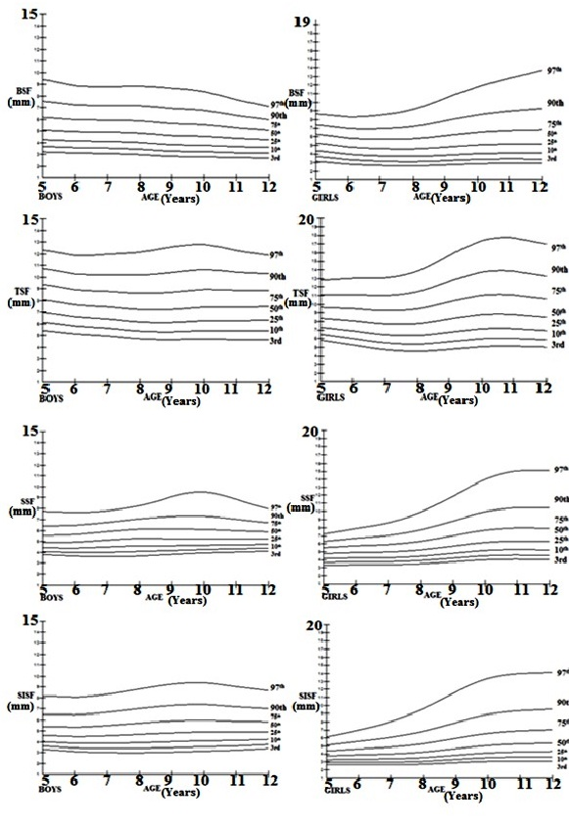

Figure 1: Age-sex specific LMS graphs of BSF, TSF, SSF and SISF among the children
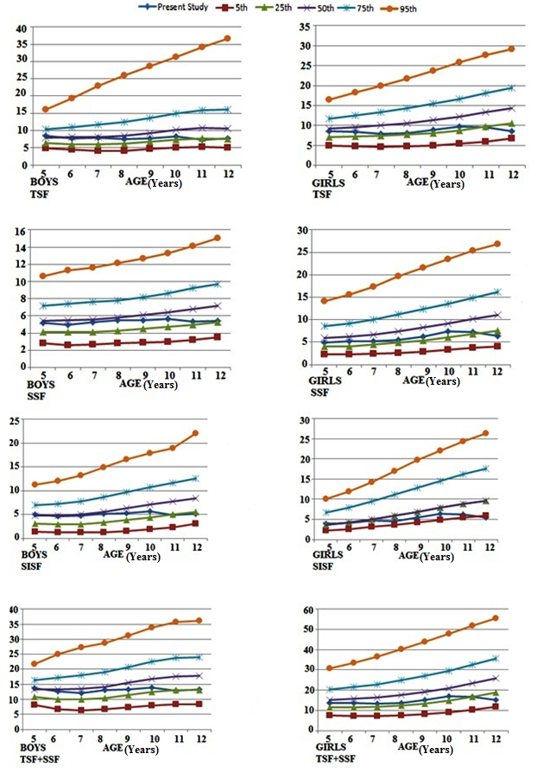

Figure 2: Comparison of TSF, SSF and ∑TSF+SSF with NHANES-III reference population among the children

Assessment of nutritional status
The assessment of nutritional status was assessed by comparing the age and sex specific mean values of skinfold thickness using the reference values of NHANES-III reference²⁸ population (Figure 2). The comparison of the present study with reference population showed that the age-sex specific mean TSF values of the boys and girls were<25thpercentile which were below the normal mean values of TSF. The mean SSF values of boys and were <5th and <10th percentile, respectively with inappropriate nutritional. The age and sex specific mean of values of SISF of the majority of boys and girls were on the 5th percentile showing poor nutritional status. The mean values of sum of TSF and SSF (∑2SKF) of boys and girls were <15th and <20th percentile, respectively. Therefore, poor nutritional status of the children was observed in the present study with reference to the NHANES-III reference population²⁸. Age groups mean values were observed to be <10th percentile in TSF, <5thpercentile in SSF and ≤5th percentile in age groups of 5-7 years in both sexes, but the mean values are similar to the higher but found to be below the 10th percentile values of reference in 10-11 years in TSF, SSF and SISF. Exceptions were observed in 12 years where TSF values were in<10th percentile (in both sexes), SSF values were in<5th percentile (in boys) and<10th percentile (in girls), SISF values were on 5th percentile for both boys and girls and ∑2SKF values were in <15th percentile for boys and in <20thpercentile in girls (Figure 2).

DISCUSSION
Human adiposity is a resource for the energy costs of growth, reproduction and immune function and the hormonal secretions of adipose tissue play a key regulatory role in these functions². Population variations in adiposity and nutritional status can be attributed to several associated factors (e.g. sex, ethnicity, diet, physical exercise patterns, socio-economic status and burden of infectious disease)^{3,5,16,19,29,30,31,32}. Adiposity level in human body composition has a degree of heritability². Studies have showed that with increasing age of the children the subcutaneous adipose tissue increases and age has high influence on the variation of subcutaneous adipose tissue^{3,16,19,20,33}. However, any pronounced sex-specific difference was found in the subcutaneous adipose tissue before puberty. Studies conducted among US children^{8,35}, children of Netherlands³⁶ and Japan³⁷ showed no significant sex difference in abdominal and subcutaneous adipose tissue measured by skinfold thickness. Studies also showed that after attainment of puberty girls tend to accumulate more adipose tissue than boys^{3,16,19,29}. Several studies have documented sexual dimorphism in subcutaneous adiposity patter among children^{3,9,16,18,33}. There were significant age-sex specific differences in the amount of subcutaneous body adiposity and PBF were observed in present study (Table 1). Some studies have reported that the absolute skinfold thicknesses were higher in girls^{3,16,18,19,29,34} but the demarcation in relative skinfold thickness were observed to occur during puberty mainly due to the increase in peripheral adipose tissue deposition in girls than boys^{5,9,29}. Such variation in subcutaneous adiposity may be attributed to environmental conditions and genotype and also serves as a good indicator of the health and nutritional status of children^{5,3,19,32}.
Sexual dimorphism in adiposity levels primarily attributed to the action of sex steroid hormones^{3,5}. Estrogen increases fat storage, resulting in more fat storage in females than in males. It is evident that the skinfold thickness directly measures subcutaneous fat tissue and reveals total lipidosis to a better extent^{17,35} and it contributes to the percentage body fat of the children. Therefore, lower levels of fat tissue gives rise to low levels of percentage body adiposity indicating the poor nutritional conditions of the children. However, several studies have provided the usefulness and validity of skinfold thickness in assessing nutritional status^{10,17,20}. It has been observed that racial/ethnic dimorphisms are observed in the accumulation of adipose tissue among children^{8,33,10}. The results of the present study showed the significantly higher adiposity assessed using skinfold thickness among the girls than boys. The higher age groups reaching puberty showed higher differences and higher values of skinfold thickness than the lower age groups. Comparison with NHANES-III reference population²⁸ showed very inappropriate nutritional status among the children and sex specific differences in the percentile values were also present (Figure 2). Undernutrition among children is a major cause of concern and it is mainly prevalent among the lower SES households. There is a scarcity of reference values for skinfold thickness (e.g. TSF, SSF, SISF and ∑TSF+SSF) except the reference values published by Frisancho²⁸ using NHANES-3 data. This was why the results of the present study were compared with the above reference to assess nutritional status of the children. Several studies have reported that the children residing in rural areas were observed to be more vulnerable to poor nutritional status than their urban counterparts where prevalence of overnutrition has become a cause of concern. The high prevalence undernutriton related to lower adiposity levels among children could be the major indicator that indicate the prevalence of undernutrition is actually being more frequent than overweight-obesity among Indian rural children^{3,19,20,30,32}. The results of the present study will be useful for policy makers in their endeavour to formulate various developmental, intervention strategies related to nutritional status and body composition. Further studies should be conducted to formulate new standards using new reference population to identify the population wise prevalence of undernutrition among children.
ACKNOWLEDGEMENT
The help and co-operation of the children, their parents and authorities of the primary schools of Phansidewa Block and the Department of Anthropology, North Bengal University are acknowledged. Financial assistance in the form of University Grants Commission-Junior research Fellowship [Reference No: 674/(NET-JUNE 2014)] to the first author is also acknowledged.The authors are also thankful laboratory assistant and subjects who participated in the study.
REFERENCES
- Hall JG, Allanson JE, Gripp KW, Slavotinek AM. Handbook of Physical Measurements. New York: Oxford University Press 2007.
- Wells JCK. The evolutionary biology of human body fatness: thrift and control.–Cambridge: Cambridge University Press 2010.
- Sen J, Mondal N. Fat mass and fat free mass as indicators of body composition among Bengalee Muslim children. Ann Hum Biol 2013;40:286-93.
- Adair LS, Fall CH, Osmond C, Stein AD, Martorell R, Ramirez-Zea M, Sachdev HS, Dahly DL, Bas I, Norris SA, Micklesfield L. Associations of linear growth and relative weight gain during early life with adult health and human capital in countries of low and middle income: findings from five birth cohort studies. Lancet 2013;382:525-34.
- Wells JC. Sexual dimorphism of body composition. Best Pract Res Clin Endocrinol Metabol 2007;21:415-30.
- Freedman DS, Sherry B. The validity of BMI as an indicator of body fatness and risk among children. Pediatr 2009;124:S23-S34.
- Jeddi, M, Dabbaghmanesh MH, Omrani GR, Ayatollahi SMT, Bagheri, Z, Bakhshayeshkaram M. Relative importance of lean and fat mass on bone mineral density in Iranian children and adolescents. Int J Endocrinol Metabol 2015;13.
- Goran MI, Kaskoun MC, Shuman WP. Intra-abdominal adipose tissue in young children. Int J Obes 1995;19: 279-83.
- Malina RM., Koziel S, Bielicki T. Variation in subcutaneous adipose tissue distribution associated with age, sex, and maturation. Am J Hum Biol 1999;11:189-200.
- Staiano AE, Broyles ST, Gupta AK, Katzmarzyk PT. Ethnic and sex differences in visceral, subcutaneous, and total body fat in children and adolescents. Obesity 2013;21:1251-5.
- Martinez EE, Smallwood CD, Quinn NL, Ariagno K, Bechard LJ, Duggan CP, Mehta NM. Body Composition in Children with Chronic Illness: Accuracy of Bedside Assessment Techniques. J Pediatr 2017;190:56-62.
- Wang Y. Is obesity associated with early sexual maturation? A comparison of the association in American boys versus girls. Pediatr 2002;110:903-10.
- Dai YL, Fu JF, Liang L, Gong CX, Xiong F, Luo FH, Liu GL, Chen SK. Association between obesity and sexual maturation in Chinese children: a muticenter study. Int J Obesity 2014;38:1312-6.
- Ramírez-Vélez R, López-Cifuentes MF, Correa-Bautista JE, González-Ruíz K, González-Jiménez E, Córdoba-Rodríguez DP, Vivas A, Triana-Reina HR, Schmidt-RioValle J. Triceps and subscapular skinfold thickness percentiles and cut-offs for overweight and obesity in a population-based sample of schoolchildren and adolescents in Bogota, Colombia. Nutrients 2016;8:595.
- Bedogni G, Lughetti L, Ferrari M, Malavolti M, Poli M, Bernasconi S, Battistini N. Sensitivity and specificity of body mass index and skinfold thicknesses in detecting excess adiposity in children aged 8-12 years. Ann Hum Biol 2003;30:132-9.
- Satake E, Nakagawa Y, Kubota A, Saegusa H, Sano S-iOhzeki T. Age and sex differences in fat distribution in non-obese Japanese children. J Pediatric Endocrinol Metab 2010;23:873-8.
- Yuca SA, Cesur Y, Yilmaz C, Mazicioglu M, Kurtoglu S. Assessment of nutritional status: Tricepsand subscapular skinfold thickness in Turkish children and adolescent. Pak J Med Sci 2011;27:115-9.
- Webster-Gandy J, Warren J, Henry CJ. Sexual dimorphism in fat patterning in a sample of 5 to 7-year-old children in Oxford. Int J Food Sci Nutr 2003;54:467-71.
- Debnath S, Mondal N, Sen J. 2017. Use of upper arm anthropometry, upper arm muscle area-by-height (UAMAH) and mid upper-arm-circumference (MUAC)-for-height as indicators of body composition and nutritional status among children. Anthropol Rev 80:85-102.
- Chowdhury SD, Ghosh T. Prediction of nutritional status from skinfold thickness in undernourished Santal children of Purulia district, India. Anthropol Anz. 2013;70:165-78.
- Kumar N, Shekhar C, Kumar P, Kundu AS. 2007. Kuppuswamy’s socioeconomic status scale – Updating for 2007. Ind J Pediatr 74:1131–2.
- Harris EF, Smith RN. Accounting for measurement error: a critical but often overlooked process. Arch Oral Biol 2009;54:S107-S117.
- Ulijaszek SJ, Kerr DA. Anthropometric measurement error and the assessment of nutritional status.Br J Nutr 1999;82:165-77.
- Deurenberg P, Pieters JJL, Hautvast JGAJ. The assessment of the body fat percentage by skinfold thickness measurements in childhood and young adolescence. Br J Nutr 1990;63:293-303.
- Westrate JA, Deurenberg P. Body composition in children: proposal for a method for calculating body fat percentage from total body density or skinfold-thickness measurements. Am J Clin Nutr 1989;50:1104-15.
- Cole TJ, Green PJ. Smoothing reference centile curves: the LMS method and penalized likelihood. Stat Med 1992;11:1305-19.
- Cole TJ, Freeman JV, Preece MA. British 1990 growth reference centiles for weight, height, body mass index and head circumference fitted by maximum penalized likelihood. Stat Med 1998;17:407-29.
- Frisancho AR. Anthropometric standards for the assessment of growth and nutritional status. University of Michigan Press 1990.
- Taylor RW, Grant AM, Williams SM, Goulding A. Sex Differences in Regional Body Fat Distribution From Preto Postpuberty. Obesity 2010;18:1410-6.
- Sen J, Mondal N, Dey S. 2011. Assessment of the nutritional status of children aged 5–12 years using upper arm composition. Ann Hum Biol 38:752–9.
- Thibault R, Genton L, Pichard C. Body composition: why, when and for who? Clin Nutr 2012;3:435-47.
- Singh J, Mondal N.. Use of upper-arm anthropometry as measure of body composition and nutritional assessment in children and adolescents (6–20 Years) of Assam, Northeast India. Ethiop J Health Sci 2014;24:243-52.
- Lee S, Kuk JL, Hannon TS, Arslanian SA. Race and gender differences in the relationships between anthropometrics and abdominal fat in youth. Obesity 2008;16:1066-71.
- Marini E, Cabras S, Rebato E et al. Sex differences in skinfold variability across human populations and during the life cycle. Ann Hum Biol 2007;34:377-92.
- Huang TTK, Johnson MS, Figueroa-Colon R, Dwyer JH, Goran MI. Growth of visceral fat, subcutaneous abdominal fat, and total body fat in children. Obesity Res 2001;9:283-9.
- Liem ET, Rolfe EDL, L’Abe´e C, Sauer PJJ, Ong KK, Stolk RP. Measuring abdominal adiposity in 6 to 7-year-old children. Eur J Clin Nutr 2009;63:835-41.
- Asayama K, Hayashibe H, Endo A, Okada T, Hara M, Masuda H Sugihara S. Threshold values of visceral fat and waist girth in Japanese obese children. Pediatrics Int2005;47:498-504.

