Supporting information for
Chemical Characterization of Whiteboard Marker Inks Available in Nepal and Health Awareness Among High School Teachers

Surendra Sharma^{1#}, Madhav Kharel^{1$}, Baburam Chalise^{1#}, Khaga Raj Sharma¹, Deepak Gyawali^{1,2}, Hari Paudyal¹, Bhanu Bhakta Neupane^{1*}
¹Central Department of Chemistry, Tribhuvan University, Kathmandu, Nepal
²Ministry of Forests and Environment, Department of Environment, Government of Nepal
Current addresses: #Department of Chemistry and Biochemistry, Texas Tech University, Lubbock, TX 79409, USA; $ Department of Environmental & Sustainable Engineering, University at Albany, State University of New York, Albany, NY 12222, United States
* Corresponding author: Bhanu Bhakta Neupane
Email: bhanu.neupane@cdc.tu.edu.np/newbhanu@gmail.com
- Survey questionnaires
Questionnaire for the thesis on the topic “Characterization of Whiteboard Marker Ink and Health Effect Assessment’’
My name is Surendra Sharma and I am currently studying for in master’s in chemistry at the Central Department of Chemistry, Tribhuvan University. We have conducted the research on the topic “Determination of Total Volatile Organic Compounds and Formaldehyde Concentrations in Indoor School Areas and Identification of Possible Sources’’ under the supervision of Dr. Bhanu Bhakta Neupane. This study will attempt to determine the health risk issues faced by teachers while using a whiteboard marker. The questionnaire consists of 14 questions and will take no longer than 10 minutes to complete. All responses will be kept anonymous, and no one will be identifiable in the research.
1) Personal Information
Date:
Name:
Address:
Name of Institute:
Email id:
2) Research Questions
a) How much time have you spent teaching?
- Less than 1 year
- 1-5 years
- 5-10 years
- More than 10 years
b) Do you use chalk or marker?
      - Yes
      - No

c) If you use markers, which brand do you prefer?
- Merit
- OEM
- Leery
- No brand
- Other

d) Is it easy to write with Marker?
- Yes
- No

e) Are you aware of health risks related to marker ink?
- Yes
- No
f) Have you faced any problems while using markers?
- Yes
- No
g) If yes, what type of problem have you faced?
- Central nervous toxicity
- Respiratory problem
- Eye irritation
- Other

If others specify………………………………….
h) Do you have any idea about the chemical composition of the whiteboard marker ink?
- Yes
- No
i) Do you wash your hands after using a marker?
- Yes
- No
j) In which season do you feel it is easy to use markers?
- Winter
- Summer
k) What kind of duster do you use to erase the whiteboard?
- Paper
- Brush
- Hand
- Other
l) Have you ever used your hand to erase?
- Yes
- No
If yes, have you ever noticed immediate action like?
- Itching on hand
- Red spot-on hand
m) How is your experience using whiteboard markers?
………………………………………………………………………………

n) What can be the alternative for whiteboard markers to minimize health risk?
…………………………………………………………………………………
“The survey is complete. Thank you for your participation.’

Table S1: Energy-dispersive X-ray spectroscopy (EDX) data for the elemental distribution of metal in the different ink samples
Element | SN1 | SN2 | SN3 | SN4 | SN5 | SN6
S | 0.046 | 0.117 | 0.000 | 0.175 | 0.125 | 0.289
SI | 0.071 | 0.17 | 0.7760 | 0.043 | 0.053 | 0.175
K | 0.029 | 0.05 | 0.06 | 0.057 | 0.086 | 0.04
Ca | 0.027 | 0.01 | 0.00 | 0 | 0 | 0.035
Fe | 0.012 | 0.007 | 0.00 | 0.003 | 0.001 | 0
Cu | 0.009 | 0.01 | 3.86 | 0.006 | 0.005 | 0.007
Co | 0.002 | 0.006 | 0.00 | 0 | 0 | 0
Cr | 0.002 | 0.001 | 0.00 | 0 | 0 | 0
P | 0 | 0.00 | 0.17 | 0.136 | 0.547 | 0
Zr | 0 | 0.13 | 0.00 | 0.009 | 0.006 | 0
Cl | 0 | 0.00 | 0.05 | 0 | 0.007 | 0.014
Zn | 0.001 | 0.00 | 0.00 | 0 | 0 | 0.046
Plastic | 99.446 | 99.511 | 95.088 | 99.57 | 98.928 | 99.368

Figure S1: FTIR data of different ink samples. (A) SN2, (B) SN3, and (C) SN4
  - SN2

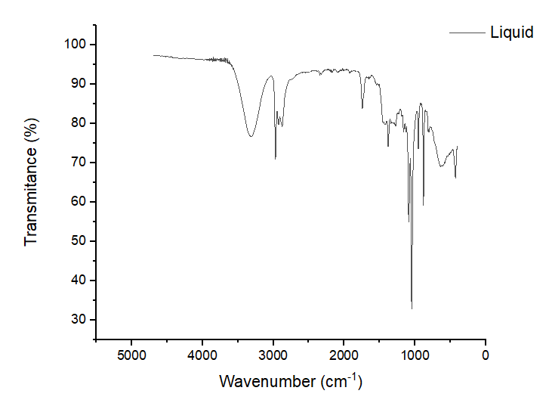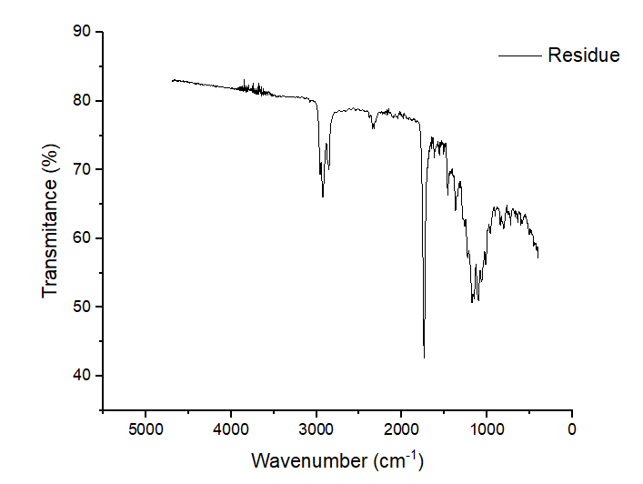

  - SN3
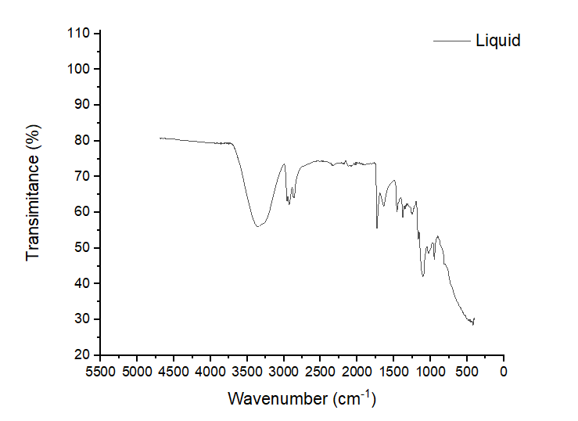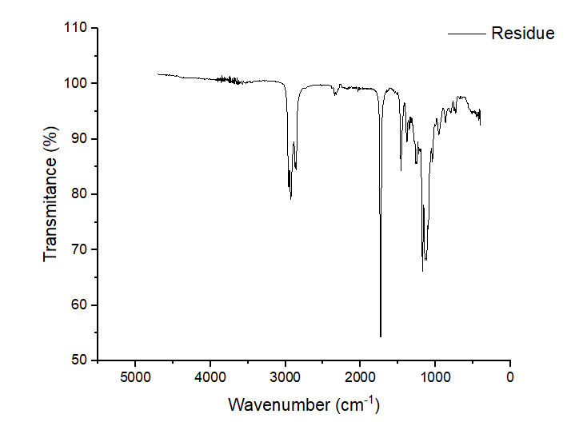

  - SN4
