Declaration form

We all authors declare that our original research article “Reality of having bed nets at home, their status and pattern of using it at night among the population Lakhantari Village Development Committee of Nepal” which is main authored by Dr. Bijay Thapa is not yet published and not sent for publication. We are signing below authorizing for the publication in your Journal.

Name | Author | Signature
Dr. Bijay Thapa | Main author
Dr. Kapil Kumar Pokharel | Co author | 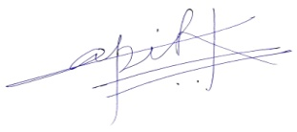
Mr. Nitendra Chaurasia | Co author | 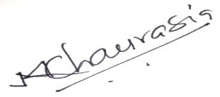
Dr. Alok Acharya | Co author | 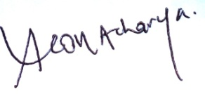
Dr. Rimu Mishra | Co author | 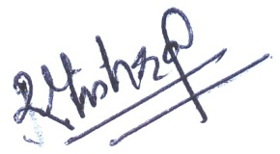
Mr. Ganesh Sharma | Co author | 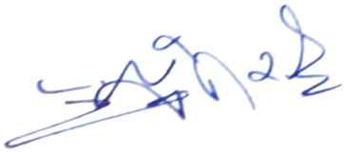

Thank you

