Tables and Figures

**Table 1. Demographic profile of total households**

|  |  |  |
| --- | --- | --- |
| **Characteristics** | **Frequency** | **Percentage %** |
| **Sex wise distribution of Head of Household** | | |
| Male | 330 | 85.9 |
| Female | 54 | 14.1 |
| **Total** | 384 | 100 |
| **Age of Head of Household** | | |
| 20-30 years | 67 | 17.4 |
| 30-40 years | 105 | 27.3 |
| 40-50 years | 44 | 11.5 |
| 50-60 years | 39 | 10.2 |
| 60-70 years | 78 | 20.3 |
| >70 years | 51 | 13.3 |
| **Total** | 384 | 100 |
| **Family type** | | |
| Nuclear | 97 | 25.3 |
| Joint | 79 | 20.6 |
| Extended | 208 | 54.2 |
| **Total** | 384 | 100 |
| **Number of families in Household** | | |
| Two | 6 | 1.6 |
| Three | 17 | 4.4 |
| Four | 57 | 14.8 |
| Five | 96 | 25.0 |
| Six | 96 | 25.0 |
| Seven | 49 | 12.8 |
| Eight | 60 | 15.6 |
| Nine | 3 | 0.8 |
| **Total** | 384 | 100 |
| **Occupation of Head of Household** | | |
| Housewife | 21 | 5.5 |
| Factory worker | 156 | 40.6 |
| Farmer | 148 | 38.5 |
| Rickshaw puller | 20 | 5.2 |
| Shopkeeper | 15 | 3.9 |
| None | 24 | 6.2 |
| **Total** | 384 | 100 |
| **Educational status** |  |  |
| Illiterate | 190 | 49.5 |
| Primary | 116 | 30.2 |
| Secondary | 55 | 14.3 |
| Higher Secondary | 2 | 0.5 |
| SLC above | 9 | 2.3 |
| Intermediate | 12 | 3.1 |
| **Total** | 384 | 100 |

**Table 2. Distribution of family members in Households**

|  |  |  |  |  |
| --- | --- | --- | --- | --- |
| **No. of Females** | | | | |
|  | **Frequency of HH** | **Percentage%** | **Mean** | **Std. Deviation** |
| One | 38 | 9.9 | 2.78 | 1.052 |
| Two | 115 | 29.9 |
| Three | 158 | 41.1 |
| Four | 39 | 10.2 |
| Five | 34 | 8.9 |
| **Total** | 384 | 100 |
| **No. of Males** | | | | |
| One | 39 | 10.2 | 2.92 | 1.07 |
| Two | 105 | 27.3 |
| Three | 110 | 28.6 |
| Four | 113 | 29.4 |
| Five | 17 | 4.4 |
| **Total** | 384 | 100 |
| **No. of Children Less than 5 years** | | | | |
| None | 272 | 70.8 | - | - |
| One | 45 | 11.7 |
| Two | 37 | 9.6 |
| Three | 23 | 6.0 |
| Four | 7 | 1.8 |
| **Total** | 384 | 100 |
| **No. of Pregnant women** | | | | |
| None | 380 | 99.0 | - | - |
| One | 4 | 1.0 |
| **Total** | 384 | 100 |

**Figure 1. Colors of bed nets used**

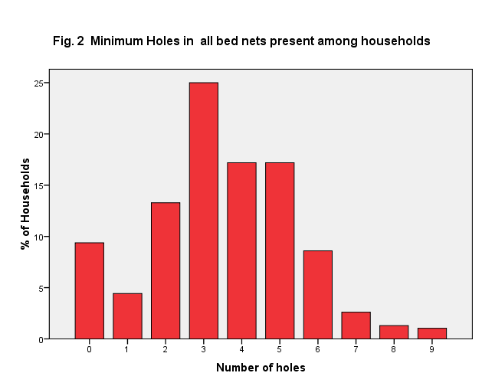

**Table no. 3 Relation between Febrile symptoms at household and holes in bed nets**

|  |  |  |  |  |
| --- | --- | --- | --- | --- |
| **Number of holes** | **Febrile symptoms** | | **Total** | **P value** |
| **No %** | **Yes %** | <0.00 |
| No holes  One hole  Two  Three  Four  Five  Six  Seven  Eight  Nine | 26 6.8 | 10 2.6% | 36 9.4% |
| 6 1.6 | 11 2.9% | 17 4.4% |
| 10 2.6% | 41 10.7% | 51 13.3% |
| 32 8.3% | 64 16.7% | 96 25.0% |
| 20 5.2% | 46 12.0% | 66 17.2% |
| 35 9.1% | 31 8.1% | 66 17.2% |
| 9 2.3% | 24 6.2% | 33 8.6% |
| 3 0.8% | 7 1.8% | 10 2.6% |
| 0 0.0% | 5 1.3% | 5 1.3% |
| 0 0.0% | 3 1.0% | 4 1.0% |
| **Total** | 135 36.7% | 249 63.3% | 384 100.0% |
| **Frequency of using bed nets** | | | | |
| 0-2 day/week  3-4day/week  5-7day/week | 0 0.0% | 11 4.5% | 11 2.9% | <0.00 |
| 130 92.2% | 232 95.5% | 362 94.3% |
| 11 7.8% | 0 0.0% | 11 2.9% |
| **Total** | 141 36.7% | 243 63.3% | 384 100.0% |

**Fig.3 Name of the disease diagnosed among household members [N=36 household]**

**Fig.4 Time duration of using same bed nets**