Tables and Figures
Table 1. Age distribution
Age group (years) | Frequency | Percent
≤20 | 2 | 1.6
21-30 | 34 | 27.9
31-40 | 74 | 60.7
41-50 | 10 | 8.2
≥50 | 2 | 1.6

Table 2. Central tendency
Variable | Mean (SD) | Median (IQR)
Age | 33.8 (7.3) | 34 (30-38)
CD4 count | 360.4 (181.1) | 328 (256 – 422.2)
OHI-S | 1.65 (0.9) | 1.5 (1 – 2.1)
DMFT | 1.57 (1.9) | 1 (0 – 2)
OHIP-14 | 2.49 (7.1) | 0 (0 – 1)

Table 3. Total OHIP Score
Score range | Frequency | Percent
0 | 91 | 74.6
1-10 | 22 | 18.1
11-20 | 4 | 3.2
>20 | 5 | 4.1

Figure 1. Correlation of CD4 count with OHIP
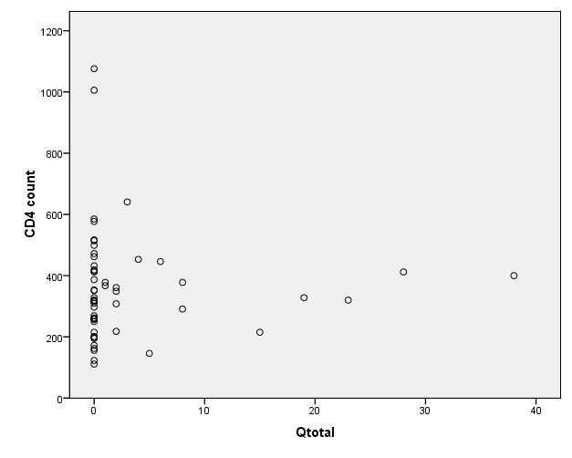
Figure 2. Correlation of CD4 count with OHI-S
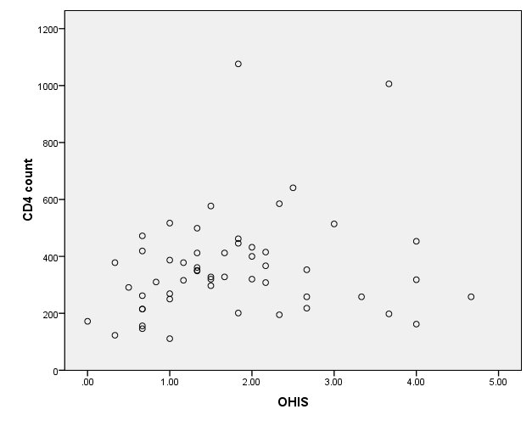
Figure 3. Correlation of CD4 count with DMFT
