Figures:
Figure 1. Picture showing the complete destruction of the right eye with extensive ecchymosis. There is dark staining of the entire scalp and face.
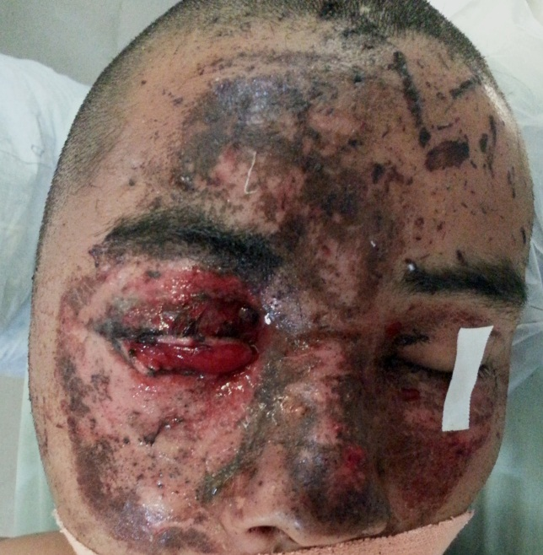
Figure 2. CT head and orbit showing a large metallic body in the right temporal fossa along with contusion and smaller bone fragments. There is destruction of the eye ball suggesting it as the entry point (A). 3D reconstruction showing the defect in the orbital wall through the bullet trasversed (B).
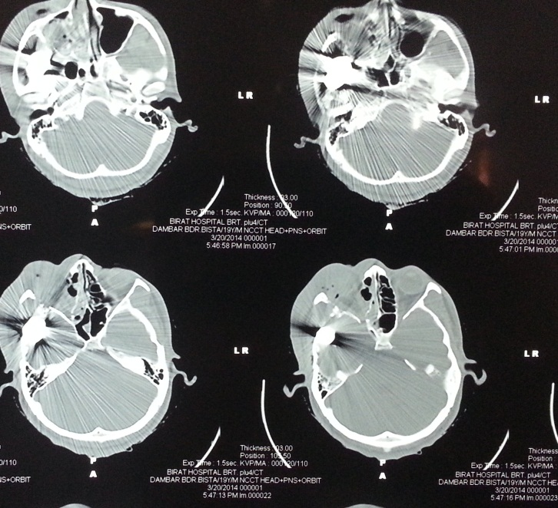
A
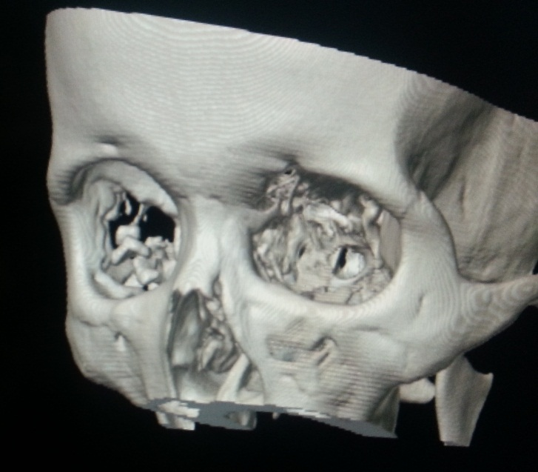
B
Figure 3. Introperative picture showing the large bullet along with dural tear and fracture of the temporal bone.
