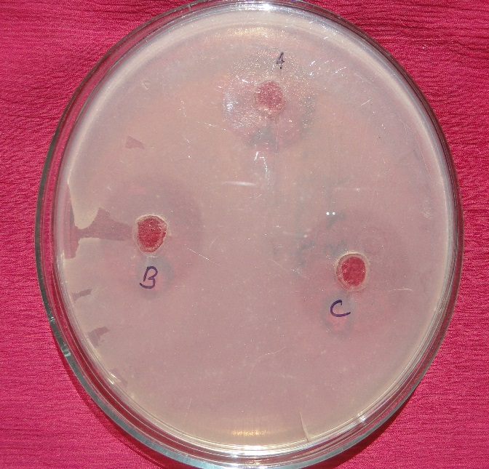
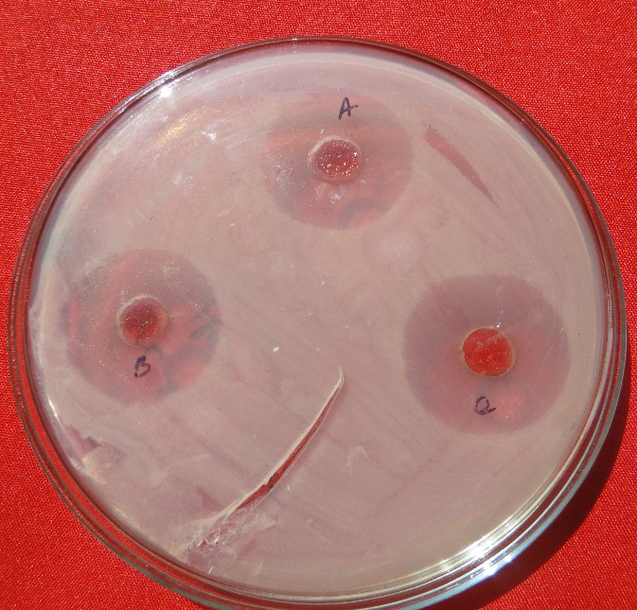
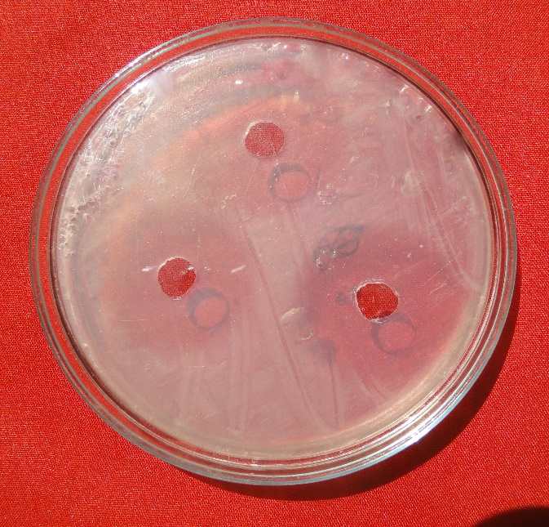
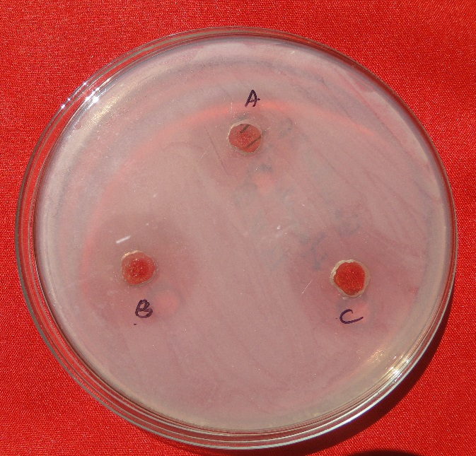
A
D
C
B

Figure 2: A-D represents the inhibition zone of BUL extracts of S. pubescens against B. subtilis, B. cereus, E. coli and X. sp. respectively.

