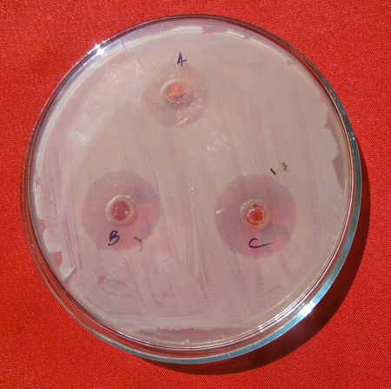
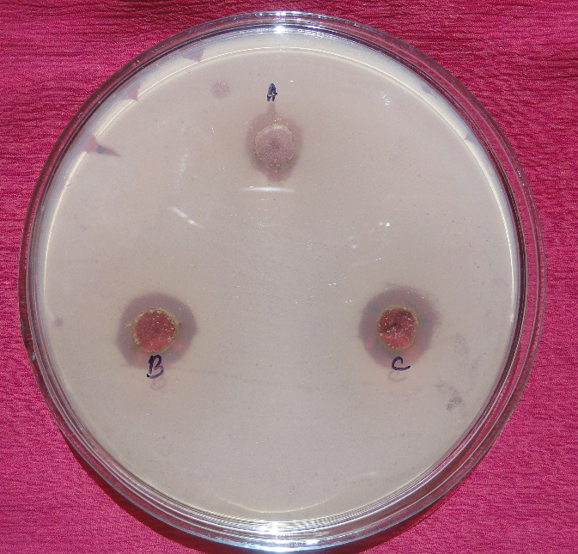
4
3
2
1
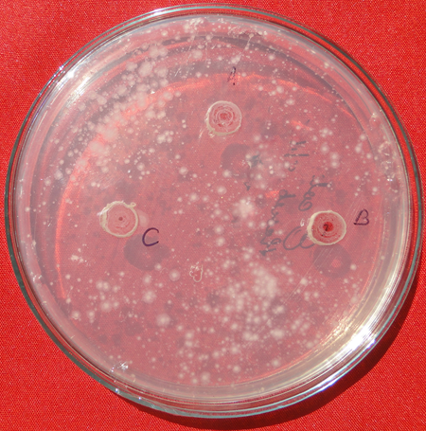
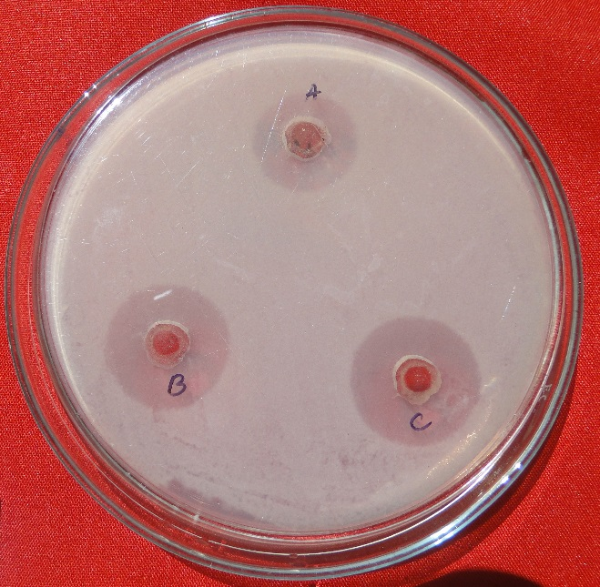
Figure 2: 1-4 represents the inhibition zone of FC, FUL, LC and FUL against B. subtilis, B. cereus, E. coli and X. sp. respectively.

