Figure 1 Chest X-ray showing bone formations bridging from right humerus to right scapula and left side ribs to left scapula
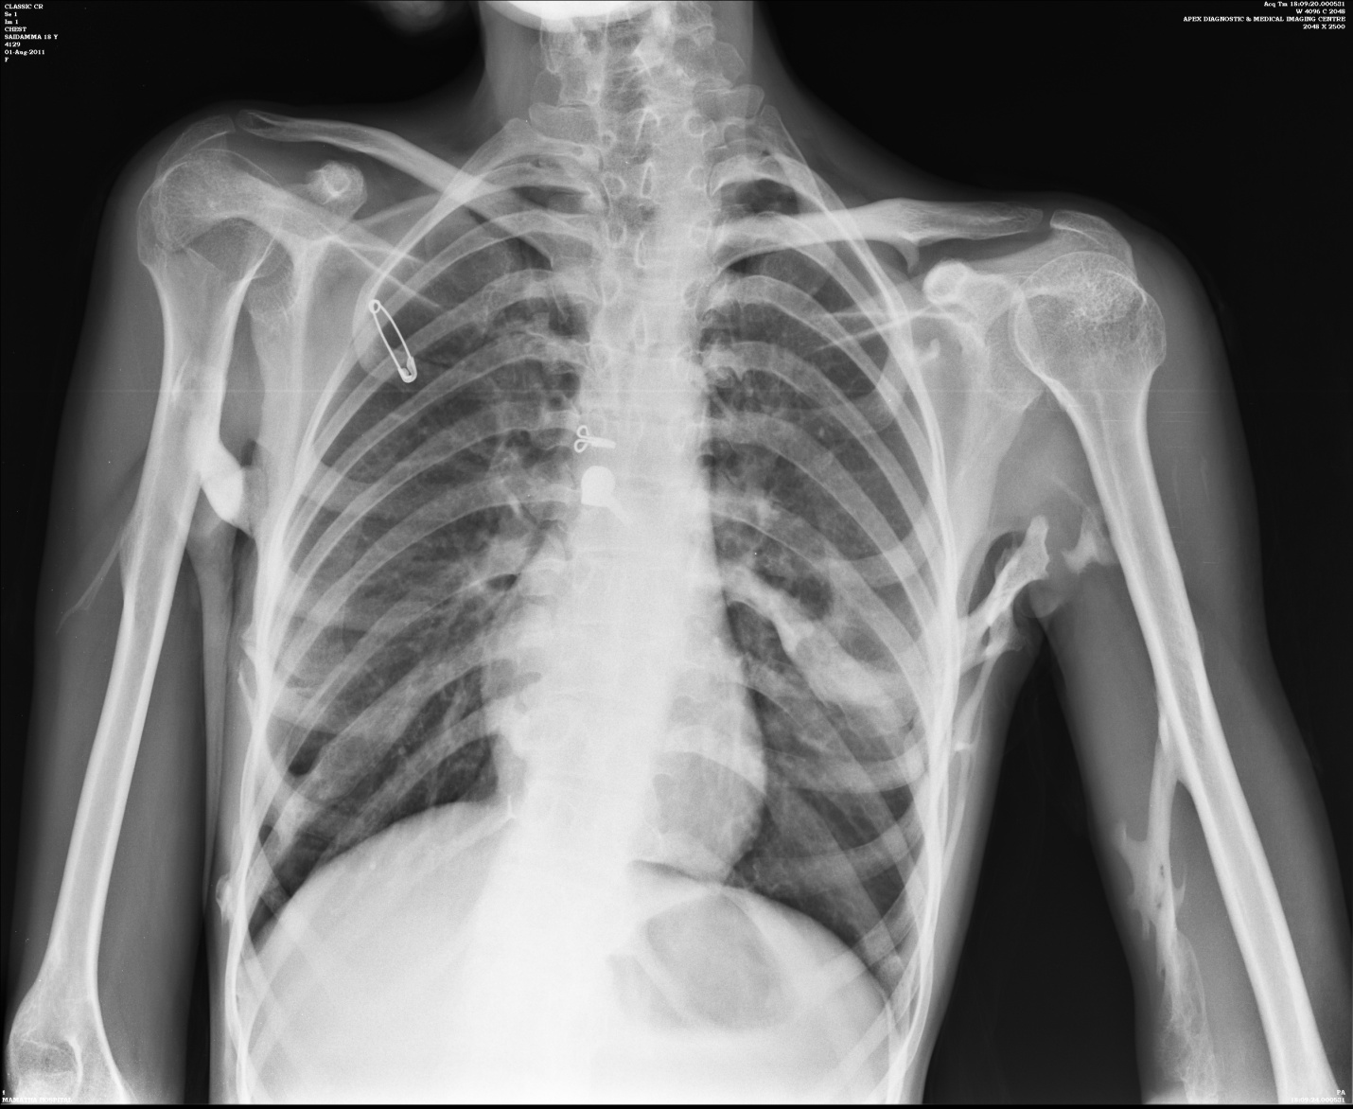

Figure 2 Bilateral short great toes

