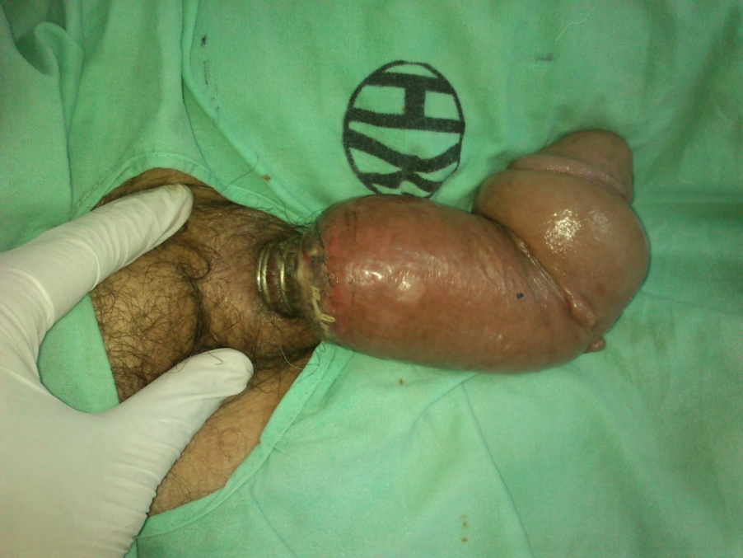

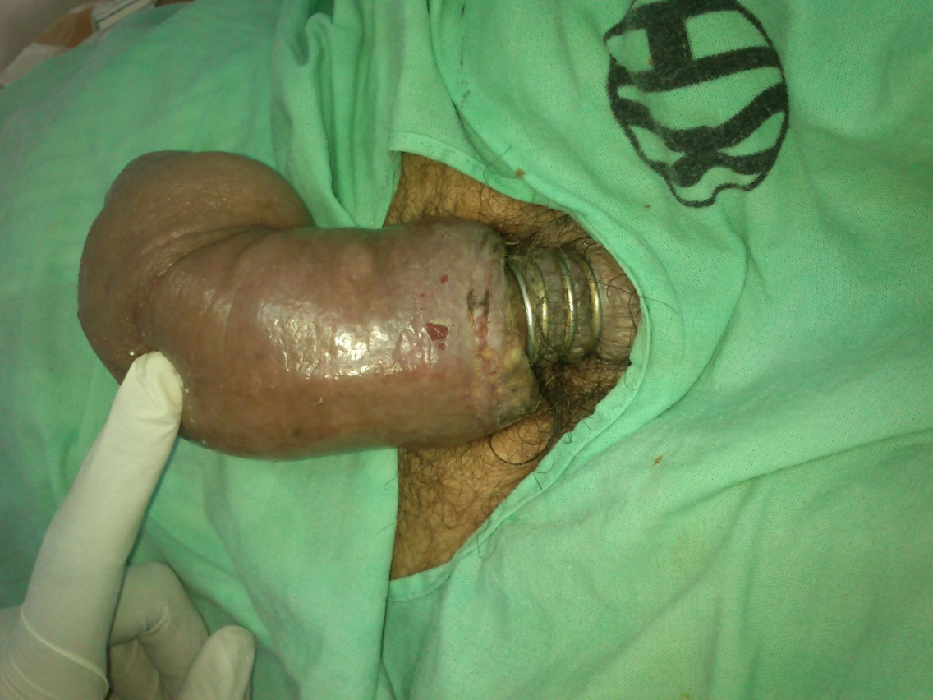

Fig 1a, b: 4 rings incarcerated at the root of the penis.
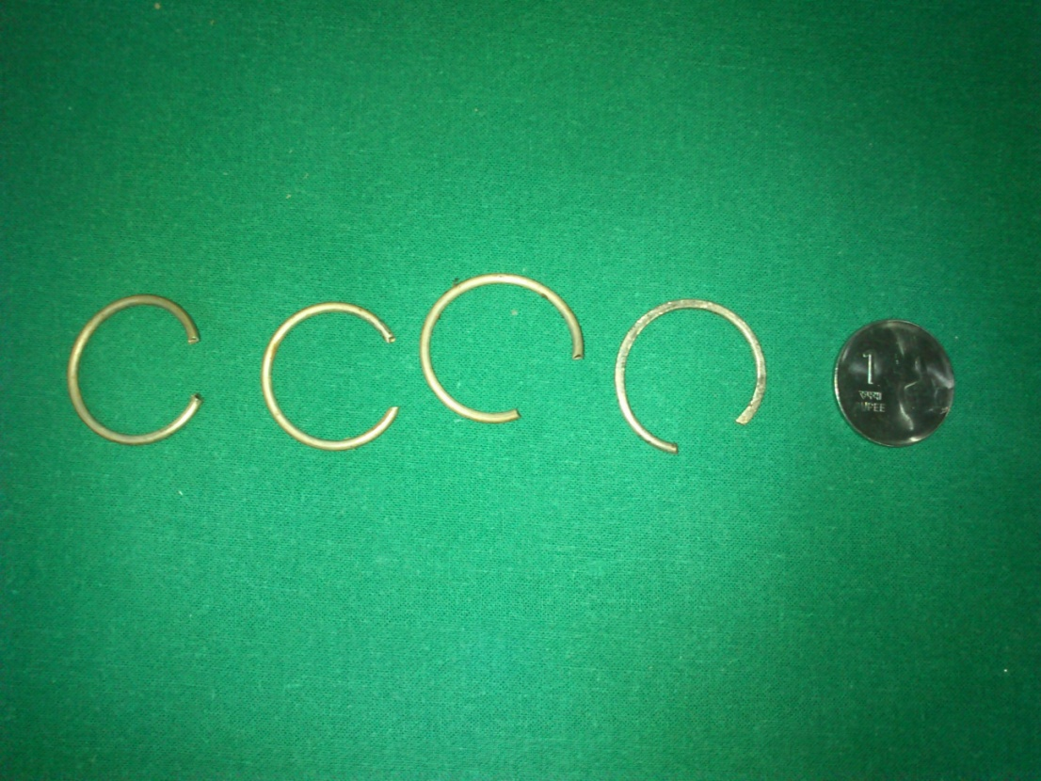
Fig 2: 4 rings removed (size in comparison to a coin)
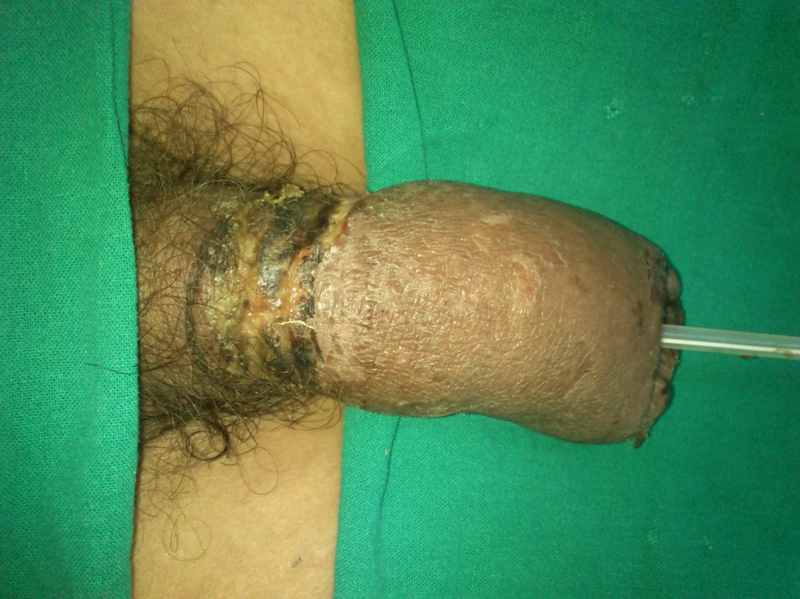
Fig 3: Post operative photo of the affected part

Fig 4: 3 weeks post operatively.

