COVERING LETTER

To,
The Editor in chief
ASIAN JOURNAL OF MEDICAL SCIENCES

Sub: Submission of “CASE REPORT” for publication
Dear Sir,
We intend to publish a case report entitled “Giant pelvic cocoon with intraprostatic extension (intravesical tortoise!!!!!!!)” in your esteemed journal. On behalf of all the contributors I will act as guarantor and will correspond with the journal from this point onward.

Prior publication - Nil
Support- Nil
Conflicts of interest- Nil
Permissions- Nil

"Upon acceptance by Asian Journal of Medical Sciences, all copyright ownership for the article is transferred to Asian Journal of Medical Sciences. We, the undersigned co-authors of this article, have contributed significantly to and share in the responsibility for above. The undersigned stipulate that the material submitted to Asian Journal of Medical Sciences is new, original and has not been submitted to another publication for concurrent consideration.
We also attest that any human and /or animal studies undertaken as part of the research from which this manuscript was derived are in compliance with regulation of our institution(s) and with generally accepted guidelines governing such work.
We further attest that we have herein disclosed any and all financial or other relationships which could be construed as a conflict of interest and that all sources of financial support for this study have been disclosed and are indicated in the acknowledgement. This statement must be signed by all the major co-authors."

Thanking you,
Yours’ sincerely,
Dr. Prasad Mylarappa
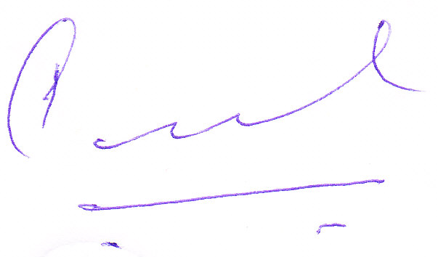
Signature

Correspondence

Dr. Prasad Mylarappa
Associate Professor
Department of urology
MS Ramaiah Medical College and Hospital
New BEL road
Bangalore
Karnataka
INDIA
PIN code- 560054
Email ID: prasadmyl@rediffmail.com

