INTRODUCTION

INTRODUCTION

Cholecystectomy is the most common elective procedure performed on
the biliary tract and the second most common abdominal operation
performed today¹. Open cholecystectomy, first performed by Carl
Langenbuch in 1888 has been the primary treatment of gall bladder
disease through the early 1990s. In 1985, the first endoscopic
cholecystectomy was performed by Erich Muhe². Shortly thereafter, pioneers in France and United States Coupled a CCD video camera with a laparoscope to allow the entire surgical team to view the operative field and performed cholecystectomies with laparoscopic equipment. In 1987, laparoscopic cholecystectomy was introduced by Philippe Mouret³ in France and quickly revolutionized the treatment of gallstones. It not only supplimented open cholecystectomy, but also more or less ended attempts for non-invasive management of gallstones, such as extracorporeal shock wave and bile salt therapy.
Laparoscopic cholecystectomy offers a cure for gallstones with a minimally invasive procedure, minor pain and scarring, and early return to full activity. Today, laparoscopic cholecystectomy is the treatment of choice for symptomatic gallstones. Absolute contraindications for the procedure are uncontrolled coagulopathy and end-stage liver disease. In the latter instance, liver transplantation, with cholecystectomy, may be used for treatment of severe recurrent gallstone disease. Rarely patients with severe obstructive pulmonary disease or congestive heart failure (e.g., cardiac ejection fraction 20%) may not tolerate pneumoperitoneum with carbon dioxide and require open cholecystectomy. Conditions formerly believed to be relative contraindications such as acute cholecystitis, gangrene and empyema of the gallbladder, biliary-enteric fistulae, obesity, pregnancy, ventriculoperitoneal shunt, cirrhosis, and previous upper abdominal procedures are now considered risk factors for a potentially difficult laparoscopic cholecystectomy. When important anatomic structures cannot be clearly identified or when no progress is made over a set period of time, a conversion to an open procedure is usually indicated.
In the elective setting, conversion to an open procedure is needed in about 5% of patients. Emergent procedures may require more skill on the part of the surgeon and be needed in patients with complicated gallstone disease; the incidence of conversion is 10% to 30%. Conversion to an open procedure is not a failure, and the possibility should be discussed with the patient preoperatively. Serious complications are rare. The mortality rate for laparoscopic cholecystectomy is about 0.1%. Wound infection and cardiopulmonary complication rates are considerably lower following laparoscopic cholecystectomy than are those for an open procedure. However, laparoscopic cholecystectomy is associated with a higher injury rate to the bile ducts . Most series quote a major bile duct injury rate of around 0.2% during open cholecystectomy, whereas the incidence of bile duct injury during laparoscopic cholecystectomy is 0.4% or high.
But subsequently it was discovered that due to the pneumoperitoneum created by the gas (commonly by the CO2) was associated with gross hemodynamic changes, post operative complications like shoulder pain and was unsafe in ASA class III and above. Then there was development of the same operative procedure by not using the gas but to create the space by using the various methods of abdominal wall lifting techniques and the gasless laparoscopic surgery concept developed using the same conventional laparoscopic instruments.But it has got some serious technical difficulties.Now the emerging trend is low presssure laparoscopic cholecystectomy. Standard pressure pneumoperitoneum for laparoscopic cholecystectomy employs a pressure range of 12-16 mm Hg. An emerging trend has been the use of low pressure pneumoperitoneum in the range of 7-10 mm Hg in an attempt to lower the impact of pneumoperitoneum like CO₂ embolism,vasovagal reflex,cardiac arrhythmia,hypercarbic acidosis and minimize haemodynamic effect of insufflation while providing adequate working space. My study proposes to compare the use of low pressure pneumoperitoneum with the use of standard pressure pneumoperitoneum.

ANATOMY

ANATOMY

Discussion of laparoscopic cholecystectomy would not be complete without a thorough review of the anatomy of the liver, biliary tree, and gallbladder. Much of today‟s hepatobiliary anatomy was described by Couinaud in the mid-1900s. The biliary system and hepatic vasculature are generally much more variable than any other part of the human anatomy.⁴
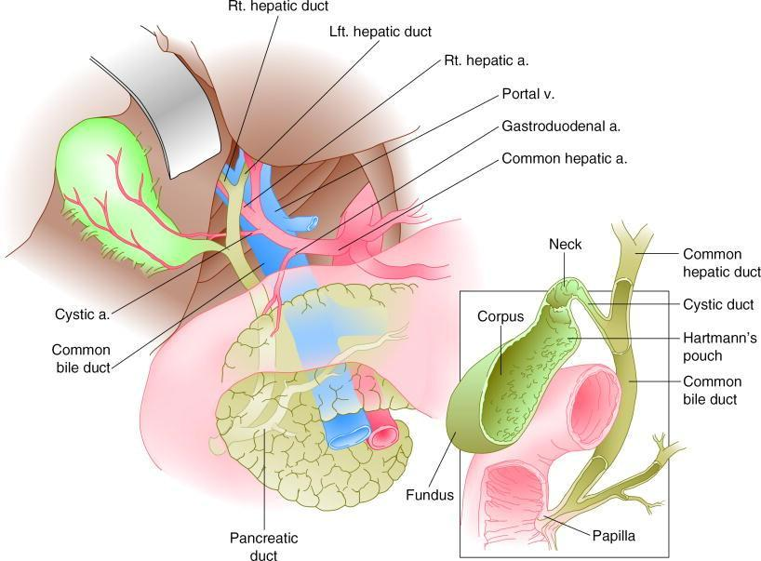

Anatomy of the biliary system and its relationship to surrounding

structures

General Anatomy of the Liver

Grossly, the liver appears divided into two lobes (right and left) by the umbilical fissure and falciform ligament. This topographical lobar anatomy is misleading

in comparison to the actual functional or segmental anatomy of the liver. Topographically, the inferior aspect of the right lobe is bound posteriorly by the transverse fissure; with the tissue lying anterior to this called the quadrate lobe. Also posteriorly, behind the portal vein, is another distinct region known as the caudate lobe. These four lobes (right, left, caudate, and quadrate) constitute the major topographical lobar anatomy of the liver. Use of the term lobes in the topographical sense has become routine in descriptions of the liver, but most hepatobiliary surgeons and endoscopists use either the French or American classification of hepatic anatomy (or both) to describe the liver‟s segmental anatomy.

French Segmental System

Couinaud most completely developed the functional anatomic description of the liver, which became known as the French segmental system for hepatic anatomy, ⁵ in the 1950s. This system shows more consideration for the hepatic venous drainage but also applies to the portal, biliary, and arterial anatomy.⁶

Instead of four hepatic divisions, as in the topographical system, there are eight divisions or segments: four on the right, three on the left, and one corresponding to the topographical caudate lobe (segment I). Segments II through IV constitute the left lobe and segments V through VIII the right lobe.

American (Lobar) System

The American system of hepatic classification is based on the fact that the distribution of the major branches of the veins, arteries, or bile ducts of the liver does not conform precisely to the topographical anatomy. The relationships between the hepatic veins and portal vein branches therefore determine the lobar anatomy of the liver in this classification system.⁷ A plane called the portal fissure (Cantlie‟s line) passes from the left side of the gallbladder fossa to the left side of the inferior vena cava to divide the liver into its right and left lobes.⁸ The left lobe consists of a medial segment, which lies to the right of the falciform ligament and umbilical fissure, and a lateral segment, which lies to the left of the falciform ligament. The right lobe consists of an anterior and a posterior segment.

The excretory apparatus of the liver consists of:

- Intrahepatic ducts

- The common hepatic duct, formed by the right and left hepatic ducts

which leave the liver at the porta hepatis;

- The gallbladder which serves as a reservoir for bile;

- The cystic duct, or duct of the gallbladder;

5) The common bile duct; formed by the junction of the common hepatic and cystic ducts.

Intrahepatic Ducts

The biliary drainage system begins at the hepatocyte/cholangiocyte level where portions of the hepatocyte membrane form small channels called canaliculi. Bile drains from the canaliculi into intrahepatic ducts that follow the segmental anatomy determined primarily by the vascular supply.⁹ The convergence of canaliculi and proximal ductal systems is called the canal of Hering. The smaller ducts unite to form a single channel called the segmental bile duct. The ductal patterns then become more variable as the biliary system travels distal from the canaliculi. The right and left hepatic ducts are formed by the confluence of the segmental ducts within the substance of the liver. The left lobar duct forms in the umbilical fissure from the union of ducts from segments II, III, and IV and then passes to the right across the base of segment IV (medial portion of the left lobe, topographical quadrate lobe). Although there are numerous segmental variations in the left ductal system, the left side is less variable at the level of the confluence than the right ductal system¹⁰. The right hepatic duct drains segments V to VIII and arises from the junction of the right anterior and posterior sectoral ducts. These ducts of the right side join each other but are extremely variable with respect to the order and site of the union. The most typical anatomy has the right posterior sectoral duct following an

almost horizontal course before joining with the anterior duct, which descends more vertically. This junction is usually found above the right branch of the portal vein. In a minority of cases, the right ducts do not all incorporate into one right hepatic duct. Instead, a right segmental or sectoral duct joins the left hepatic duct and creates a third duct that seems to join the confluence. The biliary drainage of the caudate lobe (segment I) varies considerably, but enters both the right and left hepatic duct systems about 80% of the time. In about 15% of cases, the caudate lobe drains only into the left hepatic ductal system and in about 5% it drains only into the right hepatic duct.¹¹ As the segmental ducts join to form right and left lobar (hepatic) ducts, it is not unusual for 1 to 3 cm of the lobar duct to lie within the hepatic tissue. In about 98% of cases, the right and left ducts unite in an extrahepatic position. The usual extrahepatic length of each hepatic duct varies from 0.5 to 1.5cm. Most often, a shorter extrahepatic right duct joins a longer left duct at the level of the base of the right branch of the portal vein.¹² Because of this length discrepancy, the terminal intrahepatic segment of the left hepatic duct generally is easier to delineate than the similar segment of the right hepatic duct. This anatomic fact is of considerable importance in operative procedures in which an additional length of biliary duct is needed for an anastomosis to the intestinal tract.¹³ Depending partly upon their extrahepatic length, the right and left hepatic ducts join at a wide or acute angle, or even descends parallel to each other for a variable distance before their union. Most often they merge about 1 cm below the hepatic parenchyma to form

the common hepatic duct. The angle at which the right and left ducts join is of clinical significance to both the endoscopist and hepatobiliary surgeon. When viewing the union of the lobar ducts from the level of the common hepatic duct, the right hepatic duct often is a “straight shot” relative to the more acute angle of the left hepatic duct. For this reason, the endoscopist at endoscopy and the surgeon during choledochoscopy frequently enter directly into the right lobe of the liver and have greater difficulty entering the left lobe. Changes in the

“typical” intrahepatic ductal anatomy caused by compensatory enlargement of liver tissue after damage or resection of a segment or lobe have been known for almost a century. The distorted configuration of the liver and the tendency of the lobe undergoing hypertrophy to rotate and extend across the midline cause diagnostic and operative difficulties. Vessels and ducts conform to this spatial lobar rearrangement with the following consequences: first, the portal vein lies more superficially and is therefore at risk for being injured; and second, the portal venous branches develop an anterior relationship to the bile ducts, making access to these ducts exceedingly difficult. In effect, the hilar vascular structures course obliquely anterior while the bile duct goes posteriorly.¹⁴

Common Hepatic Duct
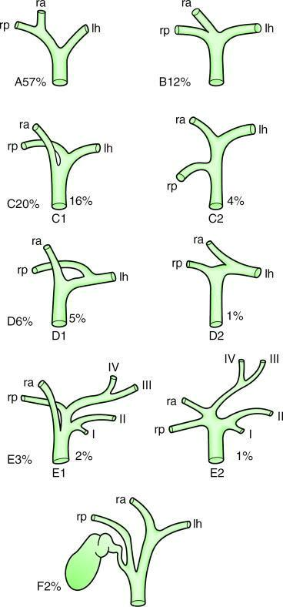

Main variations in the confluence of the left and right hepatic ducts. A, Typical anatomy of the confluence. B, Trifurcation of left, right anterior and right posterior hepatic ducts. C, Aberrant drainage of a right anterior (C1) or posterior (C2) sectoral hepatic duct into the common hepatic duct. D–F, less common variations in hepatic ductal anatomy.

The common hepatic duct is the length of biliary duct from the hepatic duct confluence to the cystic duct. The common hepatic duct makes up the left border of the triangle of Calot, which becomes important in any discussion of

the laparoscopic cholecystectomy. The length of common hepatic duct varies from 1 to 10cm depending on the location of the junction with the cystic duct, where it then becomes the common bile duct.¹⁵ The common hepatic duct at the area of the confluence is separated anteriorly from the posterior aspect of the quadrate lobe by the “hilar plate.”This structure is a fusion of Glisson‟s capsule and the connective tissue surrounding the biliary and vascular elements in this area, which, when opened, can allow excellent exposure to the confluence and common hepatic duct.¹⁰ The common hepatic duct can often be associated with accessory ducts. These accessory hepatic ducts are so common as to be found in up to 20% of people. They are readily injured at cholecystectomy if they traverse the triangle of Calot. In more than half of the cases in which an accessory duct is found, it joins the common hepatic duct somewhere along its course. Less frequently, the accessory duct joins the cystic duct. In the rarest of instances, it may join a duct in the opposite lobe. The majority of aberrant ducts are on the right side. One should have higher suspicion for aberrant hepatic ductal anatomy when there appears to be unusual arterial or distal biliary anatomy.¹⁶

Gallbladder

The gallbladder is a pear-shaped, distensible appendage of the extra hepatic biliary system, usually holding 30 to 50ml of bile. It lies in a depression on the inferior, or visceral, surface of the right lobe of the liver. The position of the 16

gallbladder marks the boundary of the right and left hepatic lobes in the American system. The gallbladder is attached to the liver by areolar connective tissue that contains multiple small lymphatics and veins. These lymphatic and veins connect the venous and lymphatic systems of the gallbladder with those of the liver. Rarely, one or more small accessory bile ducts pass through this tissue to enter the gallbladder directly (ducts of Luschka).¹⁷ In extremely unusual cases; major hepatic ducts might even drain directly into the gallbladder. Arbitrary definitions divide the gallbladder into a fundus, body, infundibulum, and neck. The fundus is the round; blind end of the gallbladder that usually projects about 1 cm beyond the free edge of the right lobe of the liver. The top of the fundus is often at the apex of an angle formed by the right lateral border of the rectus muscle and the ninth costal cartilage. In this position it comes into contact with the anterior peritoneum of the abdominal wall. The fundus becomes palpable in the right upper abdominal quadrant with gallbladder distension. Usually in association with stones or cholestasis, the fundus may become kinked upon itself, an anomaly referred to as a Phrygian cap. Grossly this may look like a fungating mass, but histologically the tissue only contains an abundance of fibrous tissue. The fundus passes without a demonstrable transition into the body, which constitutes the largest segment of the organ. Unless a mesentery is present, the entire superior surface of the gallbladder body is closely attached to the visceral surface of the liver over the area of the gallbladder bed. This intimate relationship to the visceral surface of the liver

easily permits direct spread of gallbladder inflammation, infection, or neoplasia into the parenchyma of the liver. The infundibulum of the gallbladder is the tapering transitional area between the body and neck of the organ. It usually appears as a shallow diverticulum, lying close to the under surface of the cystic duct, and occasionally obscuring the duct from view. It is attached to the right lateral surface of the second portion of the duodenum by an avascular peritoneal fold called the cholecystoduodenal ligament. The free surface of the body and the infundibulum of the gallbladder also lie in close approximation to the first portion of the duodenum as well as to the hepatic flexure and the right third of the transverse colon. The infundibulum of the gallbladder rapidly tapers into the neck, which may be narrow and curve upon itself in the form of an “S.” The neck is usually directed superiorly and to the left. It narrows into a sometimes poorly defined constriction at its junction with the cystic duct. The transition between the neck and the cystic duct can be gradual or abrupt. The neck is quite short, usually 5 to 7 mm.¹⁸ An asymmetrical outpouching of the inferior surface of the infundibulum known as Hartmann‟s pouch lies close to the neck. It can often be used as a point of traction to provide exposure during cholecystectomy, but it is occasionally adherent to the cystic duct, making the operation difficult.

Hartmann‟s pouch may also trap large gallstones that are unable to enter the neck or cystic duct.¹⁰ Unusual morphologies of the gallbladder including septations or duplications or even agenesis may occasionally present during laparotomy or laparoscopy. These are all rare anomalies with which the

hepatobiliary specialist should be familiar. A septated gallbladder is by definition a bilobar gallbladder with a single cystic duct but two fundi. Duplication of the gallbladder means the presence of two cystic ducts. A double cystic duct draining a unilocular gallbladder has once been described. More frequently encountered anomalies of the cystic duct and gallbladder are intrahepatic gallbladders and a gallbladder within the left lobe of the liver.¹⁹

Cystic Duct

The cystic duct is the route by which the gallbladder fills and empties its bile. It connects the neck of the gallbladder to the common hepatic duct. In as many as 10% of cases, a portion of the right hepatic biliary system joins the cystic duct before its junction with the common hepatic duct. Generally, the cystic duct is about 4 cm long. The length may vary from 0.5 to 8 cm depending on the site of the gallbladder and the junction with the common hepatic duct. The circumference of the duct varies from 3 to 12 mm.²⁰ The mucous membrane that lines the cystic duct usually has 4 to 10 folds, referred to as the spiral valves of Heister. The valves regulate bile flow, serving to prevent excess distension or collapse of the cystic duct, particularly as intraductal pressure changes. The valves may be extremely tortuous, complicating cannulation during intraoperative cholangiography. The cystic duct usually runs dorsally, to the right, and inferiorly to the common hepatic duct. The course may be quite tortuous, mimicking other ducts until dissected. As a general rule, the cystic

duct joins the right aspect of the common hepatic duct. The cystic duct may (1) join the common hepatic duct at various angles; (2) be parallel to the right side of the common hepatic duct before entering it; (3) be dorsal to the common duct and enter its dorsal surface; (4) be dorsal to the common duct and enter it from the left side; (5) enter the right or left hepatic duct directly; or (6) join the common duct just before it enters the posteromedial wall of the duodenum. The mode of entrance of the cystic duct into the common hepatic duct may be angular, parallel, or spiral. The angular type occurs in about 80% of people. The angle may vary from a right angle to an acute angle of 10°. With the parallel type of junction, the two ducts may run alongside each other for several centimeters. In such cases, the ducts may be closely adherent and impossible to separate without injuring the common bile duct. The complexity is compounded when a common sheath of dense connective tissue encircles the two ducts. In such cases it is considered safest to leave a long cystic duct stump attached to the common bile duct at the time of cholecystectomy. In the spiral type of junction, which occurs in about 2% of the population, the cystic duct may pass either ventral or dorsal to the common hepatic duct before joining it. Spiral cystic ducts may join on any surface of the common hepatic duct; including the left lateral side.²¹ The variable site of the union of the hepatic and cystic ducts determines the length of the common bile duct. If this union is low, that is, distal to the porta hepatis near the duodenum, the supraduodenal portion of the common bile duct is very short or even absent. If this is the case, the cystic and

common hepatic ducts run parallel for a considerable length, causing difficulties during cholecystectomy. The cystic duct may also be very short or absent, in which case the gallbladder may appear to empty directly into the common hepatic duct.

Triangle of Calot and Rouviere’s Sulcus
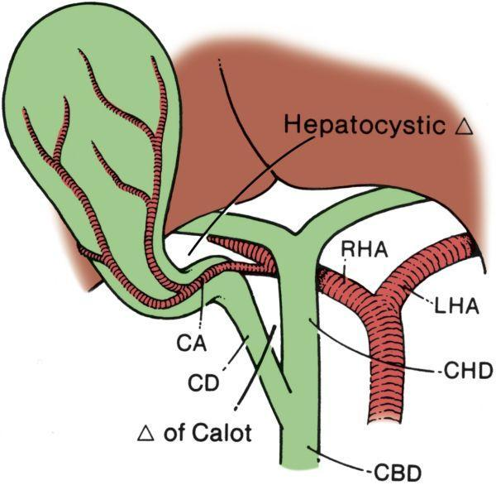

The region known as Calot‟s triangle differs today when compared to the area described by Calot in 1890 while he was a medical student. He described in his thesis a triangle bordered by the cystic artery, the cystic duct, and the common hepatic duct. The area described today as his triangle is the region bounded by the cystic duct, common (or right) hepatic duct, and inferior border of the liver. The change is thought to have occurred because of the practical use of the larger triangle that helps to frame and identify the cystic artery that lies within it.²²

Recognition of critical structures and dissection within Calot‟s triangle is of great importance during cholecystectomy, especially at the apex of the triangle.

The apex of the triangle contains the cystic artery, as discussed, as well as the right branch of the hepatic artery, 95% of accessory right hepatic arteries, and 90% of accessory bile ducts. An anomalous hepatic artery arising from the superior mesenteric trunk (replaced right hepatic artery) usually courses superiorly in the groove posterolateral to the common bile duct. Therefore, it appears on the medial side of the apex of Calot‟s triangle, just behind the cystic duct where it is vulnerable to injury during cholecystectomy. Some degree of replacement is thought to occur in up to 10% of patients.²³ Bile duct injuries during cholecystectomy most frequently occur because of poor exposure of

Calot‟s triangle, leading to confusion between the common hepatic or common bile duct and the cystic duct. Similarly, vascular injuries or significant bleeding that can obscure the dissection can occur if the exposure of this anatomy is inadequate. Multiple styles and techniques are outlined in the literature to expand Calot‟s triangle to its greatest widths and thus improve exposure of the key structures while attempting to avoid tenting the common duct into the area of dissection. In the end, these various means are all dependent on repetition and the experience of the surgeon to avoid ductal or vascular injuries.²⁴ Another landmark in this region that can be helpful in identifying the plane of the common bile duct and avoiding injuries during cholecystectomy is Rouviere‟s sulcus, identified by Rouviere in 1924 as a 2- to 5-cm sulcus lying anterior to the caudate lobe and running to the right of the liver hilum and usually containing the right portal triad. Based on anatomic studies by Couinaud and

supported by subsequent laparoscopic cholecystectomy studies, this sulcus is identifiable in approximately 75% of patients and accurately identifies the plane of the common bile duct as substantiated by cholangiogram. Identification of the sulcus requires anterosuperior and leftward retraction of the neck of the gallbladder with exposure and dissection of the posterior hepatobiliary triangle bounded by the neck of the gallbladder, the liver surface, and the plane of the sulcus. Dissection maintained ventral to the plane of the common bile duct, with care taken to identify a possible posterior cystic artery branch or tortuous hepatic artery, is safe even with tenting of the common bile duct.²⁵

Common Bile Duct
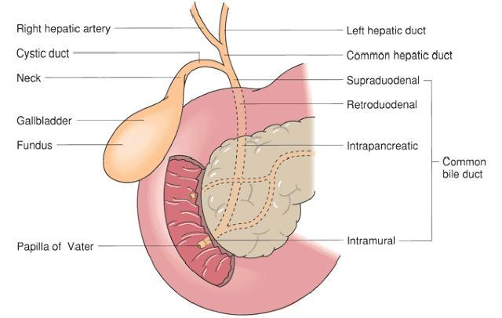

The junction of the common hepatic duct with the cystic duct forms the common bile duct. The length of the common duct is variable, reported in the adult to be as short as 1 cm and as long as 17 cm.²⁶ The upper limit of normal

for the diameter of the common bile duct was formerly controversial. Increased use of ultrasonography has now defined the upper limit of normal for common bile duct diameter as 6 mm; the upper limit of normal for the entire width of the duct including the walls is 8 mm. These measurements are described as the 95% confidence limits of normal, so one still needs to consider normal in the differential of other ductal widths. After cholecystectomy, the normal common bile duct may dilate to 10 to 12 mm. Once the common bile duct has been formed by the junction of the cystic and common hepatic ducts, it is designated as the supraduodenal segment of the common bile duct. Subsequently, it becomes the retroduodenal portion that in turn leads to the pancreatic and eventually the intraduodenal segments of the common bile duct. The supraduodenal segment is usually the longest portion of the common duct and lies in the hepatoduodenal ligament. Superior to the first portion of the duodenum, the common bile duct lies ventral to the epiploic foramen of Winslow. Classically, a stone in this segment of the common bile duct was often easily palpated during an open procedure. Multiple lymph nodes also lie close to the supraduodenal portion of the common bile duct. Most of these are on the portal (posterior) side of the duct. When enlarged, these occasionally may be mistaken for gallstones during palpation. The retroduodenal segment of the duct varies in length from 2 to 4.5 cm. It lies dorsal to the middle aspect of the duodenum and slants obliquely as it runs from the superior to the inferior duodenal surface. To the left of the retroduodenal portion of the duct is the

gastroduodenal artery. There, the common bile duct is sometimes involved in the inflammatory reaction associated with a posterior duodenal ulcer. The surgeon must also be careful not to divide or entrap the common bile duct while transecting or suturing the proximal portion of the duodenum.¹⁷ The pancreatic segment of the common bile duct is related to the head of the pancreas in either of two ways. It may be entirely retropancreatic, lying between the pancreas and areolar tissues of the retroperitoneum; or it may lie within the substance of the dorsal portion of the pancreatic head, covered dorsally by a thin layer of pancreatic tissue. This segment of the common bile duct has a gentle convex curve as it descends relatively close to the descending portion of the duodenum. About halfway along its pancreatic course, the common duct starts to curve gently to the right, and then quite abruptly turns almost 90° in the same direction to enter the descending duodenum. The superior pancreaticoduodenal branch of the gastroduodenal artery crosses this segment of the common bile duct. The location of the artery and its multiple duodenal and pancreatic branches makes exposure of the common duct in this region challenging.²⁷ The intraduodenal segment of the common bile duct passes through the duodenal wall tangentially for almost 2 cm. Most of its course lies in a submucosal plane. The classic anatomic position given for the site of penetration of the duodenum by the common bile duct is the posteromedial wall. Generally, this site is about 7 cm from the pylorus. The intraduodenal portion of the common bile duct forms the ampulla of Vater, usually as a consequence of the junction of the bile

duct and major pancreatic duct. The length of the ampulla varies from 3 to 14 mm, depending to some degree on the location of the junction. This junction forms the ampulla in one of three ways. (1) Frequently there is an extraduodenal junction of the two ducts just external to the posteromedial duodenal wall (high union). In such instances, the two ducts run parallel to one another for a distance of 2 to 10 mm before they penetrate the duodenal wall. During this close extraduodenal association, the lumens of the two ducts join and form a single lumen entering the wall. (2) During the passage of the closely applied ducts through the duodenal wall, the septum between the two may be lost just at the ampulla (low union); this would form a true common channel that would open through a single ostium on the major duodenal papilla. (3) In about 20% of cases, the septum between the ducts persists throughout the entire passage. In this case there is no common channel proximal to the major duodenal papilla, and the two ducts empty by separate ostia (absence of union).²⁸ These three junctions are the most common types, but there are rare instances when the pancreatic and common bile duct shares a long common channel before they reach the duodenum to form the ampulla. For example, as many as 90% of patients with a type III choledochal cyst have a supraduodenal junction of the pancreatic and biliary ducts leading to a lengthy single common duct. As the common bile duct proceeds through the duodenal wall, it narrows markedly. In 50% of cases, it narrows just before emptying into the ampulla. In virtually all patients the ampulla also narrows just before it empties via the major duodenal

papilla. These narrow areas are the most common sites for stone impaction in biliary calculus disease. These sites can also appear to form a ridge between the wide extraduodenal portion of the duct and the narrower intraduodenal segment. This ridge is important in the interpretation of endoscopic retrograde cholangiopancreatography (ERCPs) and during common duct explorations because it might be interpreted as a pathological mass or, unless care is taken when the intraduodenal junction is probed, a false passage might be created. The circular smooth muscle fibers in the ampulla of Vater area constitute the sphincter of Oddi, which regulates flow of bile from the liver into the duodenum. The sphincter of Oddi consists of three principal parts. The first part is the sphincter of the choledochus, the group of circular muscle fibers surrounding the intramural and submucosal bile duct that is responsible for gallbladder filling during fasting. The second portion is the pancreatic sphincter, which is the variable amuscular septum between the biliary and pancreatic ducts that laminates the secretions from these ducts. The final part is the ampullary sphincter, which is the most important component of the sphincter of Oddi.²⁹

The ampullary sphincter includes a layer of longitudinal muscle fibers that helps prevent reflux of intestinal contents into the ampulla. Relaxation of the ampullary sphincter also promotes reflux into the pancreatic duct.^{30,31}

Arterial Supply
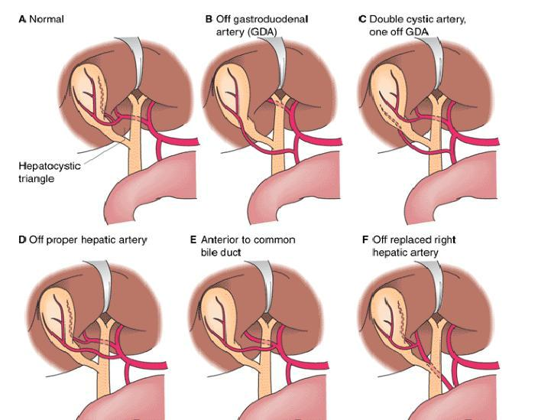

Variations in the origin and course of the cystic artery.

The hepatic artery supplies approximately 25% of the total blood flow to the liver; however, it provides up to 75% of the oxygenated blood and about 85% to 90% of the blood to the extra-hepatic biliary system. This extra-hepatic arterial system does not parallel the portal channels, although the intrahepatic system does. More than 50% of the population has the same hepatic arterial pattern.³²

The hepatic artery arises from the celiac axis and passes along the upper part of the pancreas toward the liver. Posterior and superior to the duodenum it gives off the gastroduodenal artery. Within the hepatoduodenal ligament, the hepatic artery divides into right and left branches and subsequently into smaller

branches corresponding to the portal venous system, segmental, or subsegmental anatomy. Often a third artery feeds portions of segment IV and the right lobe of the liver. Because of abundant collaterals, ligation of the hepatic artery proximal to the gastroduodenal artery fails to damage the liver. Ligation of the hepatic artery distal to the gastroduodenal artery occasionally produces hepatic necrosis. Usually, however, this does not result in serious consequences because there are also rich extrinsic collaterals to the hepatic artery beyond the gastroduodenal artery. Ligation of the right or left hepatic artery individually predictably results in marked elevation of hepatic enzyme levels but often still without severe clinical manifestations. A diffuse subcapsular arterial plexus may contribute significantly to the hepatic arterial collateral circulation, as well as supply from the celiac, superior mesenteric, and inferior phrenic artery. A recent angiographic study showed that rich collaterals can also develop in the liver‟s suspensory ligaments.³³ The most important variations of the hepatic arterial system are a right hepatic artery arising from the superior mesenteric artery and a common hepatic artery arising from a superior mesenteric trunk (“replaced” hepatic artery). Other anomalies include the left hepatic artery arising from the left gastric artery and the right hepatic artery traveling anterior rather than posterior to the portal vein. In addition, the right hepatic artery often has a curved extra-hepatic course, which may lead to inadvertent ligation during cholecystectomy. When significant hepatic arterial branches arise from the superior mesenteric artery, they usually pass behind and

to the right of the portal vein. The gallbladder receives its blood supply from the cystic artery. The cystic artery usually originates from the right hepatic artery shortly after it passes beneath the common hepatic duct. The site of origin of the cystic artery varies greatly, however. The more common variations are from an aberrant right hepatic artery, left hepatic artery, more proximal hepatic artery, gastroduodenal, or even another branch of the celiac artery. In about 10% of cases, a double cystic artery is present. In most cases, the cystic artery branches near the neck of the gallbladder. If neither a superficial or deep branch of the cystic artery is found near that point, one should suspect double cystic arteries. The blood supply of the common bile duct classically arises from the cystic artery or the posterior superior pancreaticoduodenal artery. Generally, the arterial vessels supplying the common bile duct are quite small, and easily disrupted. This characteristic, in combination with the great variation in the distribution of the arterial supply to the common bile duct and the extremely inconsistent anastomotic patterns of the vessels that supply it, probably account for the postoperative ischemic sequelae that follow extensive mobilization of long segments of the duct. Small branches from the cystic artery usually nourish the supraduodenal portion of the common bile duct. These vessels also supply the common hepatic duct and the lower part of the right hepatic duct. If ascending arterial branches from vessels supplying the lower segments of the common bile duct are not well developed, the cystic artery and occasionally the right hepatic artery will send off one or two descending branches to the first part

of the duct. The retroduodenal or second portion of the common bile duct is usually supplied by four to six branches from the posterior superior pancreaticoduodenal artery as this vessel loops around this segment of the common bile duct. One of these branches may ascend to become an accessory cystic artery. The supraduodenal branch of the gastroduodenal artery occasionally sends a tiny branch to the retroduodenal portion of the duct. Both the anterior and the posterior superior pancreaticoduodenal arteries supply the third and fourth portions of the common duct. These portions of the duct seem to have a better anastomotic arterial pattern than the first and second ductal segments. Despite the large variations in the extrinsic arterial supply of the common bile duct, there is an intrinsic arterial system that is generally consistent throughout the course of the duct. This intrinsic system is a plexus formed on the duct that provides two axial vessels, the 3 o‟clock and 9 o‟clock arteries, named for their positions relative to a cross section of the duct.³⁴

Venous Drainage

Most of the hepatic venous effluent drains into the three major hepatic veins (right, middle, and left). Each of the three has only a short extra-hepatic segment before draining into the inferior vena cava. These short extra-hepatic segments make surgical accessibility difficult, particularly for control of traumatic bleeding. The right hepatic vein, the largest of the three, provides the principal drainage for the right lobe of the liver. The main trunk of the right

hepatic vein follows an intra-segmental plane between the anterior and posterior segments. Several small veins also normally drain directly from the right lobe into the vena cava. The middle hepatic vein lies in the lobar (portal) fissure draining the medial segment of the left lobe and a portion of the anterior segment of the right lobe. The middle hepatic vein joins the left hepatic vein in 80% of dissections.³⁵ The exact site of this junction varies considerably. The left hepatic vein provides the principal venous drainage of the left lateral segment. In addition, several small veins from the caudate lobe drain inferiorly directly into the vena cava. Following thrombosis of the major hepatic veins (Budd– Chiari syndrome), these small posterior caudate veins become important in the formation of collateral drainage. Venous obstruction can also lead to varying degrees of biliary varices. There is no constant, single major venous trunk of the gallbladder. Venous return from the gallbladder occurs in multiple directions, via multiple small vessels running directly into the liver bed or toward the common duct. Venous drainage from the superior portion of the common bile duct ascends along the surface of the common duct and the hepatic and cystic ducts. It enters the liver directly rather than by joining branches of the portal vein. The venous drainage from the inferior portion of the common bile duct, however, flows into small radicals that directly enter the portal vein. The ventral surface of the common duct is marked by a constant ascending vein that can become a hindrance if bleeding from this vessel cannot be controlled during duct surgery.

Lymphatics

Hepatic lymph forms in the peri sinusoidal spaces of Disse and in the clefts of Mall to drain into larger lymphatics in the porta hepatis³⁶; this subsequently drains into the cisterna chyli and eventually into the thoracic duct. Lymphatic vessels lie near the hepatic vein in Glisson‟s capsule and around the bile ducts.

Lymphatics also pass through the diaphragm directly into the thoracic duct. Hepatic lymph nodes are found in the porta hepatis, celiac region, and near the inferior vena cava. The classic porta hepatis lymph node dissection involves a portal (posterior) as well as a celiac (anterior) dissection. Cirrhosis, veno-occlusive disease, and glycogenosis can all lead to lymph vessel dilation. Alterations in the permeability of sinusoidal epithelial cells can alter lymph flow and protein content, an observation important in the pathogenesis of ascites.³⁷ The lymphatic drainage of the gallbladder is into cystic duct nodes near the superior aspect of the cystic duct or directly into the hepatic parenchyma. Numerous lymphatics traverse the connective tissue between the gallbladder and its bed in the liver. This lymphatic (and adjacent venous) drainage accounts for the high rate of local invasion seen with gallbladder malignancies. The lymphatic drainage from the common bile duct courses superiorly and inferiorly into nodes that lie along the course of the duct and finally into a group of 6 to 10 nodes in the porta hepatis. Some lymphatic drainage from the common duct reaches the deep pancreatic group of nodes,

situated near the origin of the superior mesenteric artery, but usually the drainage reaches into the deep celiac nodal group. The drainage pattern of the extra-hepatic ductal system accounts for the need to perform a posterior and deep portal node dissection when dealing with biliary malignancies. An important degree of drainage also occurs from the ductal confluence area directly posteriorly into the caudate lobe. For that reason, several hepatobiliary surgeons advocate routine caudate lobe resection in conjunction with cholangiocarcinoma resection.

Neural Supply

The portal and pericapsular regions harbor a complex system of nerves of unknown clinical importance. An anterior neural plexus consists primarily of sympathetic fibers derived bilaterally from ganglia T7 to T10 and synapse in the celiac plexus. Fibers from the right and left vagus nerves also contribute to this plexus. The anterior plexus surrounds the hepatic arteries. A posterior plexus that intercommunicates with the anterior plexus lies around the portal vein and bile ducts. The sympathetic nerves innervate the hepatic arteries. Distension of the liver capsule or gallbladder causes pain that is referred to the right shoulder or scapula via the third and fourth cervical nerves. Interruption of the anterior neural plexus can have various physiological effects including altering the accumulation of fat in the liver and changing the lipid composition of hepatic biliary secretions.

Anatomic Changes from Gallbladder and Biliary Pathology

In addition to the pathophysiological conditions that necessitate cholecystectomy, there are multiple diseases that can lead to significant anatomic changes important for the hepatobiliary surgeon. Many of these conditions were initially thought to be contraindications to laparoscopic cholecystectomy, but as the laparoscopic surgical experience has grown, so have the indications for laparoscopic cholecystectomy. These situations include acute and chronic cholecystitis, the Mirizzi‟s syndrome, acute pancreatitis, cirrhosis, and other less frequently encountered pathological conditions. Cholecystitis, as the name suggests, is marked by acute and/or chronic forms of inflammation and fibrosing changes of the gallbladder wall. Both acute and chronic cholecystitis are notable for significant anatomic changes seen at the time of cholecystectomy. The most significant of these findings is the abundance of adhesions surrounding the gallbladder. These adhesions of the gallbladder fossa (and sometimes the entire right upper quadrant, often with omental involvement) make the surgical dissection difficult by obliterating the usually distinct tissue planes as well as making the anatomy in the all-important triangle of Calot difficult to define.^{38,39} At times these adhesions, especially in chronic cholecystitis, can lead to adherence of the gallbladder to the colon, small bowel, or even the stomach. Cholecystoenteric, cholecystocolonic, and cholecystogastric fistulas can form in these conditions and potentially lead to

the rare condition of gallstone ileus. This ileus is described as passage through a fistula of a large gallstone that would otherwise be unable to pass into the biliary tree from the gallbladder with subsequent bowel obstruction resulting from stone impaction in the distal ileum or ileocecal valve. In addition to the significance of the pathological adhesions, the friability of the gallbladder due to inflammatory changes (primarily notable in acute cholecystitis) can make retraction impossible and lead to significant incidental cholecystotomies with peritoneal soiling of bile and stones. Retraction difficulty is also seen in empyema with a gallbladder containing pus or in hydrops when the gallbladder distends with mucoid material secondary to outlet obstruction, both necessitating drainage of the gallbladder before it can be grasped for retraction.⁴⁰ The Mirizzi syndrome shows similar anatomic changes due to inflammation as those seen in acute cholecystitis, and it often presents such a difficult problem to the laparoscopic surgeon that conversion to open cholecystectomy is usually necessary. Mirizzi, an Argentinean surgeon, described this syndrome in 1948 as jaundice (and sometimes cholangitis) caused by an impacted stone in the gallbladder neck or cystic duct leading to external compression and obstruction of the common hepatic duct.⁴¹ This definition was expanded to two types in the 1980s. Type I is characterized by common hepatic duct obstruction by external compression (stone, tumor, lymphadenopathy, etc.) whereas type II is obstruction due to stone passage through a cholecystocholedochal fistula resulting from pressure necrosis between the

gallbladder or cystic duct and common hepatic duct. Both are very rare, occurring in 0.7% to 1.4% of all cholecystectomies performed, but can have a high occurrence of gallbladder carcinoma (up to 28% of cases).⁴² The nature of the condition in both types requires very close proximity of the gallbladder or cystic duct to the common hepatic duct. This proximity, in combination with the significant inflammatory changes in the triangle of Calot intrinsic to the syndrome, makes anatomic differentiation of the ducts difficult during surgical dissection.⁴³ Pancreatitis is also known to create anatomic changes affecting the ability to perform laparoscopic cholecystectomy. The most notable anatomic changes do not involve the gallbladder itself but may distort the anatomy of surrounding structures instead.⁴⁴ The intense retroperitoneal inflammation and edema that can accompany pancreatitis can have a mass effect on adjacent structures, leading to widening of the duodenal C loop, anterior displacement of the stomach, and duodenal mucosal thickening. These changes in addition to possible intra-peritoneal inflammation or fluid collections can make adequate exposure of the gallbladder fossa and Calot‟s triangle difficult.⁴⁵ Cirrhosis and its anatomic changes may not directly affect the gallbladder but can make the surgical approach difficult. Associated portal hypertension can lead to the formation of varices leading to difficulty with exposure. Among these varices is the umbilical vein, which is open to create collaterals from the left portal vein to the epigastric vessels (caput medusa), and therefore presents a direct obstruction between the umbilical trocar site and the gallbladder during laparoscopic

cholecystectomy.⁴⁶ The bleeding potential of these and other varices as well as from the gallbladder fossa is the most frequent intraoperative complication during cholecystectomy in cirrhotics. The bleeding risk is further potentiated by the coagulopathy characteristic of the protein synthesis dysfunction caused by the hepatocellular failure of cirrhosis.⁴⁷ Another anatomic change caused by the abnormal fibrosis and hepatocellular regeneration found in cirrhosis is the rigidity of the liver, making retraction of the gallbladder and surrounding tissue exceedingly difficult. Other less common pathophysiological changes of the gallbladder can cause difficulty during cholecystectomy as well. Examples of these conditions include gallbladder diverticula and adenomyomatosis of the gallbladder. Diverticular disease of the gallbladder, similar to that of the colon, includes true and false diverticula. This complication can lead to trouble during resection caused by chronic scarring of the diverticulae to surrounding structures or even intrahepatic diverticulae, necessitating a subtotal cholecystectomy to avoid significant hepatic injury or bleeding.⁴⁸

Adenomyomatosis also leads to similar changes of scarring or intrahepatic extensions, making cholecystectomy challenging. It is an acquired disease characterized by localized or diffuse extensions of gallbladder mucosa into, and often beyond, the muscular layer of the wall. Invaginations of the epithelium externally lead to Rokitansky–Aschoff sinuses, also seen in diverticular disease of the gallbladder. Adenomyomatosis has a known increase in occurrence of

gallbladder carcinoma⁴⁶ whereas no such relationship is noted with diverticular disease.

The detailed discussion of the anatomy as above, of the anatomy of the hepatobiliary tree including its anatomic variations, is extremely important for any biliary surgery either by open or laparoscopic method. It is all the more important to keep in mind when the operation is being performed by Gasless technique because the retraction, exposure etc is to some extent compromised and the role of the “ Well Thought of ” laparoscopic surgeon is all the more important.

AIMS AND OBJECTIVES

AIMS AND OBJECTIVES

AIMS:
The AIMS OF THIS STUDY is to compare the use of the low pressure pneumoperitoneum (defined as 7-10 mm Hg) with the use of standard pressure pneumoperitoneum (defined as 12-16 mm Hg) in patients undergoing laparoscopic choleczystectomy in a prospective randomized manner.

OBJECTIVES
Pneumoperitoneum related changes in standard pressure laparoscopic cholecystectomy is somehow inadvertent. Our objective is to reduce this changes by using newer mode of laparoscopic cholecystectomy i.e. low pressure laparoscopic cholecystectomy.

MY SPECIFIC OBJECTIVES ARE
To compare the operative time
To compare the intraoperative haemodynamic stability
To compare pulmonary changes
To compare the post-operative pain
To compare Incidence of Shoulder pain
To compare incidence of post op. nausea vomiting
To compare the post-operative morbidity
To compare the length of hospital stay

MATERIALS AND METHODS

MATERIALS AND METHODS

STUDY AREA : R. G. Kar Medical College And Hospital, Department of General Surgery.

STUDY POPULATION: Patients coming to OPD of Dept. of Surgery RGKMCH.

STUDY PERIOD : January 2014 –June 2015

SAMPLE SIZE :For calculation of sample size for this randomized control trial
$n=\frac{{\left(Zα+Zβ\right)}^{2}×2×S^{2}}{e^{2}}$ this equation will be used.
where Zα=standard normal deviate, value of which at 95% confidence level will be 1.96
Zβ=power of the test , considering power of the test 80% , value will be 0.84
S= pooled variance
e= Minimum clinically difference between two groups in the outcome of our concern.
Considering pains score at 12 hrs as the outcome of our concern , minimum clinically difference will be 8.
From previous study standard deviation at 12 hrs in two groups of patint where 8.5( low pressure group) and 12(standard pressure group) .
pooled varience will be = $\frac{{S_{1}}^{2}\left(n_{1}-1\right)+{S_{2}}^{2}\left(n_{2}-1\right)}{\left(n_{1}+n_{2}-2\right)}$ $n_{1}$& $n_{2}$ is the sample size of two groups of previous study.
$\frac{{8.5}^{2}\left(30-1\right)+{12}^{2}\left(30-1\right)}{\left(30+30-2\right)}$
=108.125
calculates sample size of this study will be
$$n=\frac{{\left(1.96+0.84\right)}^{2}×2×{108.125}^{2}}{8^{2}}$$

=26
so the sample size will be minimum 26 in each group
total sample size 26$×2$=52
SAMPLE DESIGN :

For allotment of study subjects in study and control arm sealed envelop technique will be used.

INCLUSION AND EXCLUSION CRITERIA

INCLUSION:
a. Cardio-respiratory compromised patients
b. ASA Grade I To III
c. Weight less than 70 Kg.BMI <25
d. Cholelithiasis with or without cholecystitis

EXCLUSION:
a. Weight >70 Kg./ BMI >25
b. ASA Grade more than III
c. Cases of acute cholecystitis
d. Acute cholecystitis
e. Choledocholithiasas
f. Mucocele or empyema of Gall Bladder
g. Prior surgery with incision through the umbilicus
h. Mental illness, dementia, or inability to provide informed consent
i. Pregnancy
j. Jaundice
k. Malnutrition

STUDY DESIGN : Randomized controlled study
STUDY TOOLS :
a. Pretested and predesigned proforma
b. Assessment of severity of pain on the basis of visual analogue scale (VAS).

STUDY TECHNIQUE : Thorough history taking (Rt. Hypochondrium pain with back radiation, nausea, vomiting ,fever) and clinical examination (Rt. Hypochondriac tenderness, muscle guarding and rigidity at Rt. Hypochondrium , Murphy‟s sign etc) will be done. Detailed cardio-vascular and respiratory system examination. After operation specimen will be sent for histopathological examination. The indoor patients admitted for laparoscopic cholecystectomy were included in this study. Informed consent was taken from the sample group after explanation and before inclusion into the study. Then after interviewing the patient a predesigned pretested schedule as given in the annexure was filled in.

CONTROL: Conventional Laparoscopic Cholesystectomy patients.

CASES: The cases were chosen randomly for the study but most of the patients are ASA grade II.

METHODS OF DATA COLLECTION: Data will be collected pre-operatively, during operationl, post operatively and at follow up at OPD for 3 months

PARAMETERS TO BE STUDIED:

Data will be collected with regards to the following parameters:
Pre-operative:
1. Thorough history taking and clinical examinations.
2. pre operative cardio-respiratory co-morbidities-
a. high blood pressure
b. uncontrolled diabetes
c. Ischaemic heart disease ,COPD etc.
Intra-operative
Operative time: starting from time of incision to time of closure in minutes.
Conversion rate:conversion into standard laparoscopic procedure from low pressure
Visceral or vascular injury - defined as injury to the CBD, Liver, Duodenum,Stomach,mesentery, rest parts of small intestine, colon, omentum, vasculature during the dissection requiring intervention (suture or stapled repair, use of hemostatic agents).
Intra operative cardito-respiratory stability monitoring by measuring the following parameters before incision, after 20 minutes intra operatively and before reversal from GA -
a. pulse
b. non invasive blood pressure(NIBP) MAP
c. central venous pressure (if required)
d. end tidal CO2 monitoring
e. arterial blood gas analysis (if required)
f. Oxygen saturation
Post-operative:
Post operative cardio-respiratory stability monitoring by measuring the following parameters at 2 hrs post operatively -
a. pulse
b. blood pressure MAP
c. respiratory rate
d. central venous pressure (if required)
e. arterial blood gas analysis (if required)
g. oxygen saturation(In percentage)
Post operative nausea and vomiting after 2 hrs

post operative pain score by using the Visual analogue scale -
a. 6 hrs post operatively
b. 12 hrs post operatively
c. 24 hrs post operatively
post operative recovery and hospital stay( in days)

wound infection

Post operative Return to normal activity in days.

PLAN FOR DATA ANALYSIS: This is a prospective single centred comparative study. All the above mentioned parameters will be compared in each groups after removing the bias. Differences between gasless and conventional laparoscopic procedures with regards to technical difficulties, post operative course and convalescence with respect to socio-demographic, co-morbidity and other predictor variables will be tested using t-test, X² tests and analysis of variance.

Procedure of standard pressure laparoscopic cholecystectomy

Before going into the detailed procedure of laparoscopic cholecystectomy we need to know the indications and contraindications of the laparoscopic cholecystectomy .

The indications for laparoscopic cholecystectomy are the same as for the open method, that being “Symptomatic cholelithiasis”.

A.Indications:

- Symptomatic gallstones

- Resolved biliary pancreatitis 3.Acalculus cholecystitis

4. Biliary colic

5.Gall bladder polyp

6.Chronic cholecystitis

B. Absolute contraindication:

1.Uncorrectable coagulopathy

2.Frozen abdomen from adhesion

3.Severe cardiac dysfunction

4.Concomitant disease requiring laparotomy

C. Relative contraindication:

1.Morbid obesity

2.Prior upper abdominal surgery

3.Pregnancy

4.Chronic obstructive airway disease

D. Preoperative preparation:

a> This is the key to the success of laparoscopic cholecystectomy. A

complete history and physical examination need to be done, any co-morbid 49

factor/disease to be identified that may have an adverse affect on the outcome of laparoscopic cholecystectomy. History of previous pancreatitis, jaundice must be documented. Routine blood counts, urine analysis, coagulation profile and liver function tests need to be checked. Ultrasound (USG) of the gall bladder and biliary structures should be obtained. Wall thickness of GB must be noted, single /multiple stones and CBD diameter should be noted.

USG indicators for possible operative difficulty include the following:

1.Gallbladder wall thickness >3mm.

2.A stone stuck in the Hartmann‟s pouch close to the bile duct

3.Large gall stone

4.Intrahepatic gall bladder

5.Gall bladder packed with stones

Prophylactic antibiotic 2nd generation cephalosporin cefuroxime 1.5 gm. given just at the time of induction of anaesthesia

- Informed consent.

- Equipments:

A. Video equipments: -

Telescope

Light transmission cable

Video camera

Processing unit

Light source

High resolution monitor

Instruments used for the study

- The conventional laparoscopic instruments are used which are

  - The gas insufflator which supplies the gas –CO2 for pneumoperitoneum.

  - Home made Abdominal Wall Lifter (AWL) which lifts the anterior abdominal wall to create space for work.

  - Trocars and ports - 10mm and 5 mm all are made up of stainless steel and re-usable .

  - Grasper – toothed and non-toothed

  - Maryland forceps

  - Hook used for dissection and coagulation

  - Spatula and ball-used to coagulate the GB fossa

- Gall bladder retrieving forceps

- Stone removal forceps

- Energy sourse- monopolar diathermy sometimes harmonic scalpel used

- Liver fan retractor

- Suction cannula

- Clip applicator

- Titanium clips

C . Open instruments- Ryle‟s tube no 16 Fr.

Towel clips Needle holder

Tooth and non tooth forceps forceps Scissor

Allis tissue holding forceps

G. The Operation: the operation performed under general naesthesia with endotracheal intubation.

Premedication with glycopyrrolate (0.2mg/kg) , midazolam (0.02mg/kg) , fentanyl (2 µg/kg)

Induction with propofol (2 mg/kg) and succinylcholine hydrochloride (1.5mg/kg)

Maintenance with halothane and a mixture of 60-70% nitrous oxide and 30-40% oxygen

Preparation and Positioning: Supine position with head end up (Reverse Trendelenberg) and left lateral tilt after Pneumoperitoneum

Anti septic skin preparation with 10% povidone iodine solution and draping.
NG tube to decompress the stomach when distended

Equipment tables and trolleys are placed in position and all device cables and tubing are routed properly on the right of the patient.

Creating Pneumoperitoneum:

Two techniques, blind and open, are there to create pneumoperitoneum. In blind
technique, a spring loaded Veress needle with a protective blunt tip is inserted
through a small incision made at the umbilicus. The anterior abdominal wall is
elevated during this procedure. Confirmation of the intraperitoneal location of
needle tip is made by the saline drop test. CO2 is then insufflated,
pneumoperitoneum is established and Veress needle is removed. The Veress
needle when inserted blindly may penetrate the bowel, bladder, mesentery,
retroperitoneal tissues and great vessels⁴⁹. In order to avoid these
complications, many surgeons prefer open method of establishing
pneumoperitoneum ,whereby an incision is made of about 1-1.5cm at the lower
margin of the umbilicus and stay sutures are placed on the fascia. Thereafter,

linea alba along with posterior fused peritoneum is incised under direct vision and Hasan‟s cannula with its blunt tipped obturator and external movable core

is inserted while gentle traction is applied to the stay sutures⁵⁰. The external cone part is secured in position on the sheath and the stay sutures are tied to

pleats on either side of the cannula, which prevents leakage of carbon dioxide and loss of pneumoperitoneum.In our hospital we create pneumoperitoneum using Hasan‟s cannula with Proper safety precautions and we have not come across any complications with its use.

After establishing the umbilical port, carbon dioxide is insufflated and

telescope is introduced through this cannula whereby the liver is inspected taking into account the state of the gall bladder. The falciform ligament and left lobe of the liver is then inspected and under direct vision through the laparoscope a second 10mm port is made is the epigastric region below the
xiphisternum, to the right of the falciform ligament. A 5mm port is then made under direct vision in the midclavicular line just below the right costal margin, while doing so the trocar and cannula are watched carefully as they come through the peritoneum. The last 5mm port is placed laterally in the anterior axillary line. This is again done under direct vision with the port aiming

towards the fundus of the gall bladder.After the insertion of secondary ports, gall bladder is grasped by using grasping forcep through the fourth port in the region of fundus and elevated. Calot‟s triangle is displayed by pushing the fundus of the gall bladder upwards and laterally.

Dissection of the Calot’s triangle:

Dissection of the Calot‟s triangle is the most important part of the Operation and should be proceeded meticulously. If there are any adhesion encountered, it should be pulled down by the blunt dissection. Scissors and diathermy use should be kept to the minimum and while using one must remain as close to the gallbladder as possible in order to prevent inadvertent injury to the vital structures present in the hepatoduodenal ligament. Once the adhesions are separated, the area of Calot‟s triangle becomes clearly defined. The peritoneum overlying the Calot‟s triangle is opened by using the scissor /blunt dissection and sweeped medially, whereby cystic duct gradually becomes apparent. The cystic duct is dissected out meticulously and secured close to the neck of the gall bladder with a clip. Next the cystic artery is identified and dissected out by blunt dissection and thereby once identified, it is clipped and divided. We usually perform posterior dissection first at the level of Hartmann‟s Pouch keeping close to the gall bladder and we find this relatively safe and secure way of encountering the cystic duct. Once the cystic duct and artery are clipped and

divided, the gallbladder is dissected off the liver bed using diathermy hook or spatula and the dissection is done in and orthograde fashion (neck to fundus).Once the gall bladder is separated upto the level of the fundus, it is not completely removed from its liver bed. While leaving the fundus attached the gall bladder fossa is carefully inspected for any evidence of bleeding or accessory bile ducts. Using irrigation and suction the liver bed is closely scrutinized; cystic artery and duct stump are also inspected to ensure the position of the clips. The gall bladder is then completely detached from the liver bed and placed above the liver held on a grasper. After checking the haemostasis and aspirating all fluids , the gall bladder is retrieved through the umbilical port.

If gall bladder is tense it is opened up once the neck is brought out on to the surface and decompressed by using the sucker, if the stone is too big ,the incision can be enlarged before delivering the gall bladder. Endobag is used for retrieval as and when necessary. Once the gall bladder has been removed the peritoneal cavity and the gallbladder fossa is inspected once again.

The ports are removed under vision to ensure no bleeding. The table is straightened and the gas is expelled out of the peritoneal cavity. The fascia at the umbilical port is closed under direct vision using port vicryl and all the skin wounds are subsequently closed. The patient is taken to the recovery room

after extubation. Gall bladder is opened and stones removed and the specimen is sent for histopathological examination.

Postoperatively the patient is allowed to take liquids in the same evening or in the next morning according to the operative findings. They are allowed out of the bed as soon as they are fit enough to walk and are discharged when they are fit. They are evaluated one week following surgery and if sutures are present, they are removed.

Laparoscopic surgery has several advantages over open surgery like smaller incisions, more tolerable postoperative period, shorter hospitalization and early return to work. Hence laparoscopic cholecystectomy has largely replaced open cholecystectomy and it is now the gold standard . In comparison to open surgery post operative pain is also reduced in laparoscopic surgery. However the pain is not completely abolished by laparoscopic surgery. In addition shoulder tip pain, backache, nausea and vomiting due to residual pneumoperitoneum are absent in conventional open cholecystectomy.

Procedure of lowp ressure laparoscopic cholecystectomy :

All the operative procedures are same exceptVeress needle will be used for insufflation of the abdomen to a pressure of 14 mm of Hg and primary cannulation will be parformed.After placement of all 4 cannulae,pressure will be reduced to 7-10 mm of HgNG tube to decompress the stomach regularly done. Now the remaining part of the operation is same as conventional laparoscopic cholecystectomy.

All the patients received second generation cephalosporin Cefuroxime 1.5 gm IV 2 doses if the intra operative findings were standard but those who had empyema GB were given 2 doses of IV Cefuroxime 1.5 gm for 2 days along with IV Metronidazole 500 mg thrice daily for two days. Injection Tramadol hydrochloride 100 mg IM three times for the first 24 hrs, injection Ondensatron 4 mg IV only when needed, injection Ranitidine hydrochloride 50 mg iv two doses for the first 24 hrs.

Measurements of pain- The pain measured 6hrs, 12 hrs and 24 hrs after operation. There are various methods of measuring the pain post operatively which are as follows-

Visual Analogue Scale (VAS) score

Numerical rating scale (NRS)

Faces rating scale (FRS)

Behavioural rating scale

Functional activity score

Subjective pain score

Visual Analogue Scale (VAS) score

The visual analogue scale(VAS)⁵¹ uses a straight line with extremities of pain intensity on either end. The line is typically 10 cm long with one end defined as

“no pain” and the other end being “excruciating unbearable pain”. The line can be either vertical or horizontal. The patients are asked to place a mark on the line to describe the amount of pain that they are currently experiencing. The distance between the end labelled “no pain” and the mark placed by the patient is measured and rounded to the nearest centimetre. To assist in describing the intensity of pain, words can be placed along the scale (e.g., mild, moderate, or severe) and the patient needs to be explained by the clinician when using VAS. Below two figures are the various presentation of the VAS score.

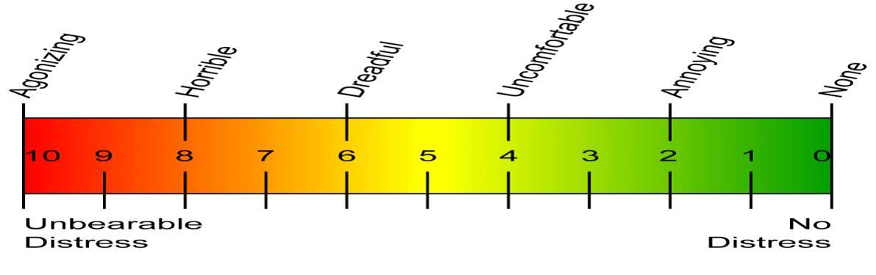
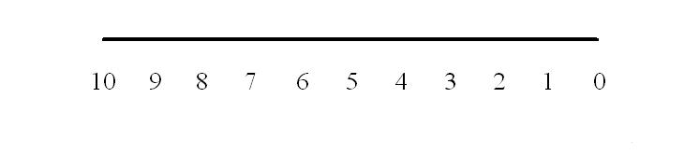

Pneumoperitoneum(PP)⁵²: To perform laparoscopic procedures the abdominal cavity is inflated with gas to create the pneumoperitoneum.

Laparoscopy is endoscopic visualization of the peritoneal cavity usually assisted by a pneumoperitoneum that distends and separates the abdominal wall from its contents. Visual clarity, space to perform diagnostic and therapeutic procedures and maintenance of a normal physiologic state is required for safe effective surgery.

Gases used for pneumoperitoneum include carbon dioxide (CO2), air, oxygen, nitrous oxide (N ₂O), argon, helium and mixtures of these gases.

CO2 gas insufflation is preferred by most laparoscopists because it has a high diffusion coefficient and is a normal metabolic end product rapidly cleared from the body. Also, CO2 is highly soluble in blood and tissues and does not support combustion.

The risk of gas embolism is lowest with CO2. Cardiac arrhythmias can occur with CO2 pneumoperitoneum because of possible CO2 induced hypercarbia, N

₂O may be preferred in patients with cardiac disease. With prolonged procedures, CO2 retention is possible as evidenced by tachycardia and acidosis.

Pneumoperitoneum is usually initiated by use of a needle ( Veress or Tuohy) or trocar device to transverse the abdominal wall and distend the peritoneal cavity.

After peritoneal access, a gas delivery system is used to inflate and maintain the abdominal distension. Preset pressures of 15 mm Hg or less are safest to maintain pneumoperitoneum and allow performance of laparoscopic techniques. Intra-abdominal pressures in excess of 25 mm Hg are associated with increased airway pressure, increased intra-thoracic pressure, increased femoral venous pressure and signs of cardiovascular stimulation with tachycardia and hypertension.

The systemic and physiological changes associated with the PP

Physiological effect:

- Mechanical

- Metabolic

Systems affected-

- Cardiovascular

- Respiratory

- Renal

- Gastro intestinal

- Peripheral vascular

- Endocrine system

- Hematologic effect

  - Immunogenic effects

  - Psychogenic effects

- Cardio vascular effects⁵³

Cardiac morbidity is a major cause of perioperative death. The realization that,

in high risk populations, perioperative myocardial ischemia is most likely to

occur after surgery (from day one to day three postoperatively) has led to

treatment strategies designed to prevent its development. Although a variety of factors may contribute to the development of postoperative myocardial

ischemia, including hypothermia, anemia, anxiety, and tracheal intubation / suctioning, responses to poorly controlled pain play a prominent role. In this

regard, activation of sympathoadrenal, and neuroendocrine axes may have a

major impact on myocardial oxygen supply and demand. Catecholamine-induced tachycardia, enhanced contractility, increased afterload and increased

preload from hypervolemia caused by enhanced release of arginine |  |  |  | vasopressin
and aldosterone, are well characterized determinants |  |  | of increased oxygen
demand. Increased | oxygen | demand, with hypervolemia, may precipitate
ischemia and acute | cardiac | failure, especially in | patients | with poorly

compensated coronary artery or valvular heart disease. Myocardial oxygen supply may be diminished as a result of pulmonary dysfunction, in particular,

atelectasis secondary to pain-induced hypoventilation and pulmonary edema resulting from stress-induced hypervolemia. Other causes of reduced oxygen supply include coronary artery constriction secondary to high

circulatory levels of catecholamine and increased coronary sympathetic tone, stress induced increase in plasma viscosity and platelet-induced occlusion; and serotonin induced coronary vasospasm secondary to platelet aggregation.

2. Respiratory effects ⁵⁴⁻⁵⁹ :

The increase in intra-abdominal pressure caused by pneumoperitoneum also affects the pulmonary system by impeding diaphragmatic movement, leading to a decrease in the functional residual capacity (FRC) of the lung. Compliance is also decreased, mostly as a result of a cephalad displacement of the diaphragm and the chest wall. This disturbance in compliance is immediately reversible on abdominal

deflation.⁵⁴ Airway pressures increase during CO₂ pneumoperitoneum because of

decreased compliance and the need to increase minute ventilation to excrete the increased CO₂ load absorbed from the peritoneal cavity. Hasukic and colleagues

measured pulmonary function tests in postoperative patients who underwent

laparoscopic cholecystectomy.⁵⁵ Pulmonary function tests demonstrated a decrease in forced expiratory volume in 1 second (FEV₁) and forced vital capacity

(FVC). Increasing pneumoperitoneum also causes an increase in alveolar dead

space, leading to potential hypoxemia.⁵⁷ This leads to ventilator-perfusion mismatching and intrapulmonary shunting. The risk of hypoxemia is counteracted by controlled mechanical ventilation during laparoscopic surgery with increased tidal volumes and the addition of positive end-expiratory pressure (PEEP). CO₂ is

the most common gas used to obtain pneumoperitoneum during laparoscopic surgery. It is absorbed into the bloodstream, where it is finally excreted by the lungs. Most of the CO₂ combines with water found in the red blood cells to form

carbonic acid. Carbonic acid further breaks down into hydrogen, which is carried by hemoglobin, and bicarbonate, which diffuses into the plasma. A small amount of CO₂ does get dissolved directly in the bloodstream and is transported to the

lungs for excretion.⁵⁸ Subcutaneous emphysema is a frequent occurrence and is commonly caused by leakage around an abdominal insufflating port. Extensive subcutaneous emphysema can be associated with significant respiratory acidosis,

necessitating prolonged postoperative ventilation.⁵⁹

3. Renal effects⁶⁰

Due to the increased intra abdominal pressure there is decreased - a.Effective renal plasma flow and decreased GFR leading to

decreased urinary output.

- Long term effect does not occur in GFR

- No change in creatinine or BUN

4. Gastrointesinal effects:

Due to the increased intra abdominal pressure there is decreased -

a. Mesenteric and celiac flow- decreased intestinal and gastric flow leading to decreased intestinal and gastric pH.

b. Decreased portal and hepatic artery flow leading to decreased hepatic perfusion and ultimately increased liver enzymes.

Sympathetic hyperactivity induced by pain increases sphincter tone and decrease motility of intestine, causing ileus, pain also increases stress ulceration due to increase in gastric acid secretion.

5. Peripheral vascular effect:

Due to the increased intra abdominal pressure there is decreased venous return and venous stasis leading to more chances of DVT

6. Endocrinal effects⁶¹:

The dominant neuroendocrine responses to pain involve Hypothalamo- pitutary- adrenocortical interactions. Those interactions result in increased catecholamine and catabolic hormone release. This effects causes sodium and water retention, and increased levels of blood glucose, free fatty

acids and lactate. The negative nitrogen balance and protein catabolism may impede patient‟s convalescence.

7. Hematological effects:

The stress response causes decrease in the levels of natural anticoagulants

,inhibition of fibrinolysis and increase in platelet reactivity which initiate a postoperative hypercoagulable state. This hypercoagulability causes a series of other events such as deep venous thrombosis and myocardial ischemia¹².

8. Immunological effects⁶²:

The stress response potentiate postoperative immunosuppression; the extent of which correlates with the extent of surgery. Stress response has been reported to depress the reticulo-endothelial system which predispose to infection.

9. Psychogenic effects:

Intense anxiety, fear, and the loss of control that accompany severe tissue injury may have profound impact on the hypothalamic-pituitary axis. Behavioural responses associated with poorly controlled pain include sleep deprivation and reduced morale. In many patients, uncontrolled postoperative pain can produce

a series of long term emotional disturbances, which could impair the patient‟s health, and cause undue fear and anxiety if subsequent surgery is required. Postoperative cognitive dysfunction occurs in up to 20% of patients after major non-cardiac surgery and may persist in about 10% of patients 3 months after surgery.

REVIEW OF LITERATURE:

REVIEW OF LITERATURE:

- Historical review of gallbladder diseases

In the ancient literature of Vedic period from 3000 to 1000 BC, „Pittam‟ (Bile?) had been mentioned as one of the three principal constituents of the body.

Charaka described „Pittam‟ as moist, sharp in action, sour pungent liquid having a fishy smell and was transformed into acid when deranged. Sushruta 800- 600

BC thought „Chyle‟ (bile) produces blood, from blood is formed flesh, from flesh originates marrow, which in turn germinates semen (Prakash, 1978).⁶³ Sir Gordon Taylor (1937) reported the findings of small calculi in the gallbladder of mummy of the Priestess of Amenon dynasty who flourished at about 1300 BC. Galen (130 –200 AD) assumed yellow bile to be one of the conversion products of absorbed food material and believed that it was expelled to the gallbladder.

„Alexander of Tralle‟ (500 AD), the Greek physician referred to gallstones as dried up tumors.⁶⁴ In 1500 Paracelsus preached that gallstones were due to impurities in the system. Realdus Columbus (1559) in his De- Re- Anatomica made references about gallstone and jaundice. Fallopius (1562) recorded stones in gallbladder and common bile duct. Marcellas Donatus (1566) also recorded gallstone. Benivienne of Florence at the end of 15th –century had made specified comments on gallstones in human.⁶⁵ Vasalius in the 16th century noted a patient with jaundice dying of gallbladder abscess. The honor of the first autopsy finding of all stones went to Bartelomen da Varignana at Belonga in 1302

(Rains, 1962).⁶⁶ Present knowledge about the composition of gallstones dates from 1770 when Poulletin de la Salle discovered a substance which was later named by Chevreul in 1816 as cholesterine. In 1731 Nitsch described that gallstone originated from inspissated bile. Petit (1743) remarked on gallstones as tumour formed by bile and retained in the gallbladder. Cho (1757) said that stagnating bile leads to the formation of gallstones. Virchow (1857) was one of the first to describe the presence of lipoid material in the epithelium of a gallbladder obtained at post-mortem examination. Frerichs (1858) stated that precipitates of a substance held in solution in the bile when unable to pass out of the gallbladder due to its catarrh, were retained for a long- time and formed concretions. Naunyn in 1860 stressed on stasis and infection on the causation of gallstones. Thudicum (1863) described gallstones as products of decomposed bile. Naunyn (1896) reported that there was a marked concentration of cholesterol esters in the bile of many patients with calculus cholecystitis. In 1905 Lord Moynihan remarked that gallstones are tomb stones erected to the memory of the organisms within it. In 1909, he gave a vivid description of the macroscopic appearance of the disease (for which he advocated cholecystectomy). Aschoff (1909) thought that stasis and hypercholesterolemia were responsible for gallstones.⁶⁷ Mc Carty (1910) was first to use the term strawberry gallbladder. It was in 1914 when Lichwitz incriminated the physiochemical phenomenon for the formation of gallstones. Rosenew in 1921 emphasised on the elective affinity of streptococci for specific tissues to explain

the formation of gallstones and appendicitis. Mentzol in 1925 was the first to make use of the term cholesterosis. Sterling in 1936 presented the theory in which agglutination reaction was the trigger mechanism compounding alteration in the bile salt, cholesterol and lecithin ratios in the causation of gallstones.⁶⁸

Thus, slowly but steadily the fundamental concept about the formation of gallstones developed. They were inflammation, stasis and metabolic alterations.

It was in 1897 when Gilbert Fournier and Paul Oudin first undertook the radiological study of gallstones. Graham and Cole in 1924 are credited for finding the technique of oral cholecystography. Intravenous cholangiography was recorded in the Second World War. Mirizzi‟s (1932-33) first performed postoperative cholangiography. Hulson (1938) conducted preoperative cholangiography.⁶⁹ Hurt and Townshed in 1948 explained the value of preoperative cholangiography in the exploration of the common bile duct.⁷⁰

Surgery of the gallbladder was first recorded in the 17th- century. In 1667

Michael Entmuller historically stated, “there are no medicines that will cure gallstones”. Wilhelm Fabry also known as Fabricius Hidances in 1618 removed gallstones by incising a man‟s parietal abscess. Vendor Weil in 1667 also removed stones while operating abdominal abscess. In 1670 Thilesius recorded a case of spontaneous discharge of stones over a period of nine years following an abscess and biliary fistula in the abdominal wall. Zamboccari in 1680 successfully performed cholecystectomy on a dog. This work was followed by

Tech (1700) on many dogs. Jean Luis Petit first suggested in 1713 that operation should be undertaken when death threatened from impacted gallstone. Bobbs of Indianapolis in 1867 performed the first unplanned cholecystectomy under the mistaken diagnosis that he was opening an ovarian cyst.⁷¹ Lawson Tait in 1879 performed a premedicated and successful cholecystectomy. Regarding this pioneer work of Tait, Oschner (1960) said, “Lawson Tait in 1879 performed the first successful operation of cholecystectomy and to me, Tait, more than any other surgeon of the period, is due to the credit of planning biliary surgery on a firm basis”.

William S. Halstead (1881) in the middle of the night performed a spectacular feat by operating on his mother single handedly and removed a quantity of gall stones from the much inflamed gallbladder. This has prolonged her life by another two years. Carl Johann Langenbuch on 15th July1882 performed the first planned and successful cholecystectomy. This pioneer work was followed by Ivanuyan 1882, Courvoisier (1890) and Boyson Rovsings (1900).⁷²

The surgeons of the past also found that cholecystectomy alone failed to cure many patients with gallbladder disease. Some more additional procedures were required. Langenbuch in 1884 first suggested cholecystostomy. Knowshy Thornton in 1889 performed the first successful planned operation of choledochotomy. Abba in 1889 is credited for doing first successful choledocholithotomy. Penrose drains were put to avoid the dangerous

consequences of bile leakage. It was Kehr (1909) who devised the T- tube and claimed its use mandatory for any operation on bile duct. Kehr also defined the indication of exploring the common bile duct.⁷³

Thus the historical review demonstrates gradual evolution of operating approaches towards cholecystitis - cholecystectomy, cholecystostomy and choledocholithotomy.

- Gall bladder surgery history especially the LPLC:

Cholecystectomy is the most common major abdominal surgical procedure performed in western countries. In United States more than 600000 cholecystectomy is performed annually. Carl Langenbuch performed the first successful cholecystectomy in 1882, and for > 100 years it was the treatment of choice for the symptomatic gall bladder stones. However the prevailing public perception of this operation as one that resulted in pain, disability and disfiguring scar engendered many attempts over the past two decades at non operative treatments of gall stones. Open cholecystectomy was safe and effective treatment for acute and chronic cholecystitis⁷⁴.

Mini-cholecystectomy⁷⁵ was first described more than two decades ago by Dubois and Berthelot and their favourable results were reported at the same time Laparoscopic cholecystectomy was introduced in 1990. Mini-cholecystectomy implies performing a cholecystectomy through 4−6 Cm

incision subcostal rectus sparing incision. But this method has not gained popularity due to the simultaneously introduction of laparoscopic cholecystectomy .

M. Barczyński et al⁷⁶ performed a prospective randomized trial on comparison of low-pressure (LP) and standard-pressure (SP) pneumoperitoneum for laparoscopic cholecystectomy in 2003. This study aimed to investigate the advantages and disadvantages of LP (7 mmHg) in comparison to SP (12 mm Hg) pneumoperitoneum in a prospective randomized clinical trial. 148 consecutive patients qualified for laparoscopic cholecystectomy (LC) due to uncomplicated symptomatic gallstones were randomized to either SPLC or LPLC. All the procedures were performed by the same experienced team of surgeons. The statistical analysis included sex, mean age, body mass index, ASA grade, operative time, complication rate, conversion rate, postoperative pain assessed by the Visual Analogue Scale of Pain (VAS) including the incidence of shoulder-tip pain, postoperative hospital stay, recovery time, and the quality of life (QOL) within 7 days following the operation. p <0.05 was considered as indicative of significance. Neither conversion to an open procedure nor major complications occurred in either group. The operative time was similar in both groups (LP 55.7 ± 8.6 min vs SP 51.9 ± 8.3 min). The mean postoperative pain score was 6.18 ± 3.48 lower after LP than SPLC and the difference amounted to 22.2% (p <0.005). The incidence of shoulder-tip pain was 2.1 times lower after LP than SPLC (p <0.05). QOL within 7 days following the operation was remarkably better after LPLC than after SPLC (p <0.01). LP pneumoperitoneum is superior to SP pneumoperitoneum in terms of lower postoperative pain, a lower incidence of shoulder-tip pain, and a better QOL within 5 days following the operation. LP should be used for LC in cases of uncomplicated symptomatic gallstones as a recommended procedure as long as an adequate exposure is obtained with this technique.

Trichak Sandhu et al⁷⁷ performed a prospective randomized clinical trial on low-pressure pneumoperitoneum versus standard pneumoperitoneum in laparoscopic cholecystectomy.They f ound that the characteristics of the patients were similar in the two groups except for the predominance of males in the standard-pressure group (controls). The procedure was successful in 68 of 70 patients in the low-pressure group compared with in 70 patients in the standard group. Operative time, number of analgesic injections, visual analogue score, and length of postoperative days were similar in both groups. Incidence of shoulder tip pain was higher in the standard-pressure group, but not statistically significantly so (27.9% versus 44.3%) (p = 0.100).Low-pressure pneumoperitoneum tended to be better than standard-pressure pneumoperitoneum in terms of lower incidence of shoulder tip pain, but this difference did not reach statistical significance following elective laparoscopic cholecystectomy.

S. P. L. Dexter et al⁷⁸ performed a randomised control trial comparing hemodynamic consequences of high- and low-pressure capnoperitoneum during laparoscopic cholecystectomy. Twenty patients were randomized to either high- or low-pressure capnoperitoneum. Anesthesia was standardized, and the end-tidal CO₂ was maintained at 4.5 kPa. Arterial blood pressure was measured invasively. Heart rate, stroke volume, and cardiac output were measured by transesophageal doppler. There were 10 patients in each group. In the high-pressure group, heart rate (HR) and mean arterial blood pressure (MABP) increased during insufflation. Stroke volume (SV) and cardiac output were depressed by a maximum of 26% and 28% (SV 0.1 > p > 0.05, cardiac output p > 0.1). In the low-pressure group, insufflation produced a rise in MABP and a peak rise in both stroke volume and cardiac output of 10% and 28%, respectively (p < 0.05).Low-pressure pneumoperitoneum is feasible for LC and minimizes the adverse hemodynamic effects of peritoneal insufflation.

Wallace et al⁷⁹ perfomed randomized trial of different insufflation pressures for laparoscopic cholecystectomy which was published in British Journal of Surgery, Volume 84, Number 4, 1 April 1997, pp. 455-458(4). Forty patients with similar preoperative characteristics were randomized, 20 to each group.There were no significant differences in intraoperative heart rate or cardiac index, although the latter fell significantly soon after insufflation in both groups. The fall in cardiac index lasted longer (7 versus 2 min) and coincided with a slower rise in mean arterial pressure in those having 15 mmHg insufflation. Changes in peak airway pressure, end-tidal carbon dioxide and arterial blood gases were similar. After operation the low-pressure group had significantly less pain, better preservation of pulmonary function and were discharged home sooner (P=0·015). Insufflation pressure significantly affects the haemodynamic changes and postoperative pain associated with laparoscopic cholecystectomy.

Joshipura et al⁸⁰ performed A Prospective Randomized, Controlled Study Comparing Low Pressure Versus High Pressure Pneumoperitoneum During Laparoscopic Cholecystectomy . Twenty-six patients for elective laparoscopic cholecystectomy were studied in a prospective, randomized, patient, and surgeon blinded manner. The intra-abdominal pressure was kept either in low pressure (8 mm Hg) or in high pressure (12 mm Hg). All patients underwent two dimensional echocardiography, pulmonary function test and color Doppler examination of lower limb vessels preoperatively and postoperatively. Arterial blood gas analysis and End Tidal CO₂ monitored before insufflation, during surgery and after deflation. Pain score was measured by visual analog scale and surgeon's comfort level was recorded. Postoperative analgesia requirement, complications, and hospital stay were recorded. Student t test used for the statistical analysis. Both groups match for the demographic parameters. Four patients required conversion to high pressure. Intraoperative pO₂ level, postoperative pain, analgesic requirement, pulmonary function, and hospital stay were favoring low pressure pneumoperitoneum in a statistically significant manner. There was no difference between 2 groups for duration of surgery, intraoperative, and postoperative complications. However, the technical difficulties were graded more (statistically nonsignificant) with low pressure pneumoperitoneum.An uncomplicated gall stone disease can be treated by low pressure laparoscopic cholecystectomy with reasonable safety by an experienced surgeon. Though surgeons experience more difficulty in dissection during low pressure pneumoperitoneum, it is significantly advantageous in terms of postoperative pain, use of analgesics, preservation of pulmonary function, and hospital stay.

Evaluation of post operative shoulder tip pain in low pressure versus standard pressure pneumoperitoneum during laparoscopic cholecystectomy a study by Mir Yasir et al⁸¹. The patients were randomly allocated to two groups (group A and group B). In group A (n = 50), low pressure pneumoperitoneum (8 mm Hg) and in group B (n = 50), standard pressure pneumoperitoneum (14 mm Hg) was generated during laparoscopic cholecystectomy. Postoperative shoulder tip pain was assessed at 4, 8 and 24 h after operation by the Visual Analogue Scale of Pain.14 patients (28%) in group B complained of post operative shoulder tip pain as compared to only 5 patients (10%) in group A. The mean intensity of post operative shoulder tip pain assessed by visual analogue scoring scale at 4, 8 and 24 h was less in group A as compared to group B, although statistical significance was seen only at 4 h. Analgesic requirements and the mean length of post operative stay in the hospital were also less in group A as compared to group B.Low pressure laparoscopic cholecystectomy (LPLC) significantly decreases the frequency and intensity of postoperative shoulder tip pain. LPLC decreases the demand for postoperative analgesics, decreases postoperative hospital stay and hence improves the quality of life in the early stage of postoperative rehabilitation.

Chok et al⁸² performed Prospective Randomized Trial on Low-pressure Versus Standard-pressure Pneumoperitoneum in Outpatient Laparoscopic Cholecystectomy in Tung Wah Hospital, Day Surgery Centre from January 2004 to December 2004. A total of 40 patients were recruited and 20 of whom were allocated to each arm. Outcome measures included operation time, treatment-related morbidity, mortality, postoperative pain (eg, shoulder-tip pain), consumption of analgesics, and level of satisfaction. All patients in both groups could be discharged on the same day. Patients' demographics and operation time were comparable in both groups. There were no treatment-related morbidity and mortality, nor was there any significant difference in postoperative pain. Less shoulder-tip pain was observed in the LPLC group though without significant difference (5% vs. 20%; P=0.151). Three patients in the LPLC group needed higher insufflation pressure (12 mm Hg) because of inadequate exposure and adhesions, and the operations were successful in all of them. Otherwise, no conversion to open procedure was noted in both groups. The consumption of analgesics was minimal and a high level of satisfaction was achieved in both groups of patients. The present study demonstrated no difference in LPLC and standard-pressure pneumoperitoneum laparoscopic pressure pneumoperitoneum in outpatient LC would not be recommended unless in selected straightforward cases.

Comparative study of low pressure versus standard pressure pneumoperitoneum in laparoscopic cholecystectomy - A randomised controlled trial by Deepaesh Benjamin Kanwer et al⁸³ consisting of 60 patients with symptomatic gallstone disease who underwent laparoscopic cholecystectomy, of which 30 patients were subjected to standard pressure pneumoperitoneum during the procedure and 30 patients to low pressure pneumoperitoneum. Both groups were comparable in all aspects. The mean operating time with low pressure pneumoperitoneum was 49.07 ± 5.72 minutes and with standard pressure pneumoperitoneum was 46.43 ± 6.92 minutes. There was no statistically significant change in blood pressure, heart rate, pain at 6 hours, need for additional analgesia or shoulder tip pain with the use of lower pressure pneumoperitoneum. Low pressure pneumoperitoneum benefits the patient in the form of lower intensity of postoperative pain but it does not positively impact intraoperative hemodynamics.
Š. Hasukić et al ⁸⁴conducted a study of Postoperative changes in liver function tests: randomized comparison of low- and high pressure laparoscopic cholecystectomy. For this study, 50 patients were randomly assigned to undergo either HPLC (n = 25) or LPLC (n = 25) Liver function tests including total bilirubin, gamma-glutamyltransferase (GGT), alkaline phosphatase (ALP), aspartate aminotransferase (AST), and alanine aminotransferase (ALT) were obtained preoperatively, then 24 and 48 h postoperatively. All patients had normal values on the preoperative liver function tests. The anesthesiologic protocol was uniform.The findings showed that ALT after 24 h (LPLC: 1473.72 ± 654.85; HPLC: 2233.74 ± 1247.33; p = 0.0096) and 48 h (LPLC: 1322.99 ± 601.51; HPLC 2007.80 ± 747.55; p = 0.0008) and AST after 24 h (LPLC: 1189.96 ± 404.79 i.j.; HPLC: 1679.40 ± 766.13; p = 0.0069) were increased in the patients who underwent HPLC. The AST levels after 48 h were statistically unchanged from baseline in both groups. Total bilirubin, ALP, and GGT levels remained unchanged from baseline in both groups, without a significant difference between the two groups.Because LPLC minimizes adverse hemodynamic effects on hepatic function, a low-pressure pneumoperitoneum should be considered for patients with compromised liver function, particularly those undergoing prolonged laparoscopic surgery.

Jie Hua et al⁸⁵ conducted a study of Low-pressure versus standard-pressure pneumoperitoneum for laparoscopic cholecystectomy: a systematic review and meta-analysis A total of 1,263 patients were included. Low-pressure pneumoperitoneum was associated with significantly decreased postoperative pain. The requirement for increased pressure was significantly greater in the low-pressure group (risk ratio = 6.16; P < .001). Operative time was similar, with only a slight statistical significance (weighted mean difference = 2.07; P < .001). Length of hospital stay was shorter in the low-pressure group (weighted mean difference = −.27; P = .01). No significant differences were found in surgical complications or conversion to open surgery.They concluded thatLow-pressure pneumoperitoneum is feasible and safe and results in reduced postoperative pain and near-equal operative time compared with standard-pressure pneumoperitoneum. More studies are required to investigate the potential benefits of the reduced length of hospital stay.

Kurinchi Selvan Gurusamy et al ⁸⁶ perfomed a comparative study between Low pressure versus standard pressure pneumoperitoneum in laparoscopic cholecystectomy.A total of 1092 participants randomly assigned to the low pressure group (509 participants) and the standard pressure group (583 participants) in 21 trials provided information for this review on one or more outcomes. Three additional trials comparing low pressure pneumoperitoneum with standard pressure pneumoperitoneum (including 179 participants) provided no information for this review. Most of the trials included low anaesthetic risk participants undergoing elective laparoscopic cholecystectomy. One trial including 140 participants was at low risk of bias. The remaining 20 trials were at high risk of bias. The overall quality of evidence was low or very low. No mortality was reported in either the low pressure group (0/199; 0%) or the standard pressure group (0/235; 0%) in eight trials that reported mortality. One participant experienced the outcome of serious adverse events (low pressure group 1/179, 0.6%; standard pressure group 0/215, 0%; seven trials; 394 participants; RR 3.00; 95% CI 0.14 to 65.90; very low quality evidence). Quality of life, return to normal activity, and return to work were not reported in any of the trials. The difference between groups in the conversion to open cholecystectomy was imprecise (low pressure group 2/269, adjusted proportion 0.8%; standard pressure group 2/287, 0.7%; 10 trials; 556 participants; RR 1.18; 95% CI 0.29 to 4.72; very low quality evidence) and was compatible with an increase, a decrease, or no difference in the proportion of conversion to open cholecystectomy due to low pressure pneumoperitoneum. No difference in the length of hospital stay was reported between the groups (five trials; 415 participants; MD -0.30 days; 95% CI -0.63 to 0.02; low quality evidence). Operating time was about two minutes longer in the low pressure group than in the standard pressure group (19 trials; 990 participants; MD 1.51 minutes; 95% CI 0.07 to 2.94; very low quality evidence).Laparoscopic cholecystectomy can be completed successfully using low pressure in approximately 90% of people undergoing laparoscopic cholecystectomy. However, no evidence is currently available to support the use of low pressure pneumoperitoneum in low anaesthetic risk patients undergoing elective laparoscopic cholecystectomy. The safety of low pressure pneumoperitoneum has to be established. Further well-designed trials are necessary, particularly in people with cardiopulmonary disorders who undergo laparoscopic cholecystectomy.

D. Davides et al ⁸⁷ were collected data prospectively from a consecutive series of patients who had undergone an elective laparoscopic cholecystectomy (LC) by the same surgeon, during the years 1993–94 (group 1, 77 patients) and 1996 (group 2, 50 patients). The groups were similar with respect to age, sex, body mass index (BMI), American Society of Anesthesiologists (ASA) grade, existence of abdominal scars due to previous surgery, and severity of gallbladder disease. Patients underwent LC with a mean intraabdominal pressure of 10.56 mmHg in group 1 and 7 mmHg in group 2, respectively.The mean operative time was 75 min and 78 min in groups 1 and 2, respectively (NS). Insertion of an additional cannula was required more frequently (24% versus 14%; NS) in group 2. There were no conversions in either group. The morbidity rate and the postoperative hospital stay were similar for both groups.Conclusion was LC can be performed routinely at low intraabdominal pressure, which may contribute to the safety and comfort of the procedure.

Perrakis et al ⁸⁸conducted a Randomized Comparison Between Different Insufflation Pressures for Laparoscopic Cholecystectomy.

Laparoscopy using carbon dioxide insufflation induces adverse effects in both the cardiovascular and the respiratory function. The use of low pressure pneumoperitoneum has been shown to reduce adverse hemodynamic effects. However, its effect on tissue trauma and postoperative pain and recovery remains controversial. The aim of this study was to compare tissue trauma, postoperative pain, and recovery in two groups of patients undergoing laparoscopic cholecystectomy, one at insufflation pressure of 8 (LC8) and the other at 15 mm Hg (LC15). Forty patients were randomized, 20 in each group. The characteristics of the patients were similar in the two groups. The procedure was completed in all patients in the LC15 group, but in 2 patients in the LC8 group the pressure was increased to 15 mm Hg to complete the operation. There were no significant differences in postoperative pain scores, analgesic consumption, and the incidence of nausea, vomiting, and shoulder pain between the two groups. C-reactive protein concentrations and white blood cell count rose significantly after surgery, but the increase was similar in the two groups. The median duration of surgery was similar, 23 minutes (range 15–65) in the LC8 group and 25 minutes (range 15–80) in the LC15 group. Using our technique of laparoscopic cholecystectomy, there were no advantages to tissue damage, postoperative pain, and recovery when a low pressure pneumoperitoneum was used.

Sarli et al⁸⁹ conducted prospective randomized trial of low-pressure pneumoperitoneum for reduction of shoulder-tip pain following laparoscopy
Ninety consecutive patients undergoing laparoscopic cholecystectomy were randomized prospectively into low-pressure (group A) and normal-pressure (group B) laparoscopic cholecystectomy groups. Patients in group A (n = 46) underwent laparoscopic cholecystectomy with 9 mmHg carbon dioxide pneumoperitoneum during most of the operation, and those in group B (n = 44) had laparoscopic cholecystectomy with 13 mmHg pneumoperitoneum. Shoulder-tip pain was recorded on a visual analogue pain scale 1, 3, 6, 12, 24 and 48 h after operation.Results The low-pressure pneumoperitoneum did not increase the duration of surgery. There were no significant intraoperative or postoperative complications in either group. Fourteen patients (32 per cent) in group B and five (11 per cent) in group A complained of shoulder pain (P < 0·05). Mean shoulder-tip pain scores at 12 and 24 h and postoperative analgesia requirements were also significantly lower in the low-pressure laparoscopic cholecystectomy group (P < 0·001).A carbon dioxide pneumoperitoneum pressure lower than that usually utilized to perform laparoscopic surgery reduces both the frequency and intensity of shoulder-tip pain following laparoscopic cholecystectomy.

RESULTS AND ANALYSIS

98

RESULTS AND ANALYSIS

This is a comparative prospective single centred study , total 52 patients selected randomly who were admitted for cholecystectomy among them 26 cases are SPLC and 26 cases for LPLC. The data were collected in respective to the age, sex, associated co-morbidity, operating time, intra operative findings, intra operative difficulties, intra operative parameters ( pulse, MAP, ET CO2, oxygen saturation in percentage) all these intra operative parameters were taken just before incision, 30 minutes intra operatively and before reversal, post operative nausea vomiting and shivering after 2 hrs, post operative pulse, MAP, oxygen saturation in percentage were taken. The pain score taken by visual analogue scale (VAS) scoring which was taken on 6hrs, 12 hrs, and 24 hrs post operatively. Data regarding the post operative complication –shoulder pain and wound infection taken, finally the post operative hospital stay and the return to the normal activity parameters collected.All these data were analysed in the IBM SPSS 20 statistics data editor and the following results found-

- Demographic parameters

  - Total number of cases 52.

Among them 48 female ( in SPLC 26 and in LPLC 26) 4 Male ( in CLC 2 and in GLLC 2 )
Table: 1- Distribution of study subjects by their sex

GENDER | TYPE OF OPERATION |  | TOTAL
 | SPLC(n=26) | LPLC(n=26)
FEMALE  MALE  TOTAL | 24(92.31%)  2(7.69%)  26 | 24(92.31%)  2(7.69%)  26 | 48  4  52

- Bar diagram of sex distribution

B. Age wise distribution of cases

Age (years) | SPLC  (n=26) |  | LPLC  (n=26)
 | No. | (%) | No. | (%)
<15 years | 0 | 0 | 0 | 0
15- 30 years | 8 | 30.77 | 4 | 15.38
31- 40 years | 9 | 34.62 | 5 | 19.23
41- 50 years | 6 | 23.08 | 12 | 46.15
>50 years | 3 | 11.54 | 5 | 19.23

Bar diagram of Age Distribution in SPLC and LPLC

2. Presence of co-morbidity .

Table: 2- Distribution of cases according to co-morbidity and type of operation.

 |  | TYPE OF OPERATION |  | Total
 |  | SPLC | LPLC
 |  | (n=26) | (n=26)
 | DM | 2(7.69%) | 1(3.85%) | 3
 | DM, HYPOTHYROID | 1(3.85%) | 1(3.85%) | 2
 | HTN | 4(15.38%) | 12(46.15%) | 16
CO-MORBIDITY | HTN ,DM | 2(7.69%) | 1(3.85%) | 3
 | HTN,HYPOTHYROID | 1(3.85%) | 0(0%) | 1
 | NIL | 16(61.54%) | 11(42.31%) | 27
Total |  | 26(100%) | 26(100%) | 52

- All the co morbid conditions are ASA II Those who have no Comorbidity are ASA I

- Here the Pearson χ² value is 1.23 and df 6 and p value is 0.266 which is statistically insignificant.

BMI (Kg/Mt²)

Table:3-Distribution of BMI in study subjects

Type | of | No | of | Mean BMI | Standard | t | df | p value

Opn |  | Cases |  |  | deviation | 2.9744 | 50 | 0.004
SPLC |  | 26 |  | 23.82 | 0.678
GLLC |  | 26 |  | 23.31 | 0.552

- In SPLC grp the mean BMI is 23.82 and in LPLC grp it is 23.31 with a p value 0.004 and is significant.

4. Intra operative findings .

40
30
20
10
0
 |  | Clear | Minor | Empyema | Mucocele |  | Gross
 |  | Anatomy | omental | GB |  |  | omental
 |  |  | adhesion |  |  |  | adhesions
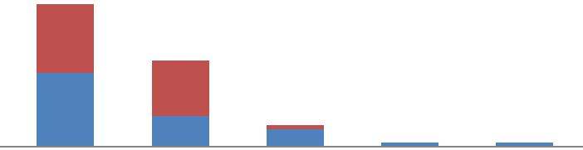

SPLC

LPLC
Distribution of cases in component bar chart with their intra operative findings in SPLC and LPLC Grp.

5. Operative time( in minutes) - from start of incision to closure of skin

Table :4 - Operative time

Type | of | No | of | Mean time | Standard | T | df | p value
Opn |  | cases |  | in minutes | deviation
SPLC |  | 26 |  | 47.69 | 13.50 | -1.5178 | 50 | 0.1354
LPLC |  | 26 |  | 53.46 | 13.91

- So the mean operating time in SPLC is 47.69 minutes and in LPLC is 53.46 minutes and the p value is statistically insignificant .

Table :5- Distribution of number |  | and percentage of cases according to the
duration of operation.
Operative time(in minutes) |  | SPLC ( n=26=100%) | LPLC(n=26=100%)
≤ 30 |  | 2(7.69%) | 0 (0%)
31-45 |  | 14(53.84%) | 12(46.15%)
46-60 |  | 8 (30.77%) | 8(30.77%)
61-75 |  | 1(3.85%) | 5(19.23%)
76-90 |  | 0(0%) | 1(3.85%)
>90 |  | 1(3.85%) | 0(0%)

6. Intra operative blood pressure monitoring - we have measured the mean arterial pressure(MAP) on mm of Hg. –

  - Before incision

    - At 20 minutes intra operatively

    - Before reversal of GA

a. The MAP before incision

Table:6- MAP before incision.

Type of opn. | No of | Mean | Standard | t | df | P value
 | cases |  | deviation
SPLC | 26 | 101.19 | 10.944 | 2.13768 | 50 | 0.03746
LPLC | 26 | 96.35 | 3.676

- So the average MAP in SPLC gr. is 101.19mm of Hg and in LPLC gr. it is 96.35mm of Hg . The p value is 0 .03746 which is

statistically significant.

b.The MAP intra operatively at 30 minutes

Table:7- MAP 20 mins. Intra operatively.

Type of | No of | Mean | Std. | t | df | P value
opn. | Cases |  | deviation
SPLC | 26 | 101.58 | 9.578 | 5.20598 | 50 | 0.000
LPLC | 26 | 91.5 | 2.395

- So the average MAP intra operatively at 30 minutes , is 101.58mm of

Hg in SPLC and in LPLC in 91.5 mm of Hg. The p

value is 0.000 which is significant.

c. The MAP before reversal from GA

Table:8- MAP before reversal of GA.

Type of | No of | Mean | Std. | t | df | P value
Opn | cases |  | deviation
SPLC | 26 | 102.15 | 8.545 | 5.9182 | 50 | 0.000
LPLC | 26 | 91.85 | 2.395

➢ So the average MAP before reversal from the GA , is 102.15 mm of Hg in SPLC and in LPLC is 91.85 mm of Hg. The p value is 0.000 which is significant.

7. Intra operative ET CO2 - we have measured the ET CO2

    - Before incision

      - At 20 minutes intra operatively

      - Before reversal of GA

a. Before incision

Table:9-ET CO2 before incision

Type of | No of | Mean | Std. | t | df | p value
opn. | Cases |  | deviation
SPLC | 26 | 42.40 | 3.359 | 11.106 | 50 | 0.000
LPLC | 26 | 35.10 | 1.296

- So the average ET CO2 before incision in SPLC gr. is 42.40 and in LPLC gr. it is 35.10 and the p value is statistically significant.

  - ET CO2 at 20 minutes intra operatively

Table :10- ET CO2 intra operatively at 20 mins.

Type of | No of | Mean | Std. | T | df | p value
Operation | Cases |  | deviation
SPLC | 26 | 41.46 | 3.425 | 6.1515 | 50 | 0.000
LPLC | 26 | 37.15 | 1.774

- So the average ET CO2 in at 30 minutes intra operatively in SPLC is 41.46 and in LPLC gr. it is 37.15 and the p value is statistically significant.

c. Before reversal of GA

Table :11- ET CO2 before reversal of GA.

Type of | No of cases | Mean | Std. deviation | T | df | p value
opn.
SPLC | 26 | 42.07 | 4.168 | 8.163 | 50 | 0.000
LPLC | 26 | 35.53 | 1.358

- So the average ET CO2 in at before reversal in SPLC gr. is 42.07and in LPLC gr. it is 35.53 and the p value is statistically significant.

8. Intra operative monitoring of pulse- we have measured the pulse

  - Before incision

    - At 20 minutes intra operatively

    - Before reversal of GA

a. Pulse before incision

Table:12- Pulse before incision

Type of | No of | Mean | Std. | t | df | p value
opn. | cases |  | deviation
SPLC | 26 | 90.54 | 7.009 | 7.1449 | 50 | 0.000
LPLC | 26 | 79.23 | 4.003

- So the average intra operative pulse before incision in SPLC gr. is 90.54 and in LPLC gr. it is 79.23. p value is statistically significant.

  - At 20 minutes intra operatively

Table:13-Pulse intra operatively at 20 mins

Type of | No of | Mean | Std. | t | Df | p value
operation | cases |  | deviation
SPLC | 26 | 88.33 | 7.558 | 4.922 | 50 | 0.000
LPLC | 26 | 80.40 | 4.561

- So the average pulse at 30 minutes intra operatively in SPLC gr. is 88.33 and in LPLC gr. it is 80.40. p value is significant .

c. Pulse before reversal of GA

Table :14- Intra operative pulse before reversal of GA.

Type of | No of | Mean | Std. | t | df | p value
opn. | Cases |  | deviation
SPLC | 26 | 86.60 | 8.681 | 3.442 | 50 | 0.001
LPLC | 26 | 79.73 | 6.638

➢ So the average pulse before reversal of GA in SPLC gr. is 86.60 and in LPLC gr. it is 79.73 . p value is statistically significant.

9. Intra operative oxygen saturation (in percentage)- the data were taken

  - Before incision

  - At 20 minutes intra operatively

c .Before reversal of GA

a. Before incision

Table:15- Intra op. Oxygen saturation before incision.

Type of | No of | Mean | Std. | t | Df | P value
opn. | Cases |  | deviation
SPLC | 26 | 97.00 | 1.414 | -3.3096 | 50 | 0.000
LPLC | 26 | 98.19 | 1.167

- So the average oxygen saturation before incision in SPLC gr. is 97 and in LPLC gr. it is 98.19, p value is statistically significant.

b. At 20 minutes intra operatively

Table:16- Intra op. Oxygen saturation at 20 mins.

Type of | No of | Mean | Std. | T | df | p value
operation | Cases |  | deviation
SPLC | 26 | 96.53 | 1.224 | -6.907 | 50 | 0.000
LPLC | 26 | 98.63 | 1.129

- So the average oxygen saturation at 30 minutes intra operatively in SPLC gr. is 96.53 and in LPLC gr. it is 98.63, p value is statistically significant.

c. Before reversal of GA

Table :17- intra op. Oxygen saturation before reversal of GA.

Type of | No of | Mean | Std. | t | Df | P value
opn. | Cases |  | deviation
SPLC | 26 | 97.47 | 1.697 | -2.240 | 50 | 0.029
LPLC | 26 | 98.37 | 1.402

- So the average oxygen saturation before reversal in SPLC gr. is 97.47 and in LPLC gr. it is 98.37, p value is statistically significant.

10. Post operative pain score - according to the Visual Analogue Scale (VAS), the data were taken -

  - 6 hrs post operatively

  - 12 hrs post operatively

  - 24 hrs post operatively

- 6 hrs post operatively

Table:18- Post op. VAS score at 6 hrs.

Type of | No of | Mean | Std. | t | df | p value
operation | Cases |  | deviation
SPLC | 26 | 5.04 | 0.662 | 6.0885 | 50 | 0.000
LPLC | 26 | 3.88 | 0.711

➢ So the 6 hrs post operative average VAS score in SPLC gr.is5.04 and in LPLC gr. it is 3.88,p value is 0.000 which is statistically significant.

b. 12 hrs post operatively

Table19- Post op. VAS score at 12 hrs.

Type of | No of | Mean | Std. | t | df | p value
operation | cases |  | deviation
SPLC | 26 | 2.23 | 0.514 | 2.825 | 50 | 0.006
LPLC | 26 | 1.77 | 0.652

- So the 12 hrs post operative VAS score is significant and higher in SPLC group.

c.24 hrs post operatively

Table:20- Post op. VAS score at 24 hrs.

Type of | No of | Mean | Std. | t | df | p value
Operation | cases |  | deviation
SPLC | 26 | 0.77 | 0.587 | 2.307 | 50 | 0.02
LPLC | 26 | 0.42 | 0.504

- 24 hrs post operative pain score is significant and higher in SPLC group.

11. Post operative Shoulder pain – total 6 cases of shoulder pain recorded in the CLC group where as no such cases recorded in GLLC group.

Table: 21- Distribution of study subjects by their presence of shoulder pain.

 |  | TYPE OF |  | Total
 |  | OPERATION
 |  | SPLC | GLLC
 |  | (n=26) | (n=26)
SHOULDER | NO | 20(76.92%) | 26(100%) | 46
TIP PAIN | YES | 6(23.08%) | 0(0%) | 6
Total |  | 26(100%) | 26(100%) | 52

- So 23.08 % of patients in SPLC gr. found to have post operative shoulder pain whereas no such cases found in LPLC gr. Pearson χ² value is 4.71 and p value is 0.02which is statistically significant.

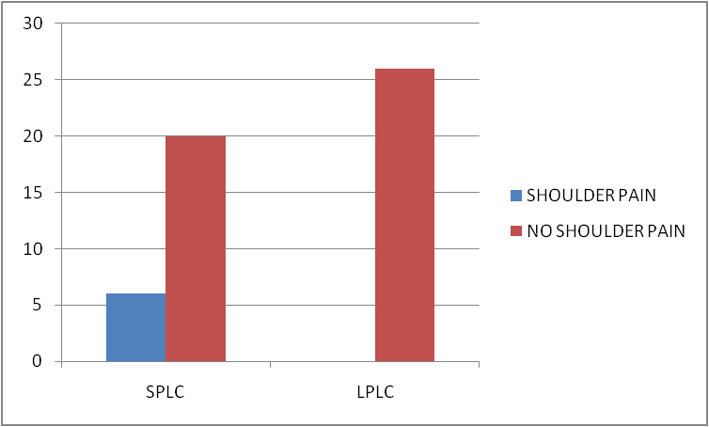

Component bar chart showing 6 cases of shoulder pain present in CLC group where as no such present in GLLC group.

12. 2 hr post operative nausea vomiting – total 10 cases of CLC group developed 2 hrs post operative nausea and vomiting whereas only 2 cases of GLLC group cases developed 2 hrs post operation nausea vomiting.

Table:23-Distribution of study subjects according to the post op.

Nausea vomiting

 | TYPE OF OPERATION |  | Total
 | SPLC | LPLC
 | (n=26) | (n=26)
NO | 16(61.54%) | 24(92.31%) | 42
2 HR POST OP NAUSEA VOMITING
YES | 10(38.46%) | 2(7.69%) | 12
Total | 26(100%) | 26(100%) | 52

- So the total 12 cases found to develop post op. Nausea vomiting among them 10 cases (38.46%) in SPLC gr. and only 2 cases (7.69%) in LPLC gr. Pearson χ ² test value is 5.308 and p value is 0.01 which is statistically significant.

Pic:10- Component bar chart showing total 12 cases of 2 hrs post operative nausea vomiting developed among them 10 cases in SPLC group and 2 in LPLC group.

13. Post operative 2 hrs pulse-

Table:24- Post op. 2 hrs pulse.

Type of | No of | Mean | Std. | t | df | p value
operation | Cases |  | deviation
SPLC | 26 | 101.53 | 10.824 | 2.671 | 50 | 0.01
LPLC | 26 | 95.33 | 6.671

- So the average post operative 2 hrs pulse rate is 101. 53 in SPLC gr. and in LPLC gr. it is 95.33. p value is significant.

14. Post operative 2 hrs oxygen saturation-

Table :25- Post op. 2 hrs oxygen saturation (%)

Type of | No of | Mean | Std. | t | df | p value
operation | Cases |  | deviation
SPLC | 26 | 97 | 1.265 | -2.887 | 50 | 0.005
LPLC | 26 | 98 | 1.233

- So the average oxygen saturation 2 hrs post operatively in SPLC gr. is 97 and in LPLC gr. is 98. p value is statistically significant.

15. Post operative 2 hrs Blood Pressure in mean arterial pressure (MAP) in mm of Hg. -

Table:26-Post op. 2 hrs MAP

Type of | No of | Mean | Std. | t | df | p value
operation | Cases |  | deviation
SPLC | 26 | 96.80 | 6.008 | 0.7870 | 50 | 0.434
LPLC | 26 | 94.23 | 16.811

- So the average 2 hrs post operative MAP in SPLC gr. is 96.80 mm of Hg and in LPLC gr. it is 94.23 mm of Hg. P value statistically insignificant and comparable to both groups.

16.Post operative 2 hrs respiratory rate per minute-

Table:27- Post op 2 hrs respiratory rate( per min.)

Type of | No of | Mean | Std. | t | df | p value
operation | Cases |  | deviation
SPLC | 26 | 21.60 | 2.594 | 4.515 | 50 | 0.000
LPLC | 26 | 18.37 | 2.942

- So the average 2 hrs post operative respiratory rate in SPLC gr. 21.60and in LPLC gr.18.37 . p value is statistically significant.

17. Post operative complication (wound infection) –

Table:28- Distribution of study subjects according to wound infection

 |  | TYPE OF OPERATION |  | Total
 |  | SPLC | LPLC
 |  | (n=26) | (n=26)
POST OP | NIL | 25(96.15%) | 24(92.31%) | 49
COMPLICATION | WOUND INFECTION | 1(3.85%) | 2(7.69%) | 3
Total |  | 26(100%) | 26(100%) | 52

- 3.85% patients developed wound infection in SPLC gr. whereas 7.69% patients developed wound infection in LPLC gr. Pearson χ² test value is

0.5 and p value is 1 which is insignificant

30
25 |  |  |  |  |  |  |  |  |  |  |  |  | no complication
20
24 |  |  |  | 25
15 |  |  |  |  |  |  |  |  |  |  |  |  | complicated with wound
10
 |  |  |  |  |  |  |  |  |  |  |  |  | Infection
5
2 |  |  |  | 1
0
 |  |  | LPLC |  | LPLC
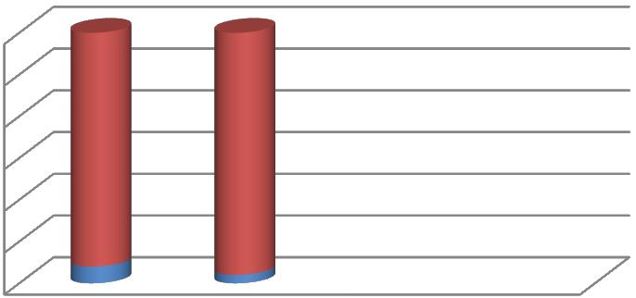
Pic:11- Bar chart showing wound complication slightly higher in SPLC

group compared to the LPLC group.

18. Post operative hospital stay in days-

Table:29- Post op. Hospital stay in days.

Type of | No of | Mean | Std. | t | df | p value
operation | Cases |  | deviation
SPLC | 26 | 2.183 | 0.9868 | -1.499 | 50 | 0.139
LPLC | 26 | 2.650 | 1.3905

- The post operative average hospital stay in LPLC group is 2.65days and in SPLC group is 2.183 days . p value insignificant and comparable to both groups.

19. Return to the normal activity( in days) –

Table:30- Return to the normal activity

Type of | No of | Mean | Std. | t | df | p value
operation | Cases |  | deviation
SPLC | 26 | 5.62 | 1.298 | -1.139 | 50 | 0.259
LPLC | 26 | 6.1 | 1.927

- So the average return to the normal activity the in SPLC group is 5.62 days and in LPLC group is 6.1 days. p value is insignificant.

DISCUSSION

DISCUSSION

This study has been performed in the Department of General Surgery at R G Kar Medical College and Hospital, Kolkata. In our Department laparoscopic cholecystectomy constitutes a major part of the total elective operations. Hence we had a great opportunity to do this study in our Department. After the first successful cholecystectomy performed in 1882 there has neen several modifications of this operation. For about 100 yrs this open cholecystectomy was the treatment of choice for all GB diseases particularly the cholelithiasis. Thereafter in 1980 there was a modification of the open cholecystectomy and few centre tried for mini cholecystectomy. But in 1987 there was a revolution in the operative management of this disease by the development of laparoscopic cholecystectomy. Worldwide there was great acceptance of this minimal invasive operative technique both by the surgeon and by the patients. The LC needed to create PP which has its serious effects in the cardiovascular , respiratory, renal, GI, endocrine, immunologic, hematologic systems etc . Specially this PP has its serious effects on the cardiovascular and respiratory system which precludes this procedure in the cardiovascular and respiratory compromised patients specially ASA II and above. So to combat these great problem and to offer this surgical procedure for these Pts. an alternative to the PP was tried. This was done by several methods of abdominal wall lifting techniques such as laparolift or laparotensor. But it has got some serious technical difficulties and limited working space.
An emerging trend has been the use of low pressures for pneumoperitoneum in the range of 7-10 mm Hg instead of the standard pressure pneumoperitoneum in an attempt to lower the impact of pneumoperitoneum on human physiology while providing adequate working space.

This study was a prospective randomised single centred study. Patients age between 24- 68 yrs were selected which comprises both male and female . Patients have been chosen with minimum age is 24 yrs and maximum age 68 yrs old. Patients were randomly selected for this study who were admitted for

cholecystectomy with reference to ASA II and more. Total 52 cases were selected randomly among them only 4 were male and rest were female which concludes that the cholelithiasis is more common in females. The minimum weight of the patient in SPLC gr. was 51.5 Kg. with BMI of 22.9 kg/mt² and height was 5 ft , the maximum weight was 68 kg and BMI 24.9 kg/mt² and height was 5 ft . 6 inches here the mean BMI was 23.82 kg/mt². In LPLC grp the minimum weight was 49.5 kg ,BMI 22 kg/mt² and height 5 ft. and the maximum weight was 67 kg , BMI 24.85 kg/mt² and height 5 ft and 6 inches, here the mean BMI was 23.31 kg/mt² slightly lower than was in SPLC gr. In our study we have taken BMI < 25 kg/mt².The average operating time in SPLC group was 47.69 minutes whereas in LPLC 53.46,and p value is 0.135 which is statistically insignificant.
operative findings mostly found to have clear anatomy in 16 cases of SPLC group and in14 cases of LPLC gr. Minor omental adhesions were found in 8 cases SPLC gr. and 6 cases of LPLC gr. The intra operative findings of empyema GB was seen in 2 cases in SPLC gr. but 4 cases in LPLC gr. One case each of gross omental adhesion and mucocele was found in LPLC gr. only no such case found in SPLC gr. So to conclude more the complicated anatomy more is the operating time.

Intra operative cardio-respiratory parameters were taken in both groups; after anaesthesia but before incision; after 20 minutes of operation intra operatively and lastly before reversal from GA.

Intra operative Mean Arterial Pressure(MAP) were taken and analysed. The mean MAP before incision in SPLC gr. was 101.19 mm of Hg where as it was in LPLC group 96.53 mm of Hg, and the p value was 0.375 which is insignificant. After 30 mins intra operative mean MAP in SPLC gr. was 101.58 mm of Hg and in LPLC gr. it was 91.5 mm of Hg, and the p value was 0.000 which is statically significant. The intra operatives mean MAP before reversal from GA in SPLC gr. was 102.15 mm of Hg and in LPLC gr. was 91.85 mm of Hg, and the p value was 0.000 which is statistically significant. So the overall intra operative mean MAP is lower in LPLC gr. and significantly higher in SPLC gr.

Intra operative End Tidal carbon dioxide(ET CO2) monitoring, the mean ET CO2 before incision was 42.40 in SPLC gr. but was quite lower in LPLC gr. and was 35.10 and the p value was 0.000 which is statistically significant. Intra operative 20 mins mean ET CO2 in SPLC gr. was 41.46 but the mean ET CO2 in LPLC was 37.15 and the p value was 0.000 which is statistically significant . The intra operative mean ET CO2 before reversal in SPLC gr. was 42.07 but in LPLC gr. was 35.53 and the p value is 0.000 which is statistically significant. So the intra operative ET CO2 was significantly higher in SPLC gr. than LPLC grp.

Intra operative mean pulse before incision in SPLC gr. was 90.54 bpm but in LPLC gr. it was 79.23 bpm and p value was 0.000 which is significant. The intra operative 20 mins mean pulse in SPLC gr. was 88.33 bpm but in LPLC gr. was 80.40 bpm with a p value is 0.000 which is statistically significant. The intra operative mean pulse before reversal in SPLC gr. was 86.60 bpm but in LPLC gr. it was 79.00 bpm with p value was 0.001 and is statistically significant. So the intra operatives mean pulse is significantly higher in SPLC gr. than LPLC gr.

Intra operative oxygen saturation (spO2) in percentage, the mean value before incision in SPLC gr. was 97 % but in GLLC gr. it was 98.19 % with a p value 0.001 and is significant. The intra operative mean spO2 at 20 mins in SPLC gr.

was 96.53% but in LPLC gr. it was 98.63 with p value was 0.000 significant. The intra operative mean spO2 before reversal in SPLC gr. was 97.47% and in LPLC gr. it was 98.37% with p value 0.029 and was significant. So the all intra operative parameters are quite stable in LPLC gr. compared to the SPLC gr.

The post operative cardio-respiratory parameters studied were Pulse , BP, Respiratory rate, oxygen saturation. The ABG and CVP was not measured. These parameters were collected 2 hrs post operatively.

The 2 hrs postoperative mean pulse in SPLC group was 101.53 bpm; but in LPLC gr. it was 95.33bpm with a p value of 0.01 which is statistically significant.

2 hrs post operative mean MAP was 96.80mm of Hg in SPLC gr. which was 94.23 mm of Hg in LPLC gr. with a p value of 0.434 which is statistically insignificant.

2 hrs post operative mean respiratory rate in SPLC gr. was 21.60/min which in LPLC gr. was 18.37/min with a p value of 0.000 which is statistically significant.

2 hours postoperative nausea vomiting was recorded in 10 cases of SPLC gr. which required antiemetic intravenously but only 2 cases was recorded in the LPLC gr.,X² value is 5.308 and p value is 0.01 which is statistically significant.

6 cases of shoulder pain was recorded in the SPLC gr. whereas no such cases recorded in the LPLC gr. and X² value is 4.71 and p value is 0.02 which is statistically significant.

The post operative pain score was recorded by using the VAS score. The patient were educated regarding the use of the VAS score and the mark was given in a 10 cm long scale where the extreme left comprises no pain and the extreme right comprises extreme painful condition. The pain score according to VAS score were taken 6 hrs post operatively, 12 hrs post operatively and 24 hrs post operatively. The 6 hrs post operative mean VAS score in SPLC gr. was 5.04 and in LPLC it was 3.88 with a p value of 0.000 which is statistically significant. The 12 hrs postoperative mean VAS score in SPLC gr. was 2.23 and in LPLC gr. was 1.77 with a p value of 0.006 which is statistically significant. 24 hrs post operative mean VAS score in SPLC gr. was 0.77 and in LPLC gr. it was 0.42

with a p value of 0.02 which is statistically significant.

Post operative complication mainly comprising as post operative wound infection. The wound infection was noted in 1 case of SPLC gr. on the 15th post operative day and the patient was diabetic, where as 2 cases of wound infection were recorded in the LPLC gr. , one on the 12th post operative day , another on the 15th post operative day and both cases were diabetic. χ² test value is 0.5 and p value is 1 which is insignificant.

The mean post operative hospital stay calculated in days in SPLC gr. was 2.183 days whereas it is 2.65 days in LPLC gr. with a p value of 0.139 which is statistically insignificant.

Post operative return to the normal activities calculated in days; the mean value

of which in SPLC gr. was 5.62 days whereas in LPLC gr. it was 6.1 days with a
p value of 0.259 which is statistically insignificant.

SUMMARY

AND

CONCLUSION

SUMMARY AND CONCLUSION

"A COMPARATIVE STUDY BETWEEN LOW PRESSURE LAPAROSCOPIC CHOLECYSTECTOMY VS. STANDARD PRESSURE LAPAROSCOPIC CHOLECYSTECTOMY WITH REGARDS TO INRAOPERATIVE CARDIORESPIRATORY CHANGES, POST OPERATIVE COURSE AND CONVALESCENCE”.
It is a randomised prospective single centred study conducted from January 2014 to June 2015 at the Department of General Surgery at R.G. Kar Medical College and Hospital, Kolkata. The cases were selected randomly with an age gr. between 24 yrs to 68yrs. Both males and females were included in this study; preferably ASA II grade cases were selected for LPLC.There is no significant difference in operative time found between the two groups in my study. All the patients in the LPLC gr. had gastric decompression by Ryle‟s tube insertion so that the stomach gets collapsed during operation and increases intra-operative space. Most of the cases intra operatively were found to have clear anatomy with minor omental adhesion. All the intra -operative cardio-respiratory parameters (pulse, MAP ,ET CO2, spO2 ) were recorded after anesthesia but just before incision, 20 mins intra-operatively, and before reversal of GA. All the parameters during the operation were quite stable in LPLC gr. compared to SPLC gr. The incidence of 2 hrs post

operative nausea and vomiting , was seen in 38.46% cases in SPLC gr. but in 7.69% cases in the LPLC gr. which concludes post operative nausea and vomiting is closely associated with high pressure pneumoperitoneum.The shoulder tip pain was found only in 23.08% cases in the SPLC gr. but no cases were found in the LPLC gr. which concludes that the pneumoperitoneum is closely associated with post operative shoulder tip pain. The post operative pain score according to the VAS score significantly higher in SPLC gr. which concludes analgesic requierment is lower in LPLC gr.. The post operative wound infection was recorded in a total of 3 cases among them 1 in CLC gr. and 2 in GLLC gr. and all were diabetic patients,there is no significant difference found. Post operatively both groups stayed at hospital with a mean in SPLC gr. of 2.183 days and in LPLC gr. it was 2.650 day so it is comparable in both groups and statistically insignificant. The return to normal life is also comparable in both groups. and in SPLC gr. it was mean 5.62 days and in LPLC gr. it was mean 6.1 days. So both groups returned to their normal activity post operatively on 6th and 7th day respectively.

Though LPLC has several disadvantages like intra-operative difficulties, little more time consuming and , especially when the world is moving towards more and more minimal and specially when nowadays the laparoscopic cholecystectomy is being performed in a single scar with single

incision laparoscopic surgery (SILS) or even without any scar in the abdomen by NOTES still by reviewing the intra-operative and postoperative cardio-respiratory stability, this is quite a safe procedure for the cardio-respiratory compromised patients undergoing laparoscopic cholecystectomy especially the ASA II and more.

We have a strong feeling that more and more of prospective study with the use of Low Pressure Laparoscopy needs to be carried out at different centres and especially in our teaching hospitals to validate the points raised. Ours being a developing country, but at the same time being a Mecca for health care destination for cheaper health care at affordable cost , needs to carry out this study at many more centres.

BIBLIOGRAPHY

BIBLIOGRAPHY

- J Minim Access Surg. 2011 Jul-Sep; 7(3): 165–168.
- Mühe E. Laparoskopische cholecystektomie. Endoskopie Heute. 1990;4:262–6.
- Litynski GS. Profiles in laparoscopy: Mouret, Dubois, and Perissat: The
laparoscopic breakthrough in Europe (1987-1988) JSLS. 1999;3:163–7. [PMC free article] [PubMed]
- Lindner H. Embryology and anatomy of the biliary tree. In: Way LW,
Pellegrini CA (eds) Surgery of the Gallbladder and Bile Ducts. Philadelphia:
Saunders, 1987:3–4, 7–8.
- Bismuth H. Surgical anatomy and anatomical surgery of the liver. In:
Blumgart LH (ed) Surgery of the Liver and Biliary Tract, 2nd Ed. Edinburgh:
Churchill Livingstone, 1994:3–7.
- Rappaport AM. Anatomic considerations. In: Schiff L (ed) Diseases of the Liver, 4th Ed. Philadelphia: Lippincott, 1975.

- Cantlie J. On a new arrangement of the right and left lobes of the liver. J
Anat Physiol (Lond) 1898; 32: IV.
- Healy JE Jr. Clinical anatomic aspects of radical hepatic surgery. J Int Coll Surg 1954; 22:542.
- Chenderovitch J. Les conceptions actielles des mecanismes de la secrection biliarie. Presse Med 1963; 71:2645.
- Hicken NF, Coray QB, Franz B. Anatomic variations of the extrahepatic
biliary system as seen by cholangiographic studies. Surg Gynecol Obstet 1949;
88:577.
- Rappaport AM. Hepatic blood flow: morphologic aspects and physiologic
regulation. In: Javitt ND (ed) Liver and Biliary Tract Physiology. Int Rev
Physiol 1980:21.
- Anson BJ, McVay CB. Surgical Anatomy, 5th Ed. Philadelphia: Saunders, 1971:597.
- Smadja C, Blumgart LH. The biliary tract and the anatomy of biliary
exposure. In Blumgart LH (ed) Surgery of the Liver and Biliary Tract, 2nd Ed.
Edinburgh: Churchill Livingstone, 1994:11–16.
- McIndoe AH, Counseller VS. A report on the bilaterality of the liver. Arch Surg 1927; 15:589.
- Thaler MM, Way LW. The biliary tract. In: Sleisenger MH, Fordtran JS
(eds) Gastrointestinal Disease. Philadelphia: Saunders, 1978:1245.
- Hjortsjo CH. The topography of the intrahepatic duct systems. Acta Anat
(Basel) 1951; 11:599.
- Meyers WC, Jones RS. Anatomy. In: Textbook of Liver and Biliary
Surgery. Philadelphia: Lippincott 1990; 18.
- Goss CM (ed). Gray‟s Anatomy, 29th American Ed. Philadelphia: Lea &
Febiger, 1974.
- Rex H. Beitrage zur Morphologie der Saugerleber. Morphol Jahrb 1888;
14:517.
- Higgins GM. The biliary tract of certain rodents with and those without a
gallbladder. Anat Rec 1926; 32:89.
- Schulenberg CAR. Anomalies of the biliary tract as demonstrated by
operative cholangiography. Med Proc 1970; 16:351.
- Muirhead WR, O‟Leary JP. Calot‟s triangle: loose interpretation or
respectful accuracy? Am Surg 1999; 65(2):186–187.
- Nahrwold DL. The biliary system. In: Sabiston DC (ed) Textbook of
Surgery. Philadelphia: Saunders, 1968:1128.
- Sekimoto M, Tomita N, Tamura S, et al. New retraction technique to allow better visualization of Calot‟s triangle during laparoscopic cholecystectomy. Surg Endosc 1998;12:1439–1441.
- Hugh TB, Kelly MD, Mekisic A. Rouviere‟s sulcus: a useful landmark in
laparoscopic cholecystectomy. Br J Surg 1997; 84(9):1253–1254.
- Jacobson JB, Brody PA. The transverse common duct. AJR 1981; 136:91.
- Hollinshead HW. The liver and the gallbladder. In: Anatomy for Surgeons, 3rd Ed. New York: Hoeber-Harper, 1982.
- Job TT. The anatomy of the duodenal portion of the bile and pancreatic
ducts. Anat Rec 1926; 32:212.
- Boyden EA. The sphincter of Oddi in man and certain representative
mammals, Surgery (St. Louis) 1937; 1:25.
- Keddie NC, Taylor AW, Sykes PA. The termination of the common bile
duct. Br J Surg 1974;61:623.
- Linder HH, Pena VA, Ruggieri RA. A clinical and anatomical study of
anomalous termination of the common bile duct into the duodenum. Ann Surg
1976;184:626.
- Michels NA. Newer anatomy of the liver and its variant blood supply and
collateral circulation. Am J Surg 1966; 112:337?
- Charnsangavej C, Chuang VP. Angiography classification of hepatic arterial collaterals. Radiology 1982; 144:485.
- Johnston EV, Anson BJ. Variations in the formation and vascular
relationships of the bile ducts. Surg Gynecol Obstet 1952; 94:669.
- Nakamura S, Tsuzuki T. Surgical anatomy of the hepatic veins and the
inferior vena cava. Surg Gynecol Obstet 1981; 152:43.
- Mallet-Guy P, et al. Recherches experimentales sur la circulation
- lymphatique due fofie. I. Donnes immediate sur la permeabilite
biliolymphatique. Lyon Chir 1962;58:847.
- Liu C, et al. Factors affecting conversion of laparoscopic cholecystectomy
to open surgery. Arch Surg 1996; 131:98–101.
- Kum C, Eypasih E, and Lefering R, et al. Laparoscopic cholecystectomy for
acute cholecystitis: is it really safe? World J Surg 1996; 20:43–49.
- Nahrwold DL. Acute cholecystitis and chronic cholecystitis and
cholelithiasis. In: Sabiston DC (ed) Textbook of Surgery, 15th Ed. Philadelphia:
Saunders, 1997:1126–1139.
- Mergener K, et al. Pseudo-Mirizzi syndrome in acute cholecystitis. Am J
Gastroenterol 1998; 93(12):2605–2606.
- Redaelli CA, et al. High coincidence of Mirizzi syndrome and gallbladder
carcinoma. Surgery (St. Louis) 1997; 121(1): 58–63.
- Posta CG. Unexpected Mirizzi anatomy: a major hazard to the common bile
duct during laparoscopic cholecystectomy. Surg Laparosc Endosc
1995;5(5):412–414.
- Tang S, et al. Timing of laparoscopic surgery in gallstone pancreatitis. Arch
Surg 1995; 130:496–500. Mall FP. A study of the structural unit of the liver. Am J Anat 1906; 5:227?
- Yeo CJ, Cameron JL. The pancreas. In: Sabiston DC (ed) Textbook of
Surgery, 15th Ed. Philadelphia: Saunders, 1997:1156–1161.
- Rikkers LF. Surgical complications of cirrhosis and portal hypertension. In:
Sabiston DC (ed) Textbook of Surgery, 15th Ed. Philadelphia: Saunders,
1997:1088–1089.
- Angrisani L, Lorenzo M, Corcione F, Vincenti R. Gallstones in cirrhotics
revisited by a laparoscopic view. J Laparoendosc Adv Surg Tech
1997;7(4):213–220.
- Kramer AJ, et al. Gallbladder diverticulum: a case report and review of the
literature. Am Surg 1998;64(4):298–301.
- N Dunne, MI Booth, and TCB Dehn Establishing pneumoperitoneum:
Verres or Hasson? The debate continues Ann R Coll Surg Engl. 2011
January; 93(1): 22–24.Published online 2010 November
4. doi: 10.1308/003588411X12851639107557
- Ahmed Khan Sangrasi et al A Safe Quick Technique for Placement of the
First Access Port for Creation of Pneumoperitoneum, JSLS. 2011 Oct-
Dec; 15(4): 504–508.doi: 10.4293/108680811X13176785204238
- Myles, Paul S. Et al The Pain Visual Analog Scale: Is It Linear or
Nonlinear? Anesthesia & Analgesia:December 1999 - Volume 89 - Issue 6 - p 1517 doi: 10.1213/00000539-199912000-00038
- Principles and Techniques of Abdominal Access and Physiology of
Pneumoperitoneum, Jon C. Gould, MD, FACS, and Ancil Philip, MD
- Joris JL, Noirot DP, Legrand MJ, et al. Hemodynamic changes during
laparoscopic cholecystectomy. Anesth Analg 1993;76:1067–71.
- Fahy BG, Barnas GM, Nagle SE, et al. Changes in lung and chest wall
properties and abdominal insufflation of carbon dioxide are immediately
reversible. Anesth Analg 1996;82:601–5.
- Hasukic S, Mesic D, Dizdarevic E, et al. Pulmonary function after
laparoscopic and open cholecystectomy. Surg Endosc 2002;16:163–5.
- Schwenk W, Bohm B, Witt C, et al. Pulmonary function following
laparoscopic or conventional colorectal resection: a randomized controlled
evaluation. Arch Surg 1999;134:6–12.
- Gutt CN, Oniu T, Mehrabi A, et al. Circulatory and respiratory
complications of carbon dioxide insufflation. Dig Surg 2004;21:95–105.
- Wagner PD, Powell FL, West JB. Ventilation, blood flow and gas exchange.
In: Mason RJ, Broaddus VC, Martin T, et al., editors. Murray and Nadel‟s
textbook of respiratory medicine. 5th ed. Philadelphia: Saunders Elsevier; 2010.
p 53–88.
- Gottlieb A, Sprung J, Zheng XM, et al. Massive subcutaneous emphysema
and severe hypercarbia in a patient during endoscopic transcervical
parathyroidectomy using carbon dioxide insufflation. Anesth Analg
1997;84:1154–6.
- Effect of Pneumoperitoneum on Renal Tissue Oxygenation and Blood Flow
in a Rat Model , Urology journal Volume 77, Issue 6 , Pages 1508.e9-1508.e15,
June 2011
- E. O‟L EARY, K. HUBBARD, W. TORMEY AND A. J. CUNNINGHAM ,
Laparoscopic cholecystectomy: haemodynamic and neuroendocrine responses
after pneumoperitoneum and changes in position, British Journal of
Anaesthesia1996;76: 640–644
- Kim WW, Jeon HM, Park SC, Lee SK, Chun SW, Kim EK.,
Comparison of immune preservation between CO2 pneumoperitoneum and gasl
ess abdominal lift laparoscopy., JSLS. 2002 Jan-Mar;6(1):11-5. ( Pub Med).
- Prakash U.B.S.: “Sushruta of Ancient India.” Surg. Gynaecol. Obstet 1978;
Feb; 146, 2, 263-272.
- Taylor G. C and Whitby L. E. H.: Br. J Surg. 1930-31; 18: 78.
- Benivenius: Gall stone. Historical review by A. J. H. Rains 1964
- Taylor G. C and Whitby L. E. H.: Br. J Surg. 1930-31; 18: 78.
- Aschoff et al: Quoted by Rains, (1909); 1964.
- Anderson W. A. D: - Pathology 5th Edition 1966.
- Mergener K, et al. Mirizzi syndrome in cholecystitis. A M J Gastroenterol
1989; 93(12): 2605-2606.
- LEE J.K. et al: Cholecystosonography: accuracy, pit falls and unusual
findings. Am. J. Surg. Feb; 139 (2): 223-8.
- Bobbs: Gall stone. Historical Review by AJH Rains 1964.
- Herman R. A plea for a safer technique of cholecystectomy. Surgery (St
Louis) 1976; 79: 609-611
- Smadja C, Blumgart LH. The biliary tract and the anatomy of biliary
exposure. In Blumgart LH(ed) Surgery of the Liver and Biliary Tract, 2nd Ed.
Edinburgh: Churchill Living stone, 1994; 11-16.
- Schwartz‟s principles of Surgery 9th edition page 1151.
- MINI-CHOLECYSTECTOMY: A FEASIBLE OPTION , Nadia Saeed,
Tauqeer Nasir, Bilal Burki, Ghulam Asghar Channa, Department of Surgery,
Ward-26, Jinnah Postgraduate Medical Centre, Karachi, Pakistan.
- Barczyński, M., Herman, R.M. A prospective randomized trial on comparison of low-pressure (LP) and standard-pressure (SP) pneumoperitoneum for laparoscopic cholecystectomy. Surg Endosc. 2003;17:533–538.CrossRef ;PubMed; Scopus (56).
- Sandhu, T., Yamada, S., Ariyakachon, V. et al, Low-pressure pneumoperitoneum versus standard pneumoperitoneum in laparoscopic cholecystectomy, a prospective randomized clinical trial. Surg Endosc. 2009;23:1044–1047.CrossRef; PubMed; Scopus (29).
- Dexter, S.P., Vucevic, M., Gibson, J. et al, Hemodynamic consequences of high- and low-pressure capnoperitoneum during laparoscopic cholecystectomy. Surg Endosc. 1999;13:376–381.CrossRef;PubMed
;Scopus (107)
- Wallace, D.H., Serpell, M.G., Baxter, J.N. et al, Randomized trial of different insufflation pressures for laparoscopic cholecystectomy. Br J Surg. 1997;84:455–458.CrossRef; PubMed;Scopus (19)
- Joshipura, V.P., Haribhakti, S.P., Patel, N.R. et al, A prospective randomized, controlled study comparing low pressure versus high pressure pneumoperitoneum during laparoscopic cholecystectomy. Surg Laparosc Endosc Percutan Tech. 2009;19:234–240.CrossRef; PubMed;Scopus (26)
- Yasir, M., Mehta, K.S., Banday, V.H. et al, Evaluation of post operative shoulder tip pain in low pressure versus standard pressure pneumoperitoneum during laparoscopic cholecystectomy. Surgeon. 2012;10:71–74.PubMed; Scopus (19)
- Chok, K.S., Yuen, W.K., Lau, H. et al, Prospective randomized trial on low-pressure versus standard-pressure pneumoperitoneum in outpatient laparoscopic cholecystectomy. Surg Laparosc Endosc Percutan Tech. 2006;16:383–386.CrossRef; PubMed; Scopus (20)
- Kanwer, D.B., Kaman, L., Nedounsejiane, M. et al, Comparative study of low pressure versus standard pressure pneumoperitoneum in laparoscopic cholecystectomy–a randomised controlled trial. Trop Gastroenterol. 2009;30:171–174.
- Hasukić, S. Postoperative changes in liver function tests: randomized comparison of low- and high-pressure laparoscopic cholecystectomy. Surg Endosc. 2005;19:1451–1455.CrossRef; PubMed; Scopus (27)
- J Hua, J Gong, L Yao, B Zhou, Z Song - Low-pressure versus standard-pressure pneumoperitoneum for laparoscopic cholecystectomy: a systematic review and meta-analysis- The American Journal of Surgery, 2014 - Elsevier.
- Gurusamy, K.S., Samraj, K., Davidson, B.R. Low pressure versus standard pressure pneumoperitoneum in laparoscopic cholecystectomy. Cochrane Database Syst Rev. 2009;2:CD006930.
- Davidas D, Birbs K, Vezakis A, Mcmohan MJ. Routine low pressure pneumoperitoneum during laparoscopic cholecystectomy. Surg Endosc. 1999:13:87–9.
- Perrakis E, Vezakis A, Velimexis G, Savanis G, Deverakis S, Antoniades J, et al. Randomized comparison between different insufflation pressure for laparoscopic cholecystectomy. Surg Laparo Endosc Percutan Tech. 2003;13:245–9.
- Sarli L, Costi R. Prospective randomized trial of low-pressure pneumoperitoneum for reduction of shoulder-tip pain following laparoscopy. The British Journal of Surgery 2000;87(9):1161-5.

PHOTOGRAPHS

PHOTOGRAPHS

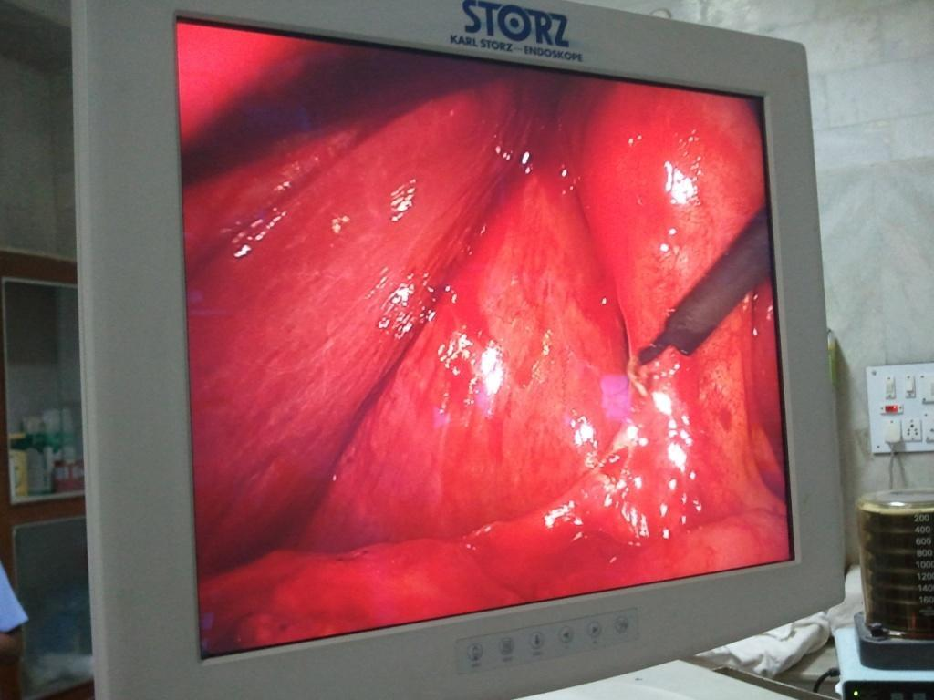

Photograph: 1- Dissection of Calot’s triangle

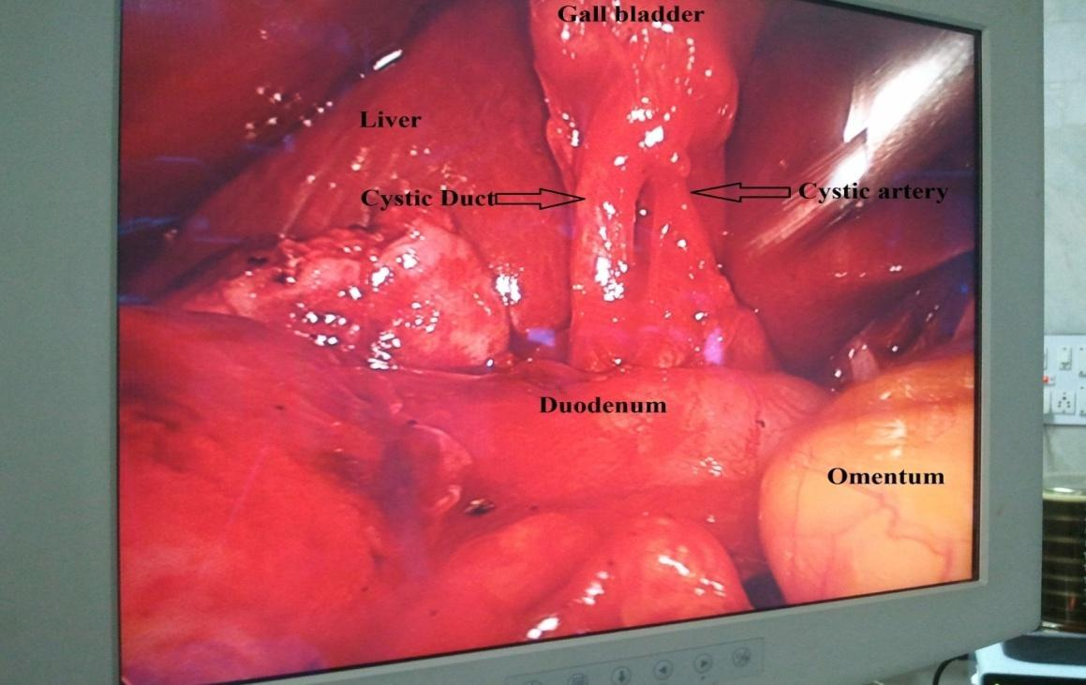

Photograph :2- Completed Calot’s triangle dissection
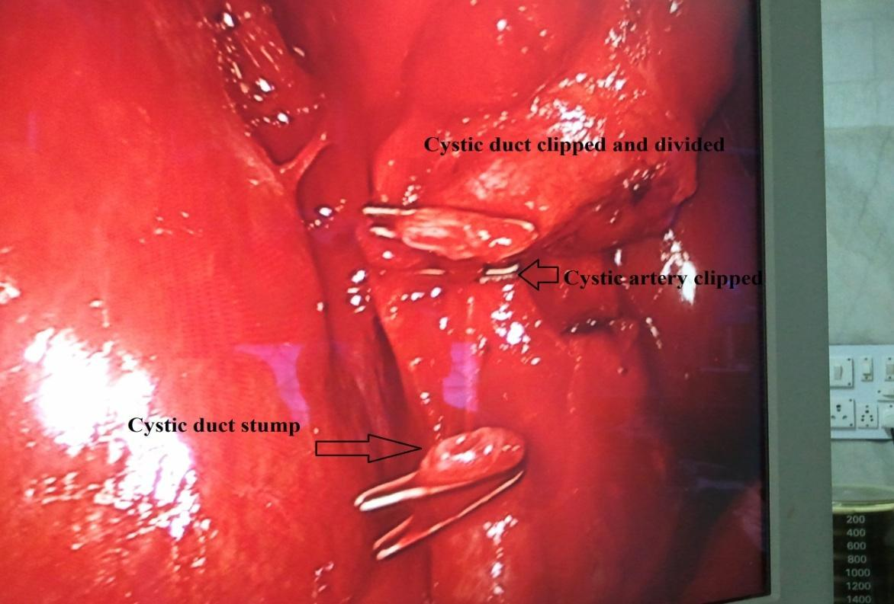

Photograph: 3- Cystic duct cut after clipping, Cystic artery clipped in low pressure laparoscopic cholecystectomy.

Laparoscopic instruments used in the study
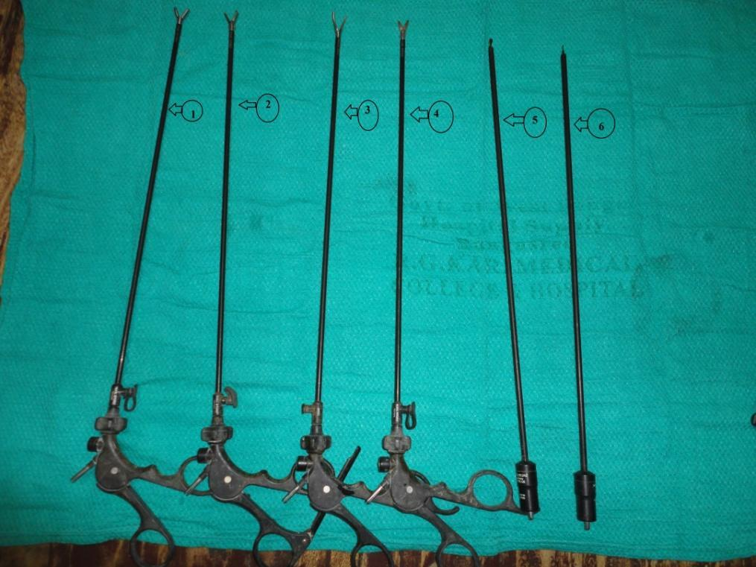

Photograph:4 - Laparoscopic instruments with their numbering as follows

1. Non-tooth grasper , 2.Tooth grasper, 3. Maryland forceps 4.Scissor, 5. Spatula, 6. Hoook
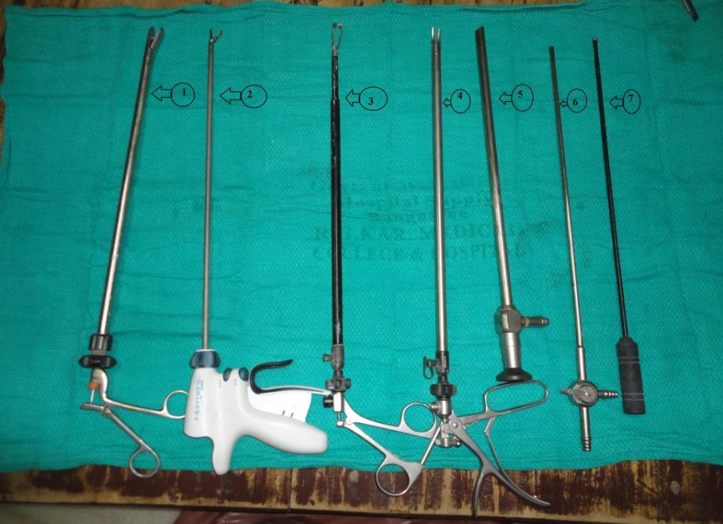

Photograph: 5- Laparoscopic instruments with their numbering as follows

- Stone retrival forceps, 2. Hermonic scalpel, 3.GB retrieving forceps

  - Clip applicator, 5. Scope 30°, 6. Sucker, 7. Ball

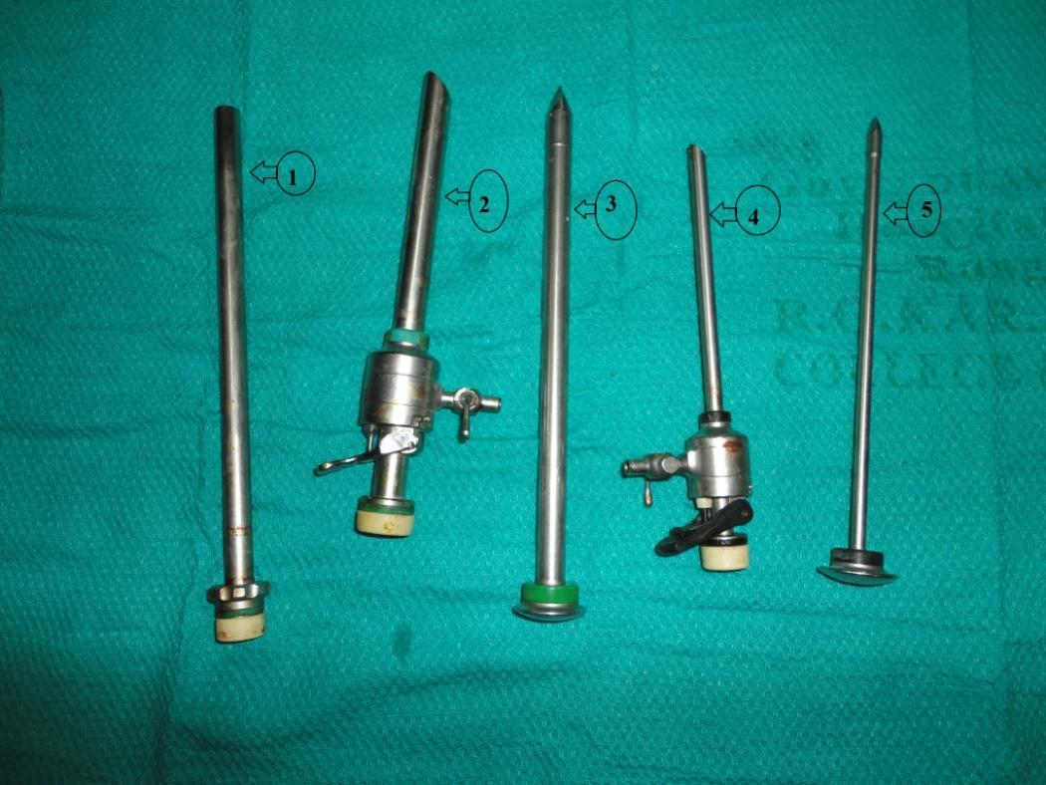

Photograph: 6- Laparoscopic instruments with their numbering as follows

1. Tube reducer -10 mm, 2. Port -10 mm, 3. Trocar -10 mm, 4. Port -5 mm 5.Trocar -5 mm
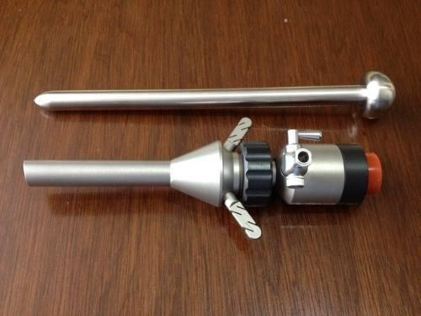

Photograph:7- The Hasson trocar with port

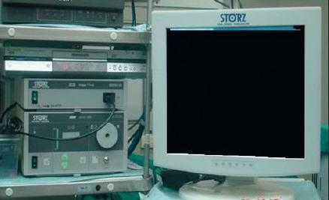

Photograph:8 - Laparoscopic Insufflator and Monitor
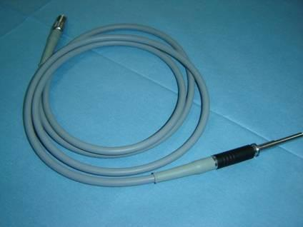

Photograph:9- Insufflation cable

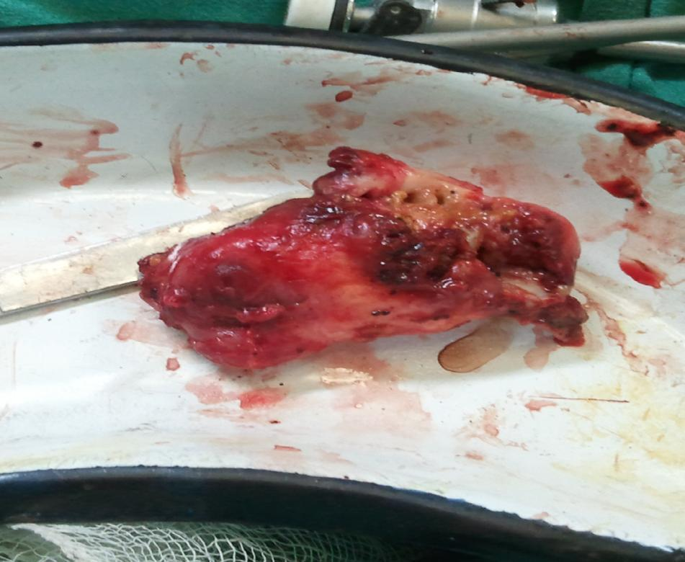

Photograph:10- One of GB Specimen in the GLLC patient

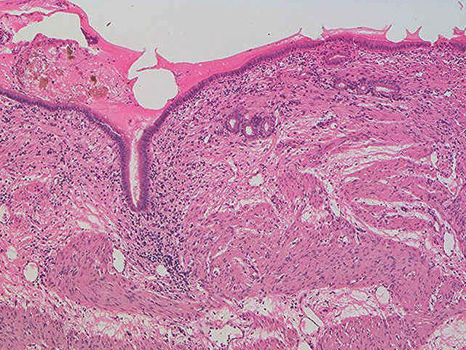

Photograph:11- Histopathological picture of chronic cholecystitis

ANNEXURES

CONSENT FORM
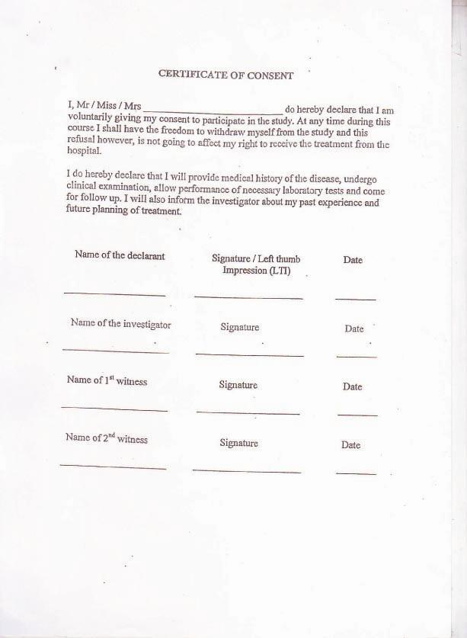
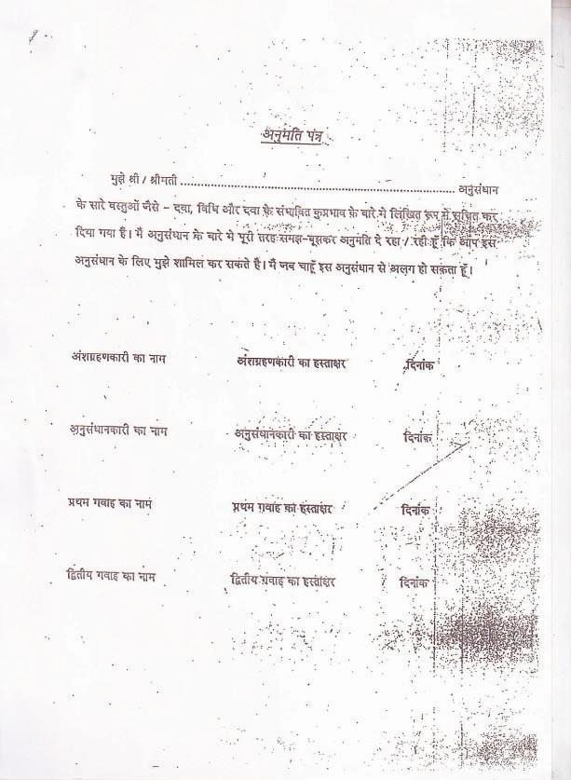

PROFORMA

Reg. No:
Name: Age: Sex: M/F BMI:
Education: Occupation:
Socio-economic status:
Address: Contact no:

Chief complaints:

History of present illness:

History of Past Illness:

History of Previous Surgery:

Family history: yes/ no

Drug history:
Personal history:

General examination:-
Decubitus:
Look:
Built:
Nutrition:
Vitals:-
Pulse -
Blood pressure -
Temp -
Pallor:
Icterus:
Cyanosis:
Nails:
Edema:
Lymph node:
Neck veins:
Neck glands:
Tongue:
Skin:
Systemic examination:
Gastro-intestinal system:
: localised tenderness right
hypochondrium
: lump in right upper abdomen
(If present,detail of the lump
specially Shape)
: other tender point
: any other findings

Cardiovascular system:
Respiratory system:
Central nervous system:
ASA grading

- Patient is a completely healthy fit patient.
- Patient has mild systemic disease.
- Patient has severe systemic disease that is not incapacitating.
- Patient has incapacitating disease that is a constant threat to life.
- A moribund patient who is not expected to live 24 hour with or without surgery.

Pre operative Investigations:

Routine Blood Investigations:

Ultrasonography of Whole Abdomen:

CT scan of Abdomen (if any):

MRCP (if any):

Type of Surgery:

Pre operative (Prophylactic) Antibiotic Given:

Intaoperative finding

Intra operative Complications:

Conversion to standard pressure: Yes / No

Operative Time:

Intra operative blood pressure - mean arterial pressure(MAP) on mm of Hg.
a. Before incision
b. At 30 minutes intra operatively
c. Before reversal of GA

Intra operative pulse -
a. Before incision
b. At 30 minutes intra operatively
c. Before reversal of GA

Intra operative ET CO2 - the ET CO2
a. Before incision
b. At 30 minutes intra operatively
c. Before reversal of GA

Intra operative oxygen saturation (in percentage)- the data were taken
a. Before incision
b. At 30 minutes intra operatively
c .Before reversal of GA
Post operative pain score - according to the Visual Analogue Scale (VAS),
a. 6 hrs post operatively
b. 12 hrs po st operatively
c. 24 hrs post operatively

Amount of Fluid, Analgesic and Antibiotic Given in First 24 hours:
Fluid: Type:
Amount:
Analgesic: Name:
Dose:
Antibiotic: Name:
Dose:
Post operative nausea and vomiting:

Length of Hospital Stay:

Wound Infection (In 3 Months):

Wound Seroma (In 1 Month):

Deep Space Infection (In 3 Months):

Time to Return to Work: Return to normal activity:
Heavy work:
Readmission in 30 days: Yes / no
(If yes specify the cause):

ABBRIVIATIONS

SPLC-Standard pressure laparoscopic cholecystectomy LPLC-Low pressure laparoscopic cholecystectomy
PP- Pneumoperitoneum

Pt.- Patient Gr.- group

CO2- Carbon-di-oxide

ASA- American society of anaesthesia NG tube- Nasogastric tube

DVT- Deep vein thrombosis MAP- Mean arterial pressure GB- Gall bladder

Mins- Minutes

Hrs.-Hours

M- Male

F- Female

Opn- Operation

GA – General anesthesia MM- Milimeter

Ft- Feet

Hg- Mercury

BMI- Body mass index

GRAND CHARt

