Table 1: Comparison of Vaginal Vs LSCS in AFI <=5(A)
Sr no. | Route of delivery | Mean | Std dev | T calculated | T tabulated | Level of significance d,f
1 | 8 (vag) | 3.3125 | 3.0919 | 0.0039 | 1.833 | .05,9
2 | 10 (LSCS) | 3.31 | 0.3324

Table 2:Comparison between vaginal Vs LSCS if AFI>5 (B)
SR NO. | NO. OF PATIENTS | MEAN | STD DEVIATION | T CALCULATED | T TABULATED | LEVEL OF SIGNIFICANCE d,f
1 | 21 (vag) | 7.2905 | 0.7004 | 1.4839 | 1.796 | 0.5,11
2 | 12 (LSCS) | 6.9 | 0.4308

Table 3:Compare between AFI <=5 AND >5 for LBW
i.e BABY WT <=2.5KG
AFI | NO. OF PATIENTS | MEAN | STD DEVIATION | T 0.5494 (CALCULATED | T (TABULATED)
<= 5 cm(A) | 9 | 3.3111 | 1.0787
>=5cm (B) | 23 | 6.9870 | 0.5494 | _9.6955 | 1.833

Table 4 :effect of induction
AFI INDEX | N=24 | Induced & had vaginal delivery | Induced & had LSCS
AFI <=5 cm (A) | 4 | 4 | 0
AFI> 5cm(B) | 20 | 14(63.6%) | 6(27.27)

Table 5:INDICATIONS LSCS when AFI <=5 & AFI >5
AFI | LSCS | INDICATIONS |  |  | %
<=5 (A) n=18 | 10 | 10(severe oligo) |  |  | 55.55%
>5 (B) n=33 | 12 | 6(FD) | 3(FP) | 3(Derranged Doppler) | 36.36%

Table 6:Maternal age & neonatal mortality:
AGE | 18-21 | 22-32 | 33-38
MORTALITY | 1 | 5 | 1
% | 14.2% | 71.42% | 14.2%

Figure 1: septicaemia and NICU Admissions:

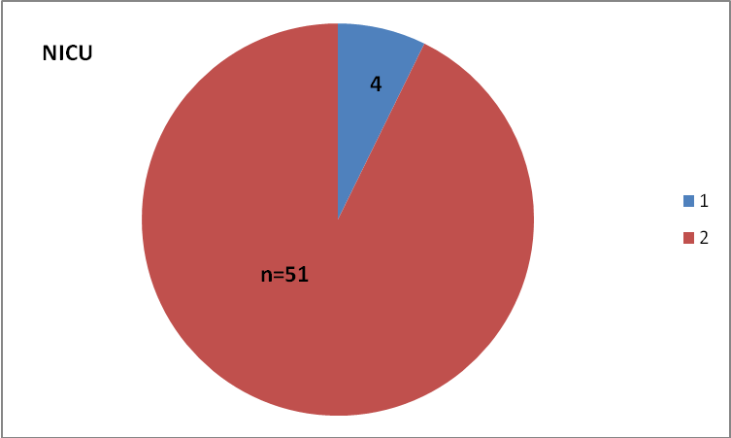
NICU 4/51 (7.8%),3 had AFI <5cm

