Figure 1 : Controls v/s Sudarshan Kriya : Increased beta and alpha activity

Figure 2: Blood Lactate Levels

Figure 3 : Menopausal Transition Flow
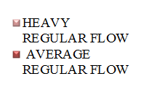
Figure 4 : Comparison of Likerts Scores for PM Symptoms
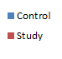
Figure 5 : Comparison of Symptoms
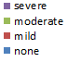

Figure 6 : Mean Scores for Health Practices
