Covering letter
Date: 9th June, 2017

To
The Editor,
Asian Journal of Medical Sciences
Sub: Submission of Manuscript for publication
Dear Sir,
We intend to publish an article entitled “Mental health and depression among school going adolescents: excerpts from a school based study of Nadia district, West Bengal” in your esteemed journal as an Original Article. On behalf of all the contributors I will act and guarantor and will correspond with the journal from this point onward. This has been seen and approved by the co-author.
The copyright disclosure statement is enclosed herewith with signature of all authors.
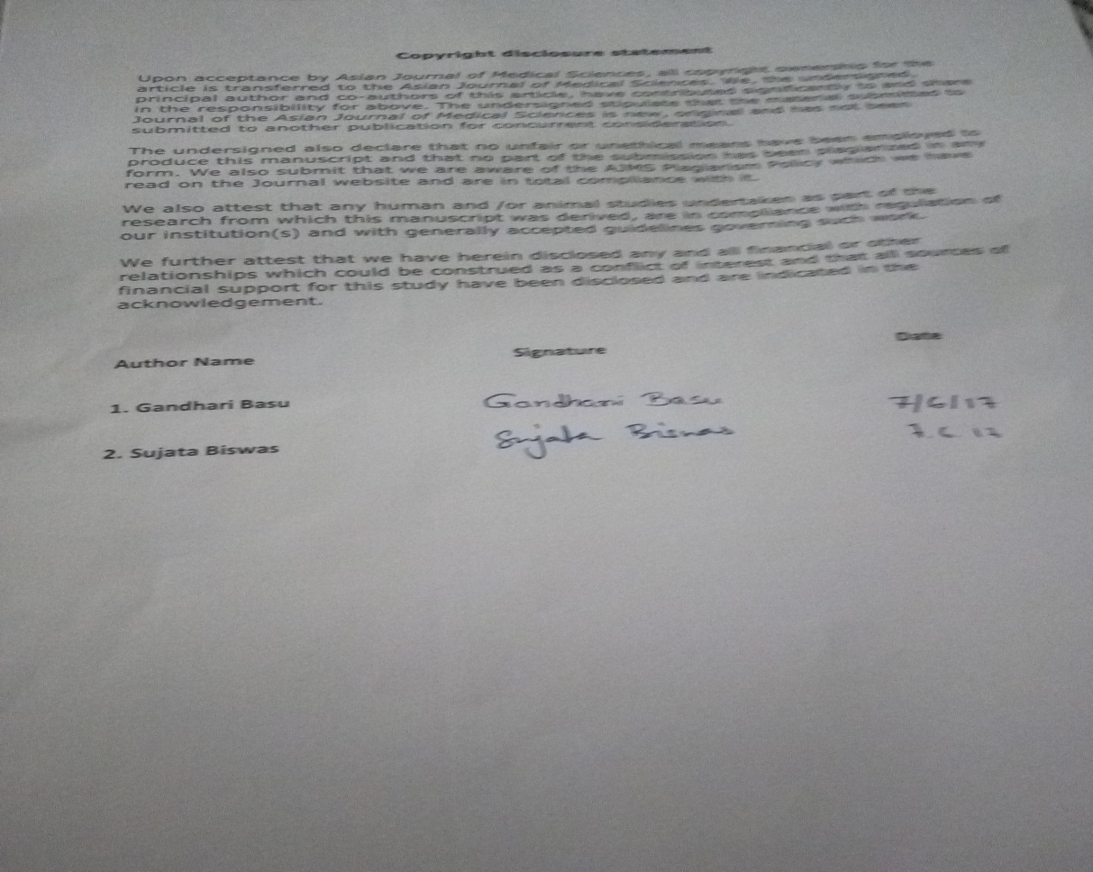
Thanking you,
Gandhari Basu

