EthnoMedicinal Knowledge of plants used by Irula Tribes, Nellithurai Beat, the Nilgiris, Tamil Nadu.

S. M. Dhivya and K.Kalaichelvi ¹
PG and Research Department of Botany, Vellalar College for Women (Autonomos), Thindal, Erode - 638012, Tamil Nadu, India. Mobile: +9188838 28744.
¹Associate Professor, PG and Research Department of Botany, Vellalar College for Women (Autonomos), Thindal, Erode - 638012, Tamil Nadu, India.
Abstract:
The study of local knowledge about natural resources is becoming increasingly important in defining strategies and actions for conservation. In recent years, work in ethnobotanical knowledge worldwide has increased especially in some parts of Europe, Asia, and Africa. India, a country with a rich culture and traditional knowledge, has contributed a major share of the world’s ethnobotanical work. There are no previous reports on the documentation of Botanical Survey of medicinal plants from Nellithurai Beat, Karmadai Range, Western Ghats, Tamil Nadu, India. The main objectives behind this study was to record the plants used for medicinal purposes in Nellithurai Beat through regular field visits. A total of 85 plant species belonging to 46 families were documented.. Their vernacular name, family, mode of preparation, medicinal uses were identified and documented. Among the total documented species were Trees (38.82%), Shrubs (35.29%), Herbs (20%), Climbers(4.70%) and Epiphytes (1.17%). The representing plants are mostly used to cure ailments like Asthma, Jaundice, Tuberculosis, Leprosy, Rheumatism, cough, fever, vomiting, skin diseases, hypertension, wound healing, diabetes, anti inflammation, anti cancerous, etc., Leaves and whole plants are the most widely (49% and 20%) used plant part of the reported medicinal plants, followed by Roots and Fruits (17%). Decoction are the most widely (50%) used mode of preparation of the reported medicinal plants, followed by Paste (16%). The study therefore concludes, it is necessary that suitability requirements are needed in order to protect the traditional knowledge in a particular area with reference to medicinal plant utilization and the study will be useful for any future ethno-pharmacological research for the discovery of new drugs.
Key words: Medicinal plants, nellithurai beat, indigenous knowledge, ailments
Introduction
Plants are playing an important role in the health of millions of people’s life in many villages of India in their day today life by its traditional usage. Herbal medicine is the foundation for about 75– 80% of the World population, mainly targeting primary health care for in the developing countries because of better cultural acceptability, compatibility with human body and lesser side effects. However, there is a drastic increase in the usage of herbal medicine was found in last few years from the developed countries (Kamboj, 2000).
India is gold mine of well practical knowledge of traditional herbal medicines. But unlike China, India has not been able to capitalize on this wealth by promoting its use in the developed world despite their renewed interest in herbal medicines (Lewis, 2001). India has wide variations in climate, soil, altitude and latitude. It is a country rich in indigenous herbal resources which grow on their varied topography and under changing agro climatic conditions permitting the growth of almost, over 6000 plants are used in traditional, folk and herbal medicines. But only 3000 plants are medicinally recognized for their value, representing about 75% of the medicinal needs of the third world countries (Chitravadivu, 2009).

The practices of traditional medicine are wide spread in China, India, Japan, Pakistan, Sri Lanka and Thailand. In India, herbal medicines have been used traditionally for a long period on the basis of the treatment for various diseases in traditional methods, practiced as Ayurveda, Unani, and Sidda in spite of tremendous developments in the field of Allopathy. During 20th century, plants remain as one of the major source of drugs in modern as well as traditional system of medicine throughout the world. Traditional medicine may be summarized as the sum total of all the knowledge and practical, whether reasonable or not, used in the diagnosis, prevention and elimination of physical, mental or social imbalances, which is relying exclusively on practical experience and observations handed down from generation to generation through either verbally or in writings. Traditional healing systems play an important role in maintaining the physical and physiological well being of the vast majority of the people in India. Today, continued deforestation and environmental degradation in many parts of India have brought about depletion of medicinal plants and their associated knowledge. Medicinal plants are the wealthy bio-resources of drugs of traditional medicinal systems, modern medicines, nutraceuticals, food supplements, and folk medicines, pharmaceuticals, intermediate and chemical entitled for synthetic drugs (Abraham. 1981).
The tribal and rural people of various parts of India are highly depending on medicinal plant therapy for meeting their health care needs. Herbal medicines have been used by them since antiquity in treating diseases. However, valid scientific data on the usage of ethnomedicinal plants is rather obscure. This is attracting the attention of several botanists and plant scientists who directing vigorous researches towards the discovery or rediscovery of several medicinal plants along with their medicinal remedies for various diseases. Several workers were reported the utility of plants for the treatment of various diseases by the different tribal and rural people inhabiting in various regions of TamilNadu (Shanmugam et al., 2011).
Recently, Schmidt et al., (2009) experimentally proved that plants offer immense scope for researchers engaged in validation of traditional claims for the development of novel drugs. Since, interest in traditional medicine has been increasing world-over ethnobotanical studies have gained prominence to explore the traditional knowledge particularly in developing countries (Joshi and Joshi, 2000). Therefore, collection of ethnobotanical information and documentation of traditional knowledge has gained prominence from the perspective of drug development (Ragupathy et al., 2008).
The main objective of this study was to assess the diversity of ethnomedicinal plants used by Irulas of Nellithurai beat and document the traditional medical practices followed in healing aliments. Similar ethnobotanical studies have been reported in several parts of India to document the traditional knowledge that has been vanishing (Rajan et al., 2002; Ganesan et al., 2004; Sandhya et al., 2006; Ignacimuthu et al., 2006). Therefore, documenting indigenous knowledge through ethnobotanical studies is important for the conservation of biological resources and their sustainable utilization.
Materials and Methods
Study area
The present study was conducted in Nellithurai beat, Karamadai range, Coimbatore district, Western Ghats, Tamil Nadu which is rich in vegetation and lies between the longitudes 76⁰ - 53”and latitudes 11⁰ - 18’. The study area has twelve villages with a total area of about 6207 Hec. long and it lies at 820-910 msl elevations. Temperature in the area ranges from 21⁰C to 30⁰C. The annual average rain fall ranges from 1000 to 1400 mm. The black and red soil, bright sunlight are the two important natural resources abundantly available in this region which are responsible for the development of the vegetation having variable medicinal properties.
Collection of information
The information on ethnomedicinal uses of plants was obtained through direct field interviews and designed questionnaire with knowledgeable people of the villages and traditional healers. The data regarding names of plant parts used and their method of preparation and made of administration of various remedies were also noted down. The medicinal value of each plant was enumerated in the following Pattern: a) Botanical name, b) Habit, c) Family, d) Vernacular name, e) parts used, f) Ethnomedicinal uses and g) Mode of action.
Identification
The plant materials were identified with the help of standard local floras (Flora of Bombay Presidency), Preliminary identification was done by examining fresh plants products from the field with the help of villagers. Few respondents were more informative and co-operative. They have shown fresh plants in the habitat, which was useful for the final identification. The identification of plant materials was confirmed with the help of published data.
Results and Discussion
All the respondents were males with 65% within the age range of 41-50 years, 25% within the age range of 51-60 years, while about 10% were above 60 years. All of them were married and most of them were traditional medicinal practitioners. Most of them claimed that they inherited their vocation and ethnomedicinal knowledge from their parents.
Ethnomedicinal survey
A total of 85 medicinal plants belonging to 46 different families were collected simultaneously recording their Vernacular names. These were reported to be used in the cure and treatment of innumerable ailments. Their botanical names, vernacular names, families, part(s) being used, mode of action and medicinal uses are shown in Table-1. Most of the plants are wholly medicinal. The local tribals of Nellithurai beat villagers are using these plants to cure many diseases like Asthma, Jaundice, Tuberculosis, Leprosy, Rheumatism, cough, fever, vomiting, skin diseases, hypertension, wound healing, diabetes, anti inflammation, anti cancerous, etc., Indigenous knowledge of folk is the important sources of locating bio-resources of the locality. The people have been using plant remedies against various ailments from time immemorial without knowing their effective constituents (Selvadurai et al., 2013).
The families with the largest number of plant species were Fabaceae and Euphorbiaceae with 7 species, followed by Mimosaceae with 5 species. The families Acanthaceae, Rubiaceae, Moraceae and Rutaceae had three species each. Poaceae, Capparidaceae, Cactaceae, Aizoceae, Anacardiaceae, Oleaceae, Verbenaceae, Proteaceae, Solanaceae, Ebenaceae and Loranthaceae had two species each. The remaining plant families had one species each (Table-2). This finding of common medicinal plant families in the study is in agreement with that of Yusuf et al., (2009) and Sajih and Uddin (2015). Among the recorded species trees (38.82%) were found to be dominating over shrub (35.29%), herbs (20%), climber (4.70%) and epiphyte (1.17%) (Table-3).
Analysis of the plant’s parts used showed that leaves are the mostly used plant parts(49.41%), followed by whole plants(20%), root and fruit (17.64%), stem and bark (11.76%), seeds (8.23%) and gum, tuber, pulp and flower (1.17% each) (Fig-1). It is important to highlight that such a wide harvesting of leaves and seeds, compared to roots which are important for survival of plants, has a less negative influence on the survival and continuity of useful medicinal plants and hence does not affect sustainable utilisation of the plants (Yirga, 2010).
The most frequently cited modes of plant used are as decoction (50.58%), paste (16.47%), juice (10.58%), extraction (8.23%), infusion (7.05%), tonic (3.57%) and raw (2.35%) (Fig-2).Both external and internal methods of application of herbal medicine have been prescribed (Sajih and Uddin 2015).
In a nutshell, scientific validation of identified plants will established their importance in treatment of various ailments this will also encourage the native people to cultivate these plants as a sources of income in addition to the preservation and conservation of these plants. Further, it has been observed that the traditional practitioners are the custodian of this traditional knowledge and they have their own reservation to pass on this unwritten traditional knowledge to their next generation. Hence, proper method must be adopted to document this traditional knowledge of the local practitioners.

Table: 2 Distribution of species among different families
S. No | Family Name | No. of Species | Percentage (%) | Total No. of species
1. | Acanthaceae | 3 | 3.57% | 85
2. | Aizoceae | 2 | 2.35% | 85
3. | Anacardiaceae | 2 | 2.35% | 85
4. | Apocynaceae | 1 | 1.17% | 85
5. | Asclepiadaceae | 1 | 1.17% | 85
6. | Arecaceae | 1 | 1.17% | 85
7. | Asteraceae | 1 | 1.17% | 85
8. | Bignoniaceae | 1 | 1.17% | 85
9. | Boraginaceae | 1 | 1.17% | 85
10. | Cactaceae | 2 | 2.35% | 85
11. | Caesalpiniaceae | 1 | 1.17% | 85
12. | Capparidaceae | 2 | 2.35% | 85
13. | Cheilanthaceae | 1 | 1.17% | 85
14. | Cucurbitaceae | 1 | 1.17% | 85
15. | Cyperaceae | 1 | 1.17% | 85
16. | Ebenaceae | 2 | 2.35% | 85
17. | Erythroxylaceae | 1 | 1.17% | 85
18. | Euphorbiaceae | 7 | 8.23% | 85
19. | Fabaceae | 7 | 8.23% | 85
20. | Lamiaceae | 2 | 2.35% | 85
21. | Loganiaceae | 1 | 1.17% | 85
22. | Loranthaceae | 2 | 2.35% | 85
23. | Malvaceae | 1 | 1.17% | 85
24. | Menispermaceae | 1 | 1.17% | 85
25. | Meliaceae | 1 | 1.17% | 85
26. | Mimosaceae | 5 | 5.88% | 85
27. | Moraceae | 3 | 3.57% | 85
28. | Oleaceae | 2 | 2.35% | 85
29. | Onagraceae | 2 | 2.35% | 85
30. | Opiliaceae | 1 | 1.17% | 85
31. | Passifloraceae | 1 | 1.17% | 85
32. | Pedaliaceae | 1 | 1.17% | 85
33. | Plumbaginaceae | 1 | 1.17% | 85
34. | Poaceae | 2 | 2.35% | 85
35. | Proteaceae | 1 | 1.17% | 85
36. | Rhamnaceae | 1 | 1.17% | 85
37. | Rosaceae | 1 | 1.17% | 85
38. | Rubiaceae | 3 | 3.57% | 85
39. | Rutaceae | 3 | 3.57% | 85
40. | Salvadoraceae | 1 | 1.17% | 85
41. | Santalaceae | 1 | 1.17% | 85
42. | Sapindaceae | 1 | 1.17% | 85
43. | Scorphulariaceae | 1 | 1.17% | 85
44. | Tiliaceae | 1 | 1.17% | 85
45. | Ulmaceae | 1 | 1.17% | 85
46. | Verbenaceae | 2 | 2.35% | 85

Table: 3 Analysis of the data based on habit
S. No | Habit | Number of species | Percentage (%) | Total no. of species
1. | Tree | 33 | 38.82% | 85
2. | Herb | 17 | 20% | 85
3. | Shrub | 30 | 35.29% | 85
4. | Climber | 4 | 4.70% | 85
5. | Epiphytes | 1 | 1.17% | 85

Fig:1 Histogram showing the percentage of parts used

Fig: 2 Pie diagram showing the mode of action of ethnomedicinal plants

Plate -1
Snapshots of some surveyed plant species

Abrus precatorius L Borreria ocymoides, Dc. Capparis sepiaria, L.
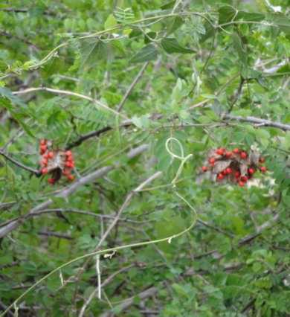
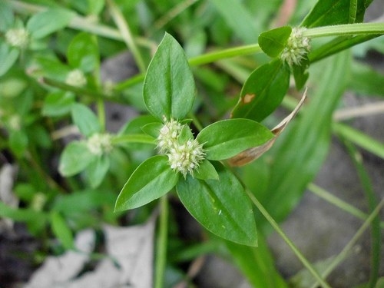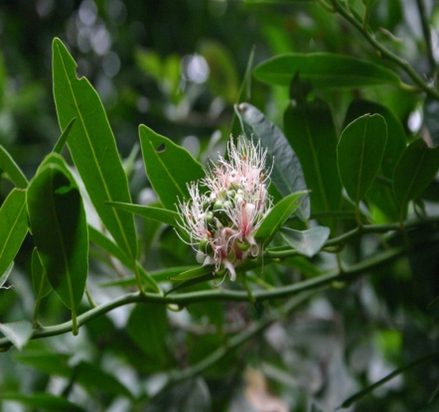

Erythroxylon monogynum, Roxb. Ficus microcarpa, Wight. Ludwigia abyssinica, A. Rich.
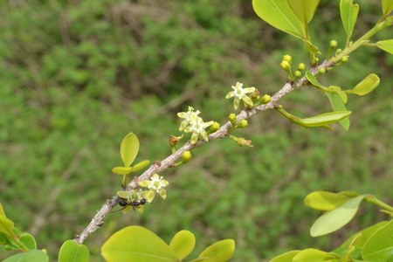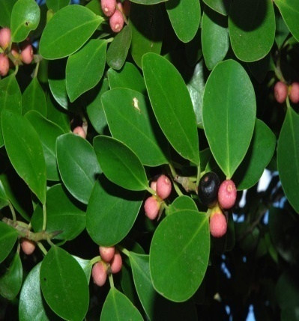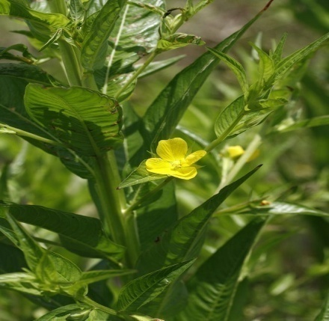

Physalis minima, L. Sapthodea campanulata, P. Beauv. Viscum articulatum, Burm. 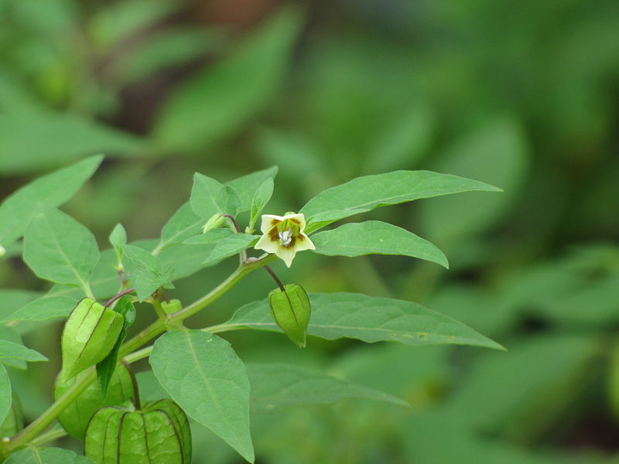 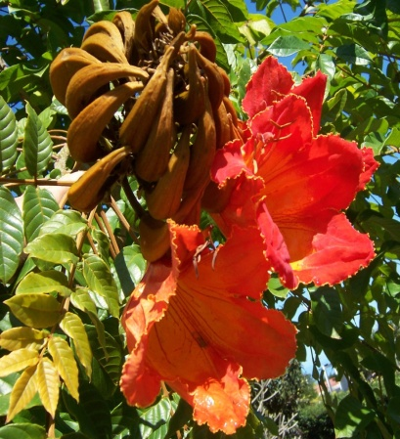 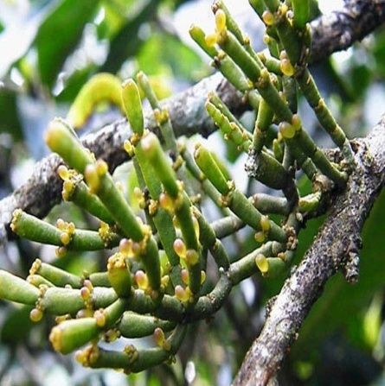

Conclusion
The medico-botanical survey of the area revealed that the people of the area possessing good knowledge of herbal drugs but as the people are in progressive exposure to modernization, their knowledge traditional uses of plants may be lost in due course. So it is important to study and record the uses of plants by different tribes for futures study. Such studies may also provide some information to biochemists and pharmacologists in screening of individual species and in rapid assessing of phyto-constituents for the treatment of various diseases.
References

[1] Abraham, Z., Glimpses of Indian Ethno botany, Oxford & Publishing Co., New Delhi, 1981, 308.

[2] Chitravadivu, C., S, Manian and K, Kalaichelvi., Middle. East Journal of Sceintific Research., 2009, 4 (3), 144..

[3] Ganesan, S., Suresh, N., Kesavan, L., 2004. Ethnomedicinal survey of lower Palani Hills of Tamil Nadu. Indian Journal of Traditional Knowledge 3(3), 299-304.
[4] Ignacimuthu, S., Ayyanar, M., SankaraSivaraman, K., 2006. Ethnobotanical investigations among tribes in Madurai District of Tamil Nadu (India). Journal of Ethnobiology and Ethnomedicine 2, 25-30.
[5] Joshi, A. R., Joshi, Kunjani, 2000. Indigenous knowledge and uses of medicinal plants by local communities of the Kali Gandaki Watershed Area, Nepal, Journal of Ethnophamacology 73(12), 175-183.
[6] Kamboj ,V. P,. Herbal medicine, Current Science., 2000, 78(1), 35.

[7] Lewis, E.M., Braz. J Med. Biol. Res., 2001, 33,179.
[8] Ragupathy, S., Newmaster, S. G., Maruthakkutti, M., Velusamy, B., Ul-Huda, M. M., 2008. Consensus of the 'Malasars' traditional aboriginal knowledge of medicinal plants in the Velliangiri holy hills, India. Journal of Ethnobiology and Ethnomedicine 27(4), 8-15.
[9] Rahmatullah,M., A-Al-Mahmud, Md. A. Rahman, Md. F. Uddin, M. Hasan, Mst. A. Khatun, A.B.M. A. Bashar, S. Ahsan, S.M.Mou, R. Begum, R. Jahan., American-Eurasian Journal of Sustainable Agriculture., 2011, 5(1), 115.
[10] Rajan, S., Sethuraman, M., Mukherjee, P. K., 2002. Ethnobiology of the Nilgiri Hills, India. Phytotherapy Research 16, 98-116.
[11] Sajib N. H. and Uddin S. B. 2015. Ethnomedicinal study of plants in Hathazari, Chittagong, Bangladesh. Tropical Agricultural Sciences. 38(2): 197-210.
[12] Sandhya, B., Thomas, S., Isabel, W., Shenbagarathai, R., 2006. Ethnomedicinal plants used by the Valaiyan community of Piranmalai Hills, Tamil Nadu, India – A pilot study. African Journal of Traditional, Complementary and Alternative Medicines 3(1), 101-114.
[13] Schmidt, C., Fronza, M., Goettert, M., Geller, F., Luik, S., Flores, E. M., Bittencourt, C. F., Zanetti, G. D., Heinzmann, B. M., Laufer, S., Merfort, I., 2009. Biological studies on Brazilian plants used in wound healing. Journal of Ethnopharmacology 122(3), 523-532.
[14] Selvadurai S., Shri Vijaya Kirubha T., Senthamarai R. and Dutty Roy S. 2013. Asian J. Biochem. Pharm. Res. 3: 116.
[15] Shanmugam S, Kalaiselvan M, Selvakumar P, Suresh K, Rajendran K. Ethnomedicinal plants used to cure diarrhoea and dysentery in Sivagangai district of f Tamil Nadu, India. Int J Res Ayur Pharm 2011; 2 (5): 991 - 994.
[16] Yigra G. 2010. Ethnobotanical study of medicinal plants in and around Almata, Southern Tigray, Northern Ethiopia. Curr Res. J. Biol Sci., 2(5), 338-344.
[17] Yusuf M., Begum J., Hoque M. N. And Chowdhury J. U. 2009. Medicinal plants of Banladesh. Chittagong, Bangladesh: BCSIR.

