Table: 2 Distribution of species among different families
S. No | Family Name | No. of Species | Percentage (%) | Total No. of species
1. | Acanthaceae | 3 | 3.57% | 85
2. | Aizoceae | 2 | 2.35% | 85
3. | Anacardiaceae | 2 | 2.35% | 85
4. | Apocynaceae | 1 | 1.17% | 85
5. | Asclepiadaceae | 1 | 1.17% | 85
6. | Arecaceae | 1 | 1.17% | 85
7. | Asteraceae | 1 | 1.17% | 85
8. | Bignoniaceae | 1 | 1.17% | 85
9. | Boraginaceae | 1 | 1.17% | 85
10. | Cactaceae | 2 | 2.35% | 85
11. | Caesalpiniaceae | 1 | 1.17% | 85
12. | Capparidaceae | 2 | 2.35% | 85
13. | Cheilanthaceae | 1 | 1.17% | 85
14. | Cucurbitaceae | 1 | 1.17% | 85
15. | Cyperaceae | 1 | 1.17% | 85
16. | Ebenaceae | 2 | 2.35% | 85
17. | Erythroxylaceae | 1 | 1.17% | 85
18. | Euphorbiaceae | 7 | 8.23% | 85
19. | Fabaceae | 7 | 8.23% | 85
20. | Lamiaceae | 2 | 2.35% | 85
21. | Loganiaceae | 1 | 1.17% | 85
22. | Loranthaceae | 2 | 2.35% | 85
23. | Malvaceae | 1 | 1.17% | 85
24. | Menispermaceae | 1 | 1.17% | 85
25. | Meliaceae | 1 | 1.17% | 85
26. | Mimosaceae | 5 | 5.88% | 85
27. | Moraceae | 3 | 3.57% | 85
28. | Oleaceae | 2 | 2.35% | 85
29. | Onagraceae | 2 | 2.35% | 85
30. | Opiliaceae | 1 | 1.17% | 85
31. | Passifloraceae | 1 | 1.17% | 85
32. | Pedaliaceae | 1 | 1.17% | 85
33. | Plumbaginaceae | 1 | 1.17% | 85
34. | Poaceae | 2 | 2.35% | 85
35. | Proteaceae | 1 | 1.17% | 85
36. | Rhamnaceae | 1 | 1.17% | 85
37. | Rosaceae | 1 | 1.17% | 85
38. | Rubiaceae | 3 | 3.57% | 85
39. | Rutaceae | 3 | 3.57% | 85
40. | Salvadoraceae | 1 | 1.17% | 85
41. | Santalaceae | 1 | 1.17% | 85
42. | Sapindaceae | 1 | 1.17% | 85
43. | Scorphulariaceae | 1 | 1.17% | 85
44. | Tiliaceae | 1 | 1.17% | 85
45. | Ulmaceae | 1 | 1.17% | 85
46. | Verbenaceae | 2 | 2.35% | 85

Table: 3 Analysis of the data based on habit
S. No | Habit | Number of species | Percentage (%) | Total no. of species
1. | Tree | 33 | 38.82% | 85
2. | Herb | 17 | 20% | 85
3. | Shrub | 30 | 35.29% | 85
4. | Climber | 4 | 4.70% | 85
5. | Epiphytes | 1 | 1.17% | 85

Fig:1 Histogram showing the percentage of parts used

Fig: 2 Pie diagram showing the mode of action of ethnomedicinal plants

Plate -1
Snapshots of some surveyed plant species

Abrus precatorius L Borreria ocymoides, Dc. Capparis sepiaria, L.
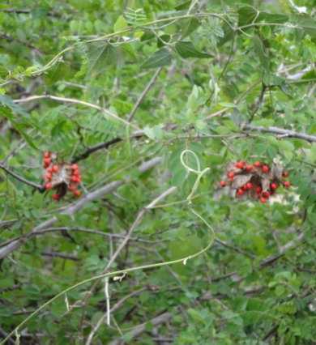
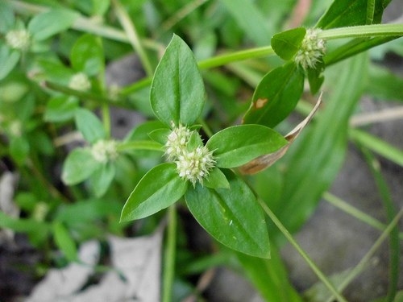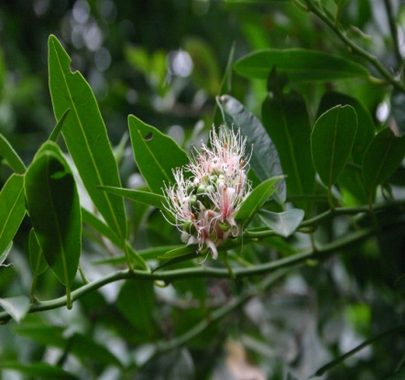

Erythroxylon monogynum, Roxb. Ficus microcarpa, Wight Ludwigia abyssinica, A. Rich.
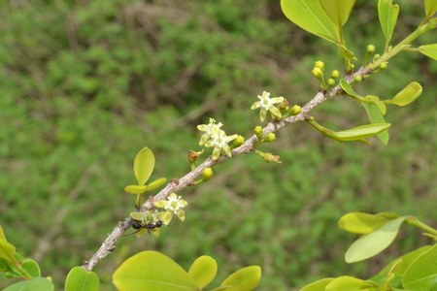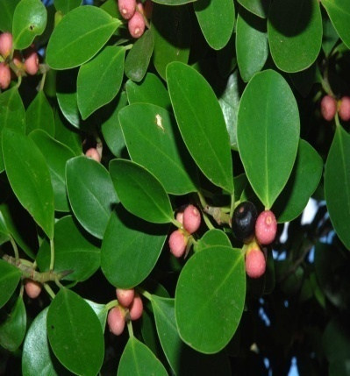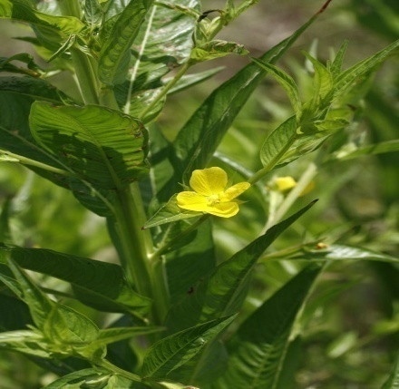

Physalis minima, L. Sapthodea campanulata, P. Beauv. Viscum articulatum, Burm. 