Letter of Undertaking
Date: 01/12/2014

Title: OXIDATIVE STRESS MEDIATED ELECTROLYTE IMBALANCE IN 30 KNOWN CASES OF KNEE OSTEOARTHRITIS PATIENTS: A CLINICAL APPROACH

Authors: Jusmita Dutta, Dilutpal Sharma, Rahul Saxena

This is to confirm that the work in this manuscript is original and that the manuscript has neither been published nor is currently under consideration for publication either in whole or in part, by any other journal. It will not be submitted for publication else-where till the decision to its acceptability by the Asian Journal of Medical Sciences.
Name (in capital): Dr. RAHUL SAXENA 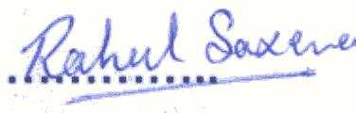
Corresponding author

Correspondence &
Reprint request: Dr. Rahul Saxena
Assistant Professor
Biochemistry Department
School of Medical Sciences & Research
Sharda Hospital, Sharda University
Greater Noida, U.P.-201030
INDIA
E-mail : rahulapril@gmail.com
Mobile No. +91- 9958255816, 8010621551

