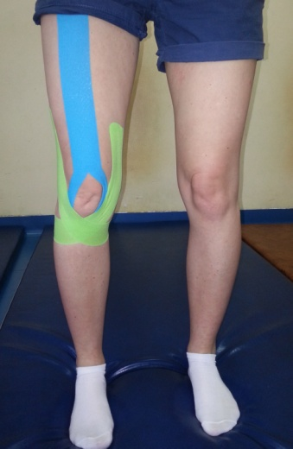
Figure 1. Application KT for quadriceps femoris with supporting proprioception

Table 1. Results of knee flexion and extension measurements, femoral measurements, and knee measurement (differences between current and previous measurements: * p<0.05, ** p<0.01, *** p<0.001)
 |  | damaged limb |  |  |  | healthy limb
 |  | measurements |  |  |  | measurements
 |  | 1 | 2 | 3 | 4 | 1 | 2 | 3 | 4
knee flexion [°] | all | 105 | 111.7*** | 118.3*** | 124.1*** | 129.8 | 129.8 | 129.8 | 129.6
 | Group 1 | 104.5 | 112.1*** | 121.8*** | 127.7*** | 132.7 | 132.7 | 132.7 | 132.3
 | Group 2 | 105.4 | 111.3*** | 115** | 120.8*** | 127.1 | 127.1 | 127.1 | 127.1
knee extension [°] | all | 6.73 | 3.04*** | 0.43*** | 0.21 | 0.21 | 0.21 | 0 | 0
 | Group 1 | 6.36 | 2.27** | 0.45** | 0 | 0 | 0 | 0 | 0
 | Group 2 | 7.08 | 3.75*** | 0.41*** | 0.41 | 0.41 | 0.41 | 0 | 0
femoral measurement 1 [cm] | all | 58.57 | 58.65 | 58.93*** | 59.22** | 59.8 | 59.87 | 59.91 | 59.91
 | Group 1 | 59.77 | 59.91 | 60.18** | 60.55* | 61.05 | 61.09 | 61.14 | 61.09
 | Group 2 | 57.46 | 57.5 | 57.79* | 58 | 58.67 | 58.75 | 58.79 | 58.83
femoral measurement 2 [cm] | all | 46.19 | 46.54*** | 46.85** | 47.11** | 47.43 | 47.5 | 47.57 | 47.63
 | Group 1 | 47.26 | 47.77*** | 48* | 48.36** | 48.5 | 48.59 | 48.59 | 48.64
 | Group 2 | 45.21 | 45.42** | 45.79* | 45.96* | 46.46 | 46.5 | 46.63 | 46.71
knee measurement [cm] | all | 40.7 | 40.39*** | 40.22** | 39.8** | 39.26 | 39.26 | 39.26 | 39.3
 | Group 1 | 41.27 | 40.91*** | 40.68** | 40.14** | 39.82 | 39.82 | 39.82 | 39.82
 | Group 2 | 40.17 | 39.92** | 39.79 | 39.5* | 38.75 | 38.75 | 38.75 | 38.83

Table 2. Results of pain level measured by Laitinen Scale (differences between groups: * p<0.05)
 |  | 1. day | 28. day | difference [p]
Group 1 | intensity of pain | 1.755 | 0.727 | p<0.01
 | frequency of pain | 1.636 | 0.636 | p<0.01
 | use of analgesics | 1.364 | 0.091 | p<0.001
 | decreased activity | 1.727 | 0.273 | p<0.001
Group 2 | intensity of pain | 2.250* | 1.000 | p<0.001
 | frequency of pain | 2.167 | 1.167* | p<0.01
 | use of analgesics | 1.750 | 0.667* | p<0.001
 | decreased activity | 1.833 | 0.833 | p<0.01

Figure 2. Assessment of physiotherapeutic treatments

